**By**

This Report Presented in Partial Fulfilment of the Requirements for the Degree of Bachelor of Science in Software Engineering.

Supervised By

Department of Software Engineering

Daffodil International University



**DAFFODIL INTERNATIONAL UNIVERSITY**

**Dhaka, Bangladesh**

**Summer 2020**

**APPROVAL**

This project titled on “TutorsAid”, submitted by Md.Muhtasim Rahman (172-35-2193) to the Department

of Software Engineering, Daffodil International University has been accepted as satisfactory for the

partial fulfilment of the requirements for the degree of Bachelor of Science in Software Engineering and approval as to its style and contents.

**Board of Examiners**

**(Name)**

**Designation**

Department of SWE

Faculty of Science & Information Technology

Daffodil International University

**Chairman**

**(Name)**

**Designation**

Department of SWE

Faculty of Science & Information Technology

Daffodil International University

**Internal Examiner 1**

**(Name)**

**Designation**

Department of SWE

Faculty of Science & Information Technology

Daffodil International University

**Internal Examiner 2**

**(Name)**

**Designation**

Department of -------

----------- University

**External Examiner**

**DECLARATION**

I hereby declare that project titled “TutorsAid” has been completed by me under the supervisor of Ms. Farzana Sadia, Assistant Professor, Department of Software Engineering, Daffodil International University for the purpose of achieving degree of Bachelor of Science from Daffodil International University. This is also declared by me that neither this project nor any part of this project has been used or submitted elsewhere for any kind of degree or awards.

**ACKNOWLEDGEMENT**

First and foremost, all the praise and thanks go to the Almighty Allah for all the blessings for all my project work, giving me patience and enabling me to complete this project on time.

I would like to express my special thanks to my respected supervisor **Ms. Farzana Sadia** for giving me her proper direction and for helping me to finish all the work in the end. I am especially grateful to my supervisor for her assistance throughout the project. Her excellent guidance, advice, valuable constructive advice, has made it possible for me to complete this project with confidence.

I am very blessed to have the opportunity to study at Daffodil International University. I would like to express my deep gratitude to our honourable department Head of SWE, for encouraging me and giving me such an opportunity. I want to thank all my respected teachers who teach us in a great, interesting and understandable way. I am grateful to them for making my journey the easiest and most enjoyable.

I am grateful to my parents as well as all the members of the family. My whole study journey would not have been so easy without their endless support and co-operation.

I am grateful to all my department staff members, lab technicians and non-teaching staff members for their ultimate support throughout my journey.

Finally, I would like to express my love to my batch mates, to the DIU members for their kind co-operation and comfort that helped me finish all the work.

**ABSTRACT**

This project aims to develop TutorsAid. The project titled "**TutorsAid**" is a web-based application. It was created using PHP and MySQL. This project has tried to incorporate all the advanced features of PHP such as to meet the project goals. A necessary platform for ordinary shopkeepers or small traders. This solution helps shopkeepers or vendors to keep all records of product price, sales, purchases information, customer information & payment information and also show daily or monthly profit. This software solution helps increase business growth and smart business management.

**CHAPTER 1: INTRODUCTION**

**1.1 Project Overview**

As Bangladesh is moving forward with the goal of ‘Digital Bangladesh’. There are many coaching centers around the capital that lack a system to help them not only attract more students but manage their tasks better.

Teachers have a lot in their hands when it comes to coaching centers and mostly have to manage everything alone the same dilemma is for the new teachers .They needed a system that can work as an assistant or even the teacher when the students needed any help or information assistant because a teacher cannot be always present and extra assistance costs a fortune.

So, we have decided to make a solution in the form of a web application to help a teacher manage all the tasks and also help maintain a support system for the students.

**Related Solution**

I’ve went to different coaching centers of various scales and sat down with teachers to gain

knowledge about their problems and come up with valid solutions to design my project. Among

the existing systems there are : Google Classroom. Despite it being a global solution for all teachers

there are a good amount of students who still find it hard to use and the teachers too have concluded

that the system doesn’t provide enough for them in terms of storing sensitive data ,records and also

doesn’t provide a less public way for students to communicate with each other. Most of the other apps

used also have the same issues and some even lack in the user friendly interface.

In my opinion, the best solution for these systems of these systems are a system that not only help them store sensitive data but also are user friendly and well organized. Requirements collected must be strictly followed and use interface should be friendlier and less complex mechanisms should be used

**1.2 Project Purpose**

The main purpose of our ‘TutorsAid’ project is to solve the problems of coaching centers all around Bangladesh and also provide solutions that would make it acceptable worldwide.

The goal is to make a system so that not only it reduces the expenses of a teacher also it helps manage better and a good system will also help the teacher attract students more to the institution.

**1.2.1 Background**

I have spent 8 years serving as a TA to various teachers of renowned institutions in Dhaka. Throughout these years I have come across many problems and countless situations where I felt I need for a change. The conventional ways of storing data had shown numerous problems and managing it was very costly. I am using all that experience and also gathered resources to build a perfect solution.

**1.2.2 Benefits & Beneficiaries**

We have beneficial aspects of this solution. They are pointed out below:

* Students no longer have to wait for hours to talk to teachers personally
* Students can get solutions easily through discussion panel
* They can view and access information easily
* Admins can uploads all the information to the system no external means needed
* Assignments can be submitted in the system.
* Normally most of these are done my hired admins which will no longer be necessary

**1.2.3 Goals**

* Make a common platform to interact
* Allow to communicate with teachers privately
* Save all Information in the application
* Add File upload system saves times and effort
* Make user friendly interface for best experience

**1.3 Stakeholders**

There are two types of Stakeholders in our Solutions. They are:

* Admin/teacher
* Student

Admin/Teacher: Admin can access all the features.

Students: Students can access all the features except the sensitive data sections.

**1.4 System Model (Block Diagram)**

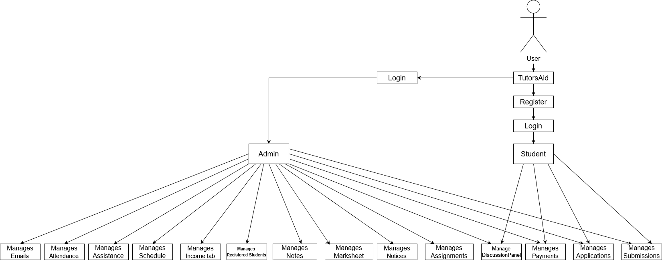

Figure 1: System Model for TutorsAid

# Figure 1: System Model for TutorsAid

**1.5 Project Schedule**

Project Schedule is important for every project to complete on time.

**1.5.1 Gantt Chart**

It is a visual view of tasks scheduled over time. It's a very smart way to show what work is scheduled to be done on a certain day. It also helps to show the start and end times of my project.

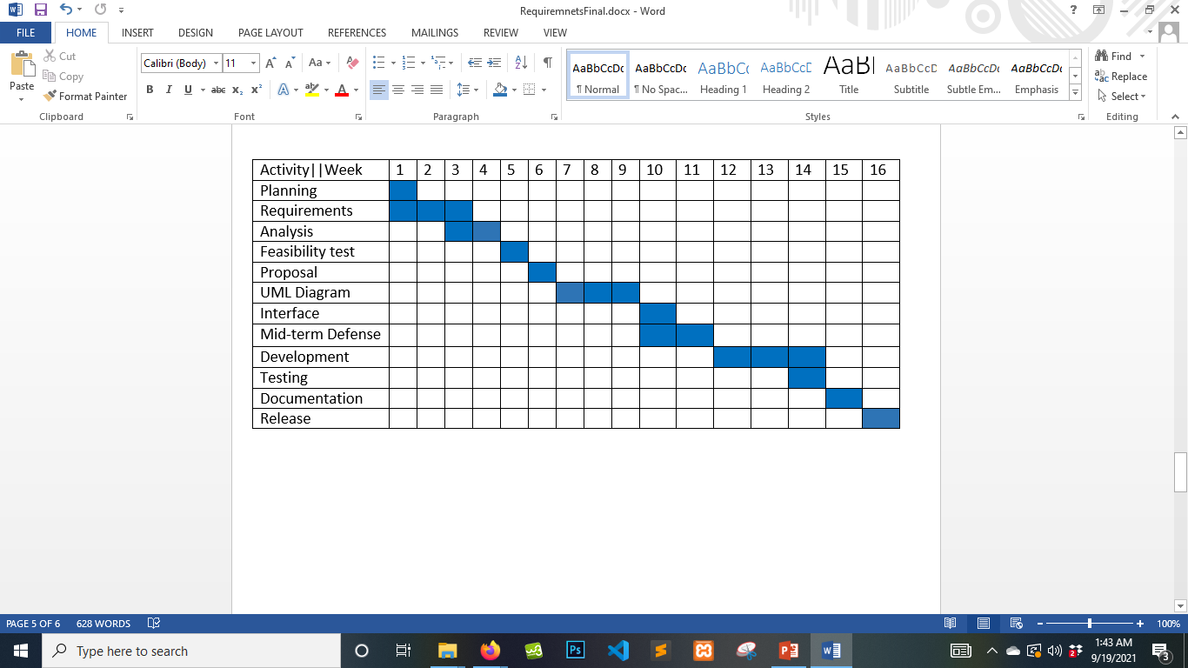

# Figure 1.1: Gantt Chart

**1.5.2 Project Timeline**

The Project timeline is given below:

|  |  |  |
| --- | --- | --- |
| **Activities** |  | **Date** |
|  |  |  |
| Topic Selection Seminar |  | 18/06/2020 |
| Brainstorming |  | 20/06/2020 - 29/06/2020 |
| Project Topic & Name Selection |  |  |
| Submit Project Proposal |  | 30/06/2020 |
| Requirement Specification |  | 15/07/2020 - 29/07/2020 |
|  |  |  |
| Mid Term Defense |  | 2/10/2021 |
| System Analysis & Design |  | 10/08/2020 - 25/08/2020 |
| Development System |  | 07/09/2020 - 15/11/2020 |
| System Testing |  | 20/09/2021 - 15/12/2021 |
| Complete Project |  | 18/12/2021 |
|  | Table 1.2: Project Timeline | |

**CHAPTER 2: SOFTWARE REQUIREMENT SPECIFICATION**

**2.1 Requirement Specification**

This system is developed on requirements provided by various teachers from tuitions centers of all kinds. We have focused on them to develop the perfect solution to overcome all the problems that students and teachers face in daily life and provided better solutions. Main goal here is to provide communication platforms between students and teachers. Teachers can communicate with students’ parents as well as save sensitive data security.

**2.2 Functional Requirements**

This section is those which are related to the technical functionality of the system. This section is described as a specific behavior of every feature and role.

2.2.1 Login

|  |  |
| --- | --- |
| FR 01 | Log in |
|  |  |
| Description | Admin and user will log in the system using user name, password. System will |
|  | verify user information from the database. If information doesn’t match with the |
|  | database, user can’t log in this system. |
| Stakeholder | Owner/Admin, Manager |
|  |  |

**2.2.2** Upload Class Schedule

|  |  |
| --- | --- |
| FR 02 | Upload Class Schedule |
|  |  |
| Description | Admin can enter class schedule menu after logging in |
|  |  |
|  |  |
| Stakeholders | Admin |
|  |  |

**2.2.3** Add Schedule

|  |  |
| --- | --- |
| FR 03 | Add Schedule |
|  |  |
| Description | Admin can add class schedule |
|  |  |
|  |  |
| Stakeholders | Admin |
|  |  |

**2.2.4** View Schedule

|  |  |
| --- | --- |
| FR 04 | View Schedule |
|  |  |
| Description | Admin can view uploaded class schedule |
|  |  |
|  |  |
| Stakeholders | Admin |
|  |  |

**2.2.5** Update Schedule

|  |  |
| --- | --- |
| FR 05 | Update Schedule |
|  |  |
| Description | Admin can update class schedule |
|  |  |
|  |  |
| Stakeholders | Admin |
|  |  |

**2.2.6** Attendance

|  |  |
| --- | --- |
| FR 06 | Attendance |
|  |  |
| Description | Admin can access attendance menu |
|  |  |
|  |  |
| Stakeholders | Admin |
|  |  |

**2.2.7** Add Attendance

|  |  |
| --- | --- |
| FR 07 | Add Attendance |
|  |  |
| Description | Admin can add attendance |
|  |  |
|  |  |
| Stakeholders | Admin |
|  |  |

**2.2.8** Check Attendance

|  |  |
| --- | --- |
| FR 08 | Check Attendance |
|  |  |
| Description | Admin can check attendance |
|  |  |
|  |  |
| Stakeholders | Admin |
|  |  |

**2.2.9** Search Attendance

|  |  |
| --- | --- |
| FR 09 | Search Attendance |
|  |  |
| Description | Admin can search attendance |
|  |  |
|  |  |
| Stakeholders | Admin |
|  |  |

**2.2.10** Check Registered Student

|  |  |
| --- | --- |
| FR 10 | Check Registered Student |
|  |  |
| Description | Admin can check who are registered to the system through this menu |
|  |  |
|  |  |
| Stakeholders | Admin |
|  |  |

**2.2.11** View List

|  |  |
| --- | --- |
| FR 11 | View List |
|  |  |
| Description | Admin can view the student list |
|  |  |
|  |  |
| Stakeholders | Admin |
|  |  |

**2.2.12** Block Student

|  |  |
| --- | --- |
| FR 12 | Block Student |
|  |  |
| Description | Admin can block students from logging in to the system |
|  |  |
|  |  |
| Stakeholders | Admin |
|  |  |

**2.2.13** Terminate Registration

|  |  |
| --- | --- |
| FR 13 | Terminate Registration |
|  |  |
| Description | Admin can terminate the registration of a student to the system |
|  |  |
|  |  |
| Stakeholders | Admin |
|  |  |

**2.2.14** Email parents

|  |  |
| --- | --- |
| FR 14 | Email parents |
|  |  |
| Description | Admin can send emails to the students parents |
|  |  |
|  |  |
| Stakeholders | Admin |
|  |  |

**2.2.15** Upload Notes

|  |  |
| --- | --- |
| FR 15 | Upload Notes |
|  |  |
| Description | Admin can enter the notes menu through this menu |
|  |  |
|  |  |
| Stakeholders | Admin |
|  |  |

2.2.16 Upload

|  |  |
| --- | --- |
| FR 16 | Upload |
|  |  |
| Description | Admin can upload notes as files to the system |
|  |  |
|  |  |
| Stakeholders | Admin |
|  |  |

**2.2.17** Check Uploads

|  |  |
| --- | --- |
| FR 17 | Check Uploads |
|  |  |
| Description | Admin can check the uploaded files to the system |
|  |  |
|  |  |
| Stakeholders | Admin |
|  |  |

**2.2.18** Income tab

|  |  |
| --- | --- |
| FR 18 | Income tab |
|  |  |
| Description | Admin can view the information’s of the income tab through this menu |
|  |  |
|  |  |
| Stakeholders | Admin |
|  |  |

**2.2.19** Add Collections

|  |  |
| --- | --- |
| FR 19 | Add Collections |
|  |  |
| Description | Admin can add collections to the income tab |
|  |  |
|  |  |
| Stakeholders | Admin |
|  |  |

**2.2.20** Show Income

|  |  |
| --- | --- |
| FR 20 | Show Income |
|  |  |
| Description | Admin can view collections in the income tab |
|  |  |
|  |  |
| Stakeholders | Admin |
|  |  |

**2.2.21** Search Payments

|  |  |
| --- | --- |
| FR 21 | Search Payments |
|  |  |
| Description | Admin can add collections to the income tab |
|  |  |
|  |  |
| Stakeholders | Admin |
|  |  |

**2.2.22** Discussion panel

|  |  |
| --- | --- |
| FR 22 | Discussion panel |
|  |  |
| Description | Admin can use this to view messages in the discussion Panel |
|  |  |
|  |  |
| Stakeholders | Admin |
|  |  |

**2.2.23** Delete Messages

|  |  |
| --- | --- |
| FR 23 | Delete Messages |
|  |  |
| Description | Admin can delete the messages in the discussion panel |
|  |  |
|  |  |
| Stakeholders | Admin |
|  |  |

**2.2.24** Marksheet

|  |  |
| --- | --- |
| FR 24 | Marksheet |
|  |  |
| Description | Admin can enter the mark sheet menu from this menu |
|  |  |
|  |  |
| Stakeholders | Admin |
|  |  |

**2.2.25** Add Marksheets

|  |  |
| --- | --- |
| FR 25 | Add Marksheets |
|  |  |
| Description | Admin can add to the mark sheets |
|  |  |
|  |  |
| Stakeholders | Admin |
|  |  |

**2.2.26** View Marksheets

|  |  |
| --- | --- |
| FR 26 | View Marksheets |
|  |  |
| Description | Admin can view the mark sheets |
|  |  |
|  |  |
| Stakeholders | Admin |
|  |  |

**2.2.27** Search Marksheets

|  |  |
| --- | --- |
| FR 27 | Search Marksheets |
|  |  |
| Description | Admin can search the mark sheets |
|  |  |
|  |  |
| Stakeholders | Admin |
|  |  |

**2.2.28** Update Marksheets

|  |  |
| --- | --- |
| FR 28 | Update Marksheets |
|  |  |
| Description | Admin can update the mark sheets |
|  |  |
|  |  |
| Stakeholders | Admin |
|  |  |

2.2.29 Notice

|  |  |
| --- | --- |
| FR 29 | Notice |
|  |  |
| Description | Admin can access the notice menu here |
|  |  |
|  |  |
| Stakeholders | Admin |
|  |  |

**2.2.30** Add Notice

|  |  |
| --- | --- |
| FR 30 | Add Notice |
|  |  |
| Description | Admin can add notice |
|  |  |
|  |  |
| Stakeholders | Admin |
|  |  |

**2.2.31** View Notice

|  |  |
| --- | --- |
| FR 31 | View Notice |
|  |  |
| Description | Admin can view notice |
|  |  |
|  |  |
| Stakeholders | Admin |
|  |  |

**2.2.32** Search Notice

|  |  |
| --- | --- |
| FR 32 | Search Notice |
|  |  |
| Description | Admin can Search notice here |
|  |  |
|  |  |
| Stakeholders | Admin |
|  |  |

**2.2.33** Assignments

|  |  |
| --- | --- |
| FR 33 | Assignments |
|  |  |
| Description | Admin can access the assignments menu here |
|  |  |
|  |  |
| Stakeholders | Admin |
|  |  |

**2.2.34** Post Assignments

|  |  |
| --- | --- |
| FR 34 | Post Assignments |
|  |  |
| Description | Admin can post assignments here |
|  |  |
|  |  |
| Stakeholders | Admin |
|  |  |

**2.2.35** View posted

|  |  |
| --- | --- |
| FR 35 | View posted |
|  |  |
| Description | Admin can view posted assignments |
|  |  |
|  |  |
| Stakeholders | Admin |
|  |  |

2.2.36 Update

|  |  |
| --- | --- |
| FR 36 | Update |
|  |  |
| Description | Admin can update the posted assignments |
|  |  |
|  |  |
| Stakeholders | Admin |
|  |  |

**2.2.37** Check submissions

|  |  |
| --- | --- |
| FR 37 | Check submissions |
|  |  |
| Description | Admin can check students submissions |
|  |  |
|  |  |
| Stakeholders | Admin |
|  |  |

**2.2.38** Register

|  |  |
| --- | --- |
| FR 38 | Register |
|  |  |
| Description | Students can register to the system |
|  |  |
|  |  |
| Stakeholders | Student |
|  |  |

2.2.39 Login

|  |  |
| --- | --- |
| FR 39 | Login |
|  |  |
| Description | Students can login after registration to the system |
|  |  |
|  |  |
| Stakeholders | Student |
|  |  |

**2.2.40** Discussion panel

|  |  |
| --- | --- |
| FR 40 | Discussion panel |
|  |  |
| Description | Students enter the panel through this menu |
|  |  |
|  |  |
| Stakeholders | Student |
|  |  |

**2.2.41** Open Panel

|  |  |
| --- | --- |
| FR 41 | Open Panel |
|  |  |
| Description | Students can view the messages in the panel |
|  |  |
|  |  |
| Stakeholders | Student |
|  |  |

**2.2.42** Post messages

|  |  |
| --- | --- |
| FR 51 | Post messages |
|  |  |
| Description | Students can post messages in the panel |
|  |  |
|  |  |
| Stakeholders | Student |
|  |  |

**2.2.43** View my Messages

|  |  |
| --- | --- |
| FR 43 | View my Messages |
|  |  |
| Description | Students can view their messages in the panel |
|  |  |
|  |  |
| Stakeholders | Student |
|  |  |

**2.2.44** Update Messages

|  |  |
| --- | --- |
| FR 4 | Update Messages |
|  |  |
| Description | Students can update their messages in the panel |
|  |  |
|  |  |
| Stakeholders | Student |
|  |  |

**2.2.45** Delete Messages

|  |  |
| --- | --- |
| FR 45 | Delete Messages |
|  |  |
| Description | Students can delete their messages in the panel |
|  |  |
|  |  |
| Stakeholders | Student |
|  |  |

**2.2.46** Check Schedule

|  |  |
| --- | --- |
| FR 46 | Check Schedule |
|  |  |
| Description | Students can check schedule after logging in. |
|  |  |
|  |  |
| Stakeholders | Student |
|  |  |

**2.2.47** See more

|  |  |
| --- | --- |
| FR 47 | See more |
|  |  |
| Description | Students can check further details about the schedule after logging in |
|  |  |
|  |  |
| Stakeholders | Student |
|  |  |

**2.2.48** Check Attendance

|  |  |
| --- | --- |
| FR 48 | Check Attendance |
|  |  |
| Description | Students can check attendance |
|  |  |
|  |  |
| Stakeholders | Student |
|  |  |

**2.2.49** Marksheet

|  |  |
| --- | --- |
| FR 49 | Marksheet |
|  |  |
| Description | Students can view their marksheet |
|  |  |
|  |  |
| Stakeholders | Student |
|  |  |

**2.2.50** View Notes

|  |  |
| --- | --- |
| FR 50 | View Notes |
|  |  |
| Description | Students can view posted assignments |
|  |  |
|  |  |
| Stakeholders | Student |
|  |  |

**2.2.51** View Notes

|  |  |
| --- | --- |
| FR 51 | View Notes |
|  |  |
| Description | Students can submit their assignments in file format here |
|  |  |
|  |  |
| Stakeholders | Student |
|  |  |

**2.2.52** View Notes

|  |  |
| --- | --- |
| FR 52 | View Notes |
|  |  |
| Description | Students can view the notes posted in file format here |
|  |  |
|  |  |
| Stakeholders | Student |
|  |  |

**2.2.53** Notice

|  |  |
| --- | --- |
| FR 53 | Notice |
|  |  |
| Description | Students can check the notice of various types |
|  |  |
|  |  |
| Stakeholders | Student |
|  |  |

**2.2.54** Search Notice

|  |  |
| --- | --- |
| FR 54 | Search Notice |
|  |  |
| Description | Students can search notice here and view results here |
|  |  |
|  |  |
| Stakeholders | Student |
|  |  |

**2.2.55** My Payments

|  |  |
| --- | --- |
| FR 55 | My Payments |
|  |  |
| Description | Students can check their payment made here |
|  |  |
|  |  |
| Stakeholders | Student |
|  |  |

**2.3 Performance Requirements**

Performance maintenance is very important for any software solution. There are some steps we need

to keep maintain. Now, I will explain about my project.

**2.3.1 Speed and Latency Requirements**

Speed and latency requirements must be ensured while retrieving data from the server.

|  |  |
| --- | --- |
| **SLR-1** | Search result must be viewed faster |
| **Description** | When user search any entity the search result must show within seconds |
| **Stakeholder** | Admin, Students |

**2.3.2 Accuracy Requirements**

All types of information Search results should be accurate. Wrong information might ruin the system solution process.

|  |  |
| --- | --- |
| **AR-1** | The results viewed after search much be accurate or relevant |
| **Description** | When user search any entity then the search result must be accurate or at least relevant |
| **Stakeholder** | Admin, Students |

**2.3.3 Capacity Requirements**

The system must be capable of handling all types of user data.

|  |  |
| --- | --- |
| **CR-1** | System will handle numerous types of data |
| **Description** | System need to handle many types of data with accuracy |
| **Stakeholder** | Admin, Students |

**2.4 Dependability Requirements**

Dependability is measured by four dimensions. Such as: Availability, Reliability, Safety, Security.

So, our system should fulfil these four types of dimension.

**2.4.1 Reliability Requirements**

Reliability means the probability that the system will operate without failure

|  |  |
| --- | --- |
| **RR-1** | System must be available 24/7 |
| **Description** | System must be available all the time , updated and malware free |
| **Stakeholder** | N/A |

**2.4.2 Fault-Tolerance Requirements**

To ensure fault-tolerance to the users, it is important to ensure 0% crush and must show accurate results.

|  |  |
| --- | --- |
| **FTR-1** | System should operate with any errors |
| **Description** | Both users can access our system at the same time and the operations can be carried out with any errors |
|  |  |
| **Stakeholder** | N/A |

**2.4.3 Safety-Critical Requirements**

There is no safety-critical requirement in my project.

**2.5 Maintainability and Supportability Requirements**

It is very important to provide after support or service to the end users.

**2.5.1 Maintenance Requirements**

|  |  |
| --- | --- |
| **MR-1** | System must help in operations |
| **Description** | It is very important that the system supports the user in operations |
| **Stakeholder** | Admin |

**2.5.2 Supportability Requirements**

There is some dimension of supportability requirements. They are:

* Maintainability
* Configurability
* Compatibility
* Serviceability

**2.5.3 Adaptability Requirements**

There are no adaptability requirements of my project.

**2.6 Security Requirements**

Security requirements for system solutions is very important. It should be functional requirements. Software Security set on security of an application system. There are some security related requirements. They are:

* Signing in an admin or manager
* Get access according to the information of the user who has logged in.
* Signing out as a student

**2.6.1 Access Requirements**

There is no access requirement in my project.

**2.6.2 Integrity Requirements**

There is no integrity requirement in my project.

**2.6.3 Privacy Requirements**

It is a very important aspect of a software, the admin can see the students who are accessing the system and they can take actions. The students have to input valid data to enter the system.

**2.7 Usability and Human-Interaction Requirements**

The main target of developing any system solution is to make it user friendly and easy for students of any age and parents why less computer knowledge.

**2.7.1. Ease of Use Requirements**

Our Solution is easy to use and understandable

|  |  |
| --- | --- |
| **EUR-1** | System must be user friendly and running smoothly |
| **Description** | This solution is easy usage for all users |
| **Stakeholder** | Admin, student |

**2.7.2 Personalization Requirements**

Our Solution is capable for personalized requirement

|  |  |
| --- | --- |
| **PR-1** | The admin can add sensitive data and store files for future usage |
| **Description** | This solution is capable to complete this requirement |
| **Stakeholder** | Admin |

**2.7.3 Accessibility Requirements**

Here no specific accessibility requirements in my project.

**2.7.4 User Documentation Requirements**

No user documentation requirements in my project.

**2.7.5 Training Requirements**

Don’t need any training requirements in my project.

**CHAPTER 3**

**SYSTEM ANALYSIS & DESIGN**

**3.1 Use Case Diagram**

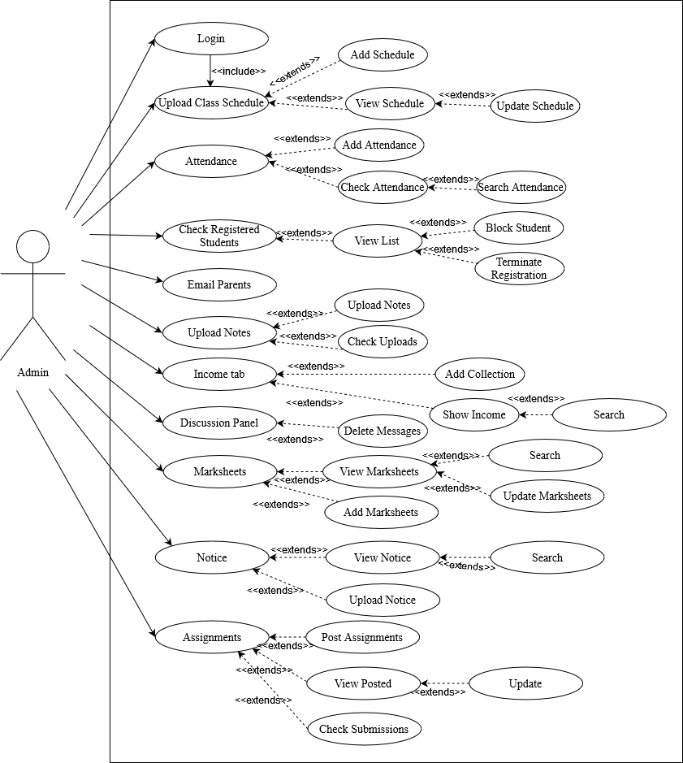

# Figure 3.1: Admin Use case for TutorsAid

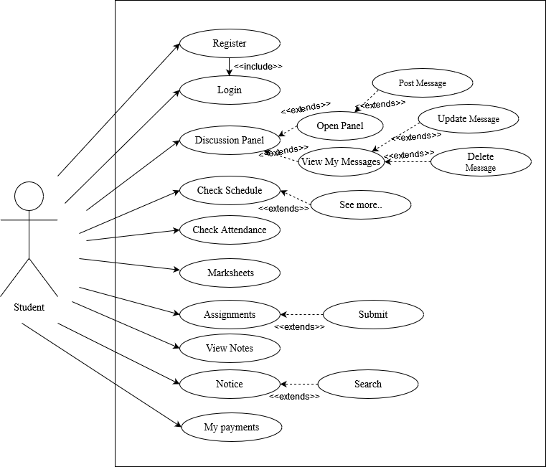

# Figure 3.2: Student Use case for TutorsAid

**3.2 Use Case Description**

**3.2.1 Log In**

|  |  |  |  |
| --- | --- | --- | --- |
|  |  | |  |
| Use case | Admin login | |  |
| Use case no. | 01 |  |  |
| Goal | Admin accesses the admin panel | |  |
|  |  | |  |
| Pre-condition | Login with name & password | |  |
| Primary actors | Admin |  |  |
|  |  |  |  |
| Trigger | This will be button and form | |  |
| Description/ | Step | Action |  |
| Main success | 1. | Enter the website |  |
|  | 2. | Enter Admin Login |  |
|  | 3. | Enter name and password |  |
|  | 4. | Click ‘Login’ |  |
| Alternative flows | N/a |  |  |
| Quality requirement | N/a |  |  |
| **3.2.2 Upload Class schedule** |  |  |  |
|  |  | | |
| Use case | Upload Class schedule | |  |
| Use case no. | 02 |  |  |
| Goal | Admin can access the schedule menu | |  |
| Pre-condition | Admin must login | |  |
| Primary actors | Admin |  |  |
| Secondary actors |  |  |  |
| Trigger | Press “Upload class schedule” button | |  |
| Description/ | Step | Action |  |
|  | 1. | Click into “Upload Class schedule” in dashboard |  |
|  |  |  |  |
| Alternative flows | N/a |  |  |
| Quality requirement | N/a |  |  |

**3.2.3 Add schedule**

|  |  |
| --- | --- |
| Use case | Add schedule |
| Use case no. | 3 |
| Goal | Admin can add new class schedule |
| Pre-condition | Admin must access the schedule menu |
| Primary actors | Admin |
| Trigger | There will be a schedule button |
| Description/ | Step Action  1. Click into “Upload Class schedule” in menu  2. Click into “Add schedule” in menu |
| Main success | Admin adds new schedule |
| Alternative flows | Admin views schedule |
| Quality requirement | N/a |

**3.2.4 View schedule**

|  |  |
| --- | --- |
| Use case | View schedule |
| Use case no. | 4 |
| Goal | Admin can view class schedule |
| Pre-condition | Admin must access the schedule menu |
| Primary actors | Admin |
| Trigger | There will be a schedule button |
| Description/ | Step Action  1. Click into “Upload Class schedule” in menu  2. Click into “View schedule” in menu |
| Main success | Admin views schedule |
| Alternative flows | Admin adds new schedule |
| Quality requirement | N/a |

**3.2.5 Update schedule**

|  |  |
| --- | --- |
| Use case | Update schedule |
| Use case no. | 5 |
| Goal | Admin can update class schedule |
| Pre-condition | Admin must access the schedule menu |
| Primary actors | Admin |
| Trigger | There will be a “update schedule” button |
| Description/ | Step Action  1. Click into “Upload Class schedule” in menu  2. Click into “view schedule” in menu  3. Click into “update” |
| Main success | Admin updates schedule |
| Alternative flows | N/a |
| Quality requirement | N/a |

**3.2.6 Attendance**

|  |  |
| --- | --- |
| Use case | Attendance |
| Use case no. | 6 |
| Goal | Admin can access the attendance menu |
| Pre-condition | Admin must be logged in |
| Primary actors | Admin |
| Trigger | There will be a “Attendance” button |
| Description | Step Action  1. Click into “Attendance” in menu |
| Main success | Admin enters attendance menu |
| Alternative flows | N/a |
| Quality requirement | N/a |

**3.2.7 Add Attendance**

|  |  |
| --- | --- |
| Use case | Add Attendance |
| Use case no. | 7 |
| Goal | Admin can add students attendance |
| Pre-condition | Admin must be logged in |
| Primary actors | Admin |
| Trigger | There will be a “Add Attendance” button |
| Description/ | Step Action  1. Click into “Attendance” in menu  2. Click into “Add Attendance” in menu  3. Click into “Add” |
| Main success | Admin adds students attendance |
| Alternative flows | Admin checks students attendance |
| Quality requirement | N/a |

**3.2.8 Check Attendance**

|  |  |
| --- | --- |
| Use case | Check Attendance |
| Use case no. | 8 |
| Goal | Admin can check students attendance |
| Pre-condition | Admin must be logged in |
| Primary actors | Admin |
| Trigger | There will be a “Check Attendance” button |
| Description/ | Step Action  1. Click into “Attendance” in menu  2. Click into “Check Attendance” in menu |
| Main success | Admin checks students attendance |
| Alternative flows | Admin adds students attendance |
| Quality requirement | N/a |

**3.2.9 Search Attendance**

|  |  |
| --- | --- |
| Use case | Search Attendance |
| Use case no. | 9 |
| Goal | Admin can search students attendance |
| Pre-condition | Admin must check attendance |
| Primary actors | Admin |
| Trigger | There will be a “Search bar” button |
| Description/ | Step Action  1. Click into “Attendance” in menu  2. Click into “Check Attendance” in menu  3. Click into “search” in menu |
| Main success | Admin search students attendance |
| Alternative flows | N/a |
| Quality requirement | N/a |

**3.2.10 Registered students**

|  |  |
| --- | --- |
| Use case | Registered students |
| Use case no. | 10 |
| Goal | Admin can view Registered Students Menu |
| Pre-condition | Admin be logged in |
| Primary actors | Admin |
| Trigger | There will be a “Reg students” button |
| Description/ | Step Action  1. Click into “Reg students” in menu |
| Main success | Admin can access the reg students menu |
| Alternative flows | N/a |
| Quality requirement | N/a |

**3.2.11 View List**

|  |  |
| --- | --- |
| Use case | View List |
| Use case no. | 11 |
| Goal | Admin can view list of registered students |
| Pre-condition | Admin has to access registered students list |
| Primary actors | Admin |
| Trigger | There will be a “View List” button |
| Description/ | Step Action  1. Click into “Reg students” in menu  2. Click into “View List” in menu |
| Main success | Admin can access the reg students menu |
| Alternative flows | N/a |
| Quality requirement | N/a |

**3.2.12 Block Student**

|  |  |
| --- | --- |
| Use case | Block Student |
| Use case no. | 12 |
| Goal | Admin can block registration of the student |
| Pre-condition | Admin has to access view list |
| Primary actors | Admin |
| Trigger | There will be a “Block student” button |
| Description/ | Step Action  1. Click into “Reg students” in menu  2. Click into “View List” in menu  3. Click into “Block” |
| Main success | Admin can block students |
| Alternative flows | Admin can terminate the students registration |
| Quality requirement | N/a |

**3.2.13 Terminate Registration**

|  |  |
| --- | --- |
| Use case | Terminate Registration |
| Use case no. | 13 |
| Goal | Admin can terminate registration of the student |
| Pre-condition | Admin has to access view list |
| Primary actors | Admin |
| Trigger | There will be a “terminate” button |
| Description | Step Action  1. Click into “Reg students” in menu  2. Click into “View List” in menu  3. Click into “terminate” |
| Main success | Admin can terminate the students registration |
| Alternative flows | Admin can block students |
| Quality requirement | N/a |

**3.2.14 Email parents**

|  |  |
| --- | --- |
| Use case | Email Parents |
| Use case no. | 14 |
| Goal | Admin can send the parents email |
| Pre-condition | Admin has to access Email menu |
| Primary actors | Admin |
| Trigger | There will be a “Email” button |
| Description | Step Action  1. Click into “Email Parents” in menu  2. Click into “Send” in menu |
| Main success | Admin can send emails successfully |
| Alternative flows | N/a |
| Quality requirement | N/a |

**3.2.15 Notes**

|  |  |
| --- | --- |
| Use case | Notes |
| Use case no. | 15 |
| Goal | Admin can access the notes menu |
| Pre-condition | Admin has to login |
| Primary actors | Admin |
| Trigger | There will be a “Notes” button |
| Description | Step Action  1. Click into “Notes” in menu |
| Main success | Admin can access the notes menu |
| Alternative flows | N/a |
| Quality requirement | N/a |

**3.2.16 Upload Notes**

|  |  |
| --- | --- |
| Use case | Upload Notes |
| Use case no. | 16 |
| Goal | Admin can upload notes to the system |
| Pre-condition | Admin has to access notes menu |
| Primary actors | Admin |
| Trigger | There will be a “Upload Notes” button |
| Description | Step Action  1. Click into “Notes” in menu  2. Click into “Upload Notes” in menu |
| Main success | Admin can upload notes to the system |
| Alternative flows | Admin checks uploaded notes to the system |
| Quality requirement | N/a |

**3.2.17 Check Uploads**

|  |  |
| --- | --- |
| Use case | Check Uploads |
| Use case no. | 17 |
| Goal | Admin can check uploaded notes |
| Pre-condition | Admin has to access notes menu |
| Primary actors | Admin |
| Trigger | There will be a “Check Notes” button |
| Description | Step Action  1. Click into “Notes” in menu  2. Click into “Check Notes” in menu |
| Main success | Admin checks uploaded notes to the system |
| Alternative flows | Admin can upload notes to the system |
| Quality requirement | N/a |

**3.2.18 Income Tab**

|  |  |
| --- | --- |
| Use case | Income Tab |
| Use case no. | 18 |
| Goal | Admin can access the information in the incmetab |
| Pre-condition | Admin has to login |
| Primary actors | Admin |
| Trigger | There will be a “IncomeTab” button |
| Description | Step Action  1. Click into “IncomeTab” in menu |
| Main success | Admin can view information in the IncomeTab to the system |
| Alternative flows | N/a |
| Quality requirement | N/a |

**3.2.19 Add Collections**

|  |  |
| --- | --- |
| Use case | Add Collections |
| Use case no. | 19 |
| Goal | Admin can add collections to the incometab |
| Pre-condition | Admin has to access incometab menu |
| Primary actors | Admin |
| Trigger | There will be a “Add Income” button |
| Description | Step Action  1. Click into “IncomeTab” in menu  2. Click into “Add Collections” in menu |
| Main success | Admin can add collections to the incometab |
| Alternative flows | Admin can view collections in the IncomeTab |
| Quality requirement | N/a |

**3.2.20 Show Income**

|  |  |
| --- | --- |
| Use case | Show Income |
| Use case no. | 20 |
| Goal | Admin can view collections to the incometab |
| Pre-condition | Admin has to access incometab menu |
| Primary actors | Admin |
| Trigger | There will be a “Show Collection” button |
| Description | Step Action  1. Click into “IncomeTab” in menu  2. Click into “Show Collection” in menu |
| Main success | Admin can view collections in the IncomeTab |
| Alternative flows | Admin can add collections to the incometab |
| Quality requirement | N/a |

**3.2.21 Search Income**

|  |  |
| --- | --- |
| Use case | SearchIncome |
| Use case no. | 21 |
| Goal | Admin can search collections to the incometab |
| Pre-condition | Admin has to access ” Show collections” |
| Primary actors | Admin |
| Trigger | There will be a “Search” button |
| Description | Step Action  1. Click into “Show collections” in menu  2. Click into “Search” in menu |
| Main success | Admin can search Collections in the Income Tab |
| Alternative flows | N/a |
| Quality requirement | N/a |

**3.2.22 Discussion panel**

|  |  |
| --- | --- |
| Use case | Discussion panel |
| Use case no. | 22 |
| Goal | Admin can view students messages in the discussion panel |
| Pre-condition | Admin has to login |
| Primary actors | Admin |
| Trigger | There will be a “Discussion Panel” button |
| Description | Step Action  1. Click into “Discussion Panel” in menu |
| Main success | Admin can view the Discussion Panel |
| Alternative flows | N/a |
| Quality requirement | N/a |

**3.2.23 Delete Messages**

|  |  |
| --- | --- |
| Use case | Delete Messages |
| Use case no. | 23 |
| Goal | Admin can delete students messages in the discussion panel |
| Pre-condition | Admin has to open Discussion Panel |
| Primary actors | Admin |
| Trigger | There will be a “Delete” button |
| Description | Step Action  1. Click into “Discussion Panel” in menu  2. Click into “Delete” |
| Main success | Admin can delete messages in the Discussion Panel |
| Alternative flows | N/a |
| Quality requirement | N/a |

**3.2.24 Marksheets**

|  |  |
| --- | --- |
| Use case | Marksheets |
| Use case no. | 24 |
| Goal | Admin can access the marksheet menu |
| Pre-condition | Admin has to login |
| Primary actors | Admin |
| Trigger | There will be a “Marksheet” button |
| Description | Step Action  1. Click into “Marksheet” in menu |
| Main success | Admin can access the marksheet menu |
| Alternative flows | N/a |
| Quality requirement | N/a |

**3.2.25 View Marksheets**

|  |  |
| --- | --- |
| Use case | View Marksheets |
| Use case no. | 25 |
| Goal | Admin can view the marksheets of the students |
| Pre-condition | Admin has to access the marksheet menu |
| Primary actors | Admin |
| Trigger | There will be a “View Marksheet” button |
| Description | Step Action  1. Click into “Marksheet” in menu  2. Click into “View Marksheet” in menu |
| Main success | Admin can view the marksheets |
| Alternative flows | Admin can add the marksheets |
| Quality requirement | N/a |

**3.2.26 Update Marksheets**

|  |  |
| --- | --- |
| Use case | Update Marksheets |
| Use case no. | 26 |
| Goal | Admin can update the marksheets of the students |
| Pre-condition | Admin has to access the view marksheet |
| Primary actors | Admin |
| Trigger | There will be a “Update” button |
| Description | Step Action  1. Click into “Marksheet” in menu  2. Click into “View Marksheet” in menu  3. Click into “Update” |
| Main success | Admin can update the marksheets |
| Alternative flows | Admin can search the marksheets |
| Quality requirement | N/a |

**3.2.27 Search Marksheets**

|  |  |
| --- | --- |
| Use case | Search Marksheets |
| Use case no. | 27 |
| Goal | Admin can search the marksheets of the students |
| Pre-condition | Admin has to access view marksheets |
| Primary actors | Admin |
| Trigger | There will be a “Search” button |
| Description | Step Action  1. Click into “Marksheet” in menu  2. Click into “View Marksheet” in menu  3. Click into “Search” |
| Main success | Admin can search the marksheets |
| Alternative flows | Admin can update the marksheets |
| Quality requirement | N/a |

**3.2.28 Add Marksheets**

|  |  |
| --- | --- |
| Use case | Add Marksheets |
| Use case no. | 28 |
| Goal | Admin can add the marksheets of the students |
| Pre-condition | Admin has to access the marksheet menu |
| Primary actors | Admin |
| Trigger | There will be a “Add Marksheet” button |
| Description | Step Action  1. Click into “Marksheet” in menu  2. Click into “Add Marksheet” in menu |
| Main success | Admin can add the marksheets |
| Alternative flows | Admin can view the marksheets |
| Quality requirement | N/a |

**3.2.29 Notice**

|  |  |
| --- | --- |
| Use case | Notice |
| Use case no. | 29 |
| Goal | Admin can enter the notice menu |
| Pre-condition | Admin has to login |
| Primary actors | Admin |
| Trigger | There will be a “Notice” button |
| Description | Step Action  1. Click into “Notice” in menu |
| Main success | Admin can enter the notice menu |
| Alternative flows | N/a |
| Quality requirement | N/a |

**3.2.30 View Notice**

|  |  |
| --- | --- |
| Use case | View Notice |
| Use case no. | 30 |
| Goal | Admin can view notice |
| Pre-condition | Admin has to access notice menu |
| Primary actors | Admin |
| Trigger | There will be a “View Notice” button |
| Description | Step Action  1. Click into “Notice”  2. Click into “View Notice” in menu |
| Main success | Admin can view notice in the menu |
| Alternative flows | Admin can add notice in the menu |
| Quality requirement | N/a |

**3.2.31 Add Notice**

|  |  |
| --- | --- |
| Use case | Add Notice |
| Use case no. | 31 |
| Goal | Admin can add notice |
| Pre-condition | Admin has to access notice menu |
| Primary actors | Admin |
| Trigger | There will be a “Add Notice” button |
| Description | Step Action  1. Click into “Notice”  2. Click into “Add Notice” in menu |
| Main success | Admin can add notice in the menu |
| Alternative flows | Admin can view notice in the menu |
| Quality requirement | N/a |

**3.2.32 Search Notice**

|  |  |
| --- | --- |
| Use case | Search Notice |
| Use case no. | 32 |
| Goal | Admin can search notice |
| Pre-condition | Admin has to view notice |
| Primary actors | Admin |
| Trigger | There will be a “Search” button |
| Description | Step Action  1. Click into “Notice”  2. Click into “View Notice” in menu  3. Click into “Search” in menu |
| Main success | Admin can search notices |
| Alternative flows | N/a |
| Quality requirement | N/a |

**3.2.33 Assignments**

|  |  |
| --- | --- |
| Use case | Assignments |
| Use case no. | 33 |
| Goal | Admin can enter the assignments menu |
| Pre-condition | Admin has to login |
| Primary actors | Admin |
| Trigger | There will be a “assignments” button |
| Description | Step Action  1. Click into “Assignments” in menu |
| Main success | Admin can enter the assignments menu |
| Alternative flows | N/a |
| Quality requirement | N/a |

**3.2.34 Post Assignments**

|  |  |
| --- | --- |
| Use case | Post Assignments |
| Use case no. | 34 |
| Goal | Admin can post new assignments |
| Pre-condition | Admin has to enter the assignments menu |
| Primary actors | Admin |
| Trigger | There will be a “Post Assignments” button |
| Description | Step Action  1. Click into “Assignments” in menu  2. Click into “Post Assignments” in menu |
| Main success | Admin can post assignments |
| Alternative flows | Admin can view posted |
| Quality requirement | N/a |

**3.2.35 View Posted**

|  |  |
| --- | --- |
| Use case | View posted |
| Use case no. | 35 |
| Goal | Admin can view posted assignments |
| Pre-condition | Admin has to access assignments menu |
| Primary actors | Admin |
| Trigger | There will be a “View Posted” button |
| Description | Step Action  1. Click into “Assignments” in menu  2. Click into “View Posted” in menu |
| Main success | Admin can view posted |
| Alternative flows | Admin can post assignments |
| Quality requirement | N/a |

**3.2.36 Check Submissions**

|  |  |
| --- | --- |
| Use case | Check submissions |
| Use case no. | 36 |
| Goal | Admin can check submissions |
| Pre-condition | Admin has to access assignments menu |
| Primary actors | Admin |
| Trigger | There will be a “Check Submissions” button |
| Description | Step Action  1. Click into “Assignments” in menu  2. Click into “Check Submissions” in menu |
| Main success | Admin can check students submissions |
| Alternative flows | N/a |
| Quality requirement | N/a |

**3.2.37 Update Assignments**

|  |  |
| --- | --- |
| Use case | Update Assignments |
| Use case no. | 37 |
| Goal | Admin can update assignments |
| Pre-condition | Admin has to access view posted |
| Primary actors | Admin |
| Trigger | There will be a “Update” button |
| Description | Step Action  1. Click into “Assignments” in menu  2. Click into “View Posted” in menu  3. Click into “Update” in menu |
| Main success | Admin can update the posted assignments |
| Alternative flows | N/a |
| Quality requirement | N/a |

**3.2.38 Register**

|  |  |
| --- | --- |
| Use case | Register |
| Use case no. | 38 |
| Goal | Student registers into the system |
| Pre-condition | Student has to input valid information and enter the system |
| Primary actors | Student |
| Trigger | There will be a “register” button |
| Description | Step Action  1. Click into “Register ” in menu  2. Enter email , password , name and confirm password  3. Click into “Register” in form |
| Main success | Student enters the system |
| Alternative flows | N/a |
| Quality requirement | N/a |

**3.2.39 Login**

|  |  |
| --- | --- |
| Use case | Login |
| Use case no. | 39 |
| Goal | Student logins into the system |
| Pre-condition | Student has to input valid information |
| Primary actors | Student |
| Trigger | There will be a “Login” button |
| Description | Step Action  1. Click into “Login” in menu  2. Enter email and password  3. Click into “Login” in form |
| Main success | Student enters the system |
| Alternative flows | N/a |
| Quality requirement | N/a |

**3.2.40 Discussion Panel**

|  |  |
| --- | --- |
| Use case | Discussion panel |
| Use case no. | 40 |
| Goal | Student has view messages in the discussion panel |
| Pre-condition | Student has to login into the system |
| Primary actors | Student |
| Trigger | There will be a “Discussion Panel” button |
| Description | Step Action  1. Click into “discussion panel ” in menu |
| Main success | Student enters the Discussion Panel |
| Alternative flows | N/a |
| Quality requirement | N/a |

**3.2.41 Open** **Panel**

|  |  |
| --- | --- |
| Use case | Open panel |
| Use case no. | 41 |
| Goal | Student can view the panel messages |
| Pre-condition | Student has to open discussion panel menu |
| Primary actors | Student |
| Trigger | There will be a “Open Panel” button |
| Description | Step Action  1. Click into “Open Panel ” in menu |
| Main success | Student enters the Discussion Panel |
| Alternative flows | Student can view their messages in View My Messages |
| Quality requirement | N/a |

**3.2.42 Post Messages**

|  |  |
| --- | --- |
| Use case | Post Messages |
| Use case no. | 42 |
| Goal | Student can post messages in the panel |
| Pre-condition | Student has to open panel |
| Primary actors | Student |
| Trigger | There will be a “Post” button |
| Description | Step Action  1. Click into “Post ” in menu |
| Main success | Student posts in the Discussion Panel |
| Alternative flows | N/a |
| Quality requirement | N/a |

**3.2.43 View My Messages**

|  |  |
| --- | --- |
| Use case | View My Messages |
| Use case no. | 43 |
| Goal | Student can view their messages in the panel |
| Pre-condition | Student has to enter the discussion Panel menu |
| Primary actors | Student |
| Trigger | There will be a “View My messages” button |
| Description | Step Action   1. Click into “Discussion Panel” in menu   2. Click into “View My Messages” in menu |
| Main success | Student views their messages in the Discussion Panel |
| Alternative flows | N/a |
| Quality requirement | N/a |

**3.2.44 Update Messages**

|  |  |
| --- | --- |
| Use case | Update Messages |
| Use case no. | 44 |
| Goal | Student can update their messages in the panel |
| Pre-condition | Student has to view my messages menu |
| Primary actors | Student |
| Trigger | There will be a “Update” button |
| Description | Step Action   1. Click into “Discussion Panel” in menu 2. Click into “View My Messages” in menu 3. Click into “Update” |
| Main success | Student updates their messages in the Discussion Panel |
| Alternative flows | Student deletes their messages |
| Quality requirement | N/a |

**3.2.45 Delete Messages**

|  |  |
| --- | --- |
| Use case | Delete Messages |
| Use case no. | 45 |
| Goal | Student can Delete their messages in the panel |
| Pre-condition | Student has to delete my messages menu |
| Primary actors | Student |
| Trigger | There will be a “delete” button |
| Description | Step Action   1. Click into “Discussion Panel” in menu 2. Click into “View My Messages” in menu 3. Click into “delete” |
| Main success | Student deletes their messages in the Discussion Panel |
| Alternative flows | Student updates their messages |
| Quality requirement | N/a |

**3.2.46 Check Schedule**

|  |  |
| --- | --- |
| Use case | Check Schedule |
| Use case no. | 46 |
| Goal | Student can check schedule |
| Pre-condition | Students must log in |
| Primary actors | Student |
| Trigger | Dashboard |
| Description | Step Action   1. Student logs in and views |
| Main success | Student views the schedule in the discussion panel |
| Alternative flows | Students can press the see more |
| Quality requirement | N/a |

**3.2.47 See More**

|  |  |
| --- | --- |
| Use case | See More |
| Use case no. | 47 |
| Goal | Student can check further details about the schedule |
| Pre-condition | Students must log in |
| Primary actors | Student |
| Trigger | Press the “See more” Button |
| Description | Step Action   1. Click into “See More” |
| Main success | Student can view more info |
| Alternative flows | N/a |
| Quality requirement | N/a |

**3.2.48 Check Attendance**

|  |  |
| --- | --- |
| Use case | Check Attendance |
| Use case no. | 48 |
| Goal | Student can check attendance |
| Pre-condition | Students must log in |
| Primary actors | Student |
| Trigger | Press the “Attendance” Button |
| Description | Step Action   1. Click into “Attendance” |
| Main success | Student can view their own attendance |
| Alternative flows | N/a |
| Quality requirement | N/a |

**3.2.49 Check Marksheet**

|  |  |
| --- | --- |
| Use case | Check Marksheet |
| Use case no. | 49 |
| Goal | Student can check marksheet |
| Pre-condition | Students must log in |
| Primary actors | Student |
| Trigger | Press the “Marksheet” Button |
| Description | Step Action   1. Click into “Marksheet” |
| Main success | Student can view their own marksheet |
| Alternative flows | N/a |
| Quality requirement | N/a |

**3.2.50 Assignments**

|  |  |
| --- | --- |
| Use case | Assignments |
| Use case no. | 50 |
| Goal | Students can check posted assignments |
| Pre-condition | Students must log in |
| Primary actors | Student |
| Trigger | Press the “Assignments” Button |
| Description | Step Action   1. Click into “Assignments” |
| Main success | Student can view assignments posted by the admin |
| Alternative flows | N/a |
| Quality requirement | N/a |

**3.2.51 Submit**

|  |  |
| --- | --- |
| Use case | Submit |
| Use case no. | 51 |
| Goal | Students can submit their assignments here |
| Pre-condition | Students must access the assignments menu in due time |
| Primary actors | Student |
| Trigger | Press the “Assignments” Button |
| Description | Step Action   1. Click into “Assignments” 2. Press ‘Submit’ button |
| Main success | Student can submit their assignments |
| Alternative flows | N/a |
| Quality requirement | N/a |

**3.2.52 View Notes**

|  |  |
| --- | --- |
| Use case | View Notes |
| Use case no. | 52 |
| Goal | Students can view the notes posted |
| Pre-condition | Students must be login |
| Primary actors | Student |
| Trigger | Press the “View Notes” Button |
| Description | Step Action   1. Click into “View Notes” |
| Main success | Student can view notes |
| Alternative flows | N/a |
| Quality requirement | N/a |

**3.2.53 Notice**

|  |  |
| --- | --- |
| Use case | Notice |
| Use case no. | 53 |
| Goal | Students can view Notice |
| Pre-condition | Students must be login |
| Primary actors | Student |
| Trigger | Press the “View Notice” Button |
| Description | Step Action   1. Click into “View Notice” |
| Main success | Student can view notices posted |
| Alternative flows | N/a |
| Quality requirement | N/a |

**3.2.54 Search**

|  |  |
| --- | --- |
| Use case | Search |
| Use case no. | 54 |
| Goal | Students can search in the notice |
| Pre-condition | Students must enter the notice |
| Primary actors | Student |
| Trigger | Press the “Search” Button |
| Description | Step Action   1. Click into “View Notes” 2. Click into “Search” |
| Main success | Student can search notices successfully |
| Alternative flows | N/a |
| Quality requirement | N/a |

**3.2.55 My Payments**

|  |  |
| --- | --- |
| Use case | My Payments |
| Use case no. | 55 |
| Goal | Students can view the payments they made |
| Pre-condition | Students must be login |
| Primary actors | Student |
| Trigger | Press the “My Payments” Button |
| Description | Step Action   1. Click into “My Payments” |
| Main success | Student can their payments |
| Alternative flows | N/a |
| Quality requirement | N/a |

**3.3 Activity Diagram**

**3.3.1 Log in**

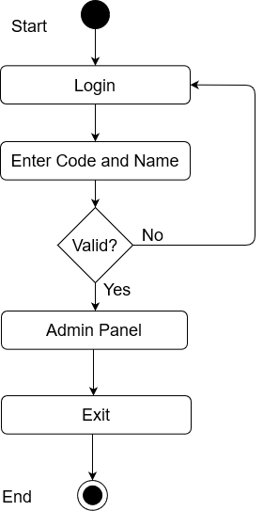

# Figure 3.1:Activity Diagram for Admin Login

**3.3.2 Upload Class Schedule**

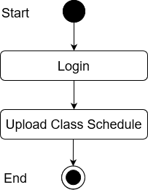

# Figure 3.2: Activity Diagram for Upload Class Schedule

**3.3.3 Add Schedule**

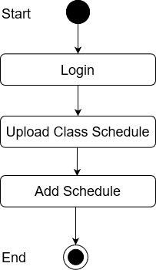

# Figure 3.3: Activity Diagram for Add Schedule

**3.3.4 View Schedule**

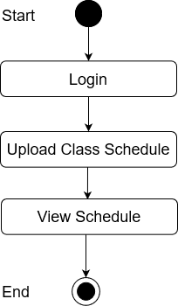

# Figure 3.4: Activity Diagram for View Schedule

**3.3.5 Update Schedule**

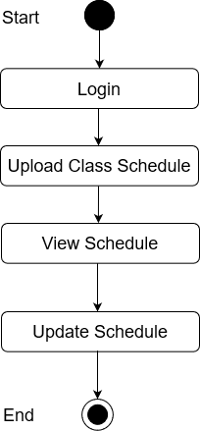

# Figure 3.5: Activity Diagram for Update Schedule

**3.3.6 Attendance**

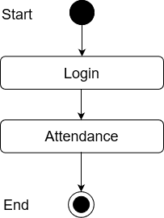

# Figure 3.6: Activity Diagram for Attendance

**3.3.7 Add Attendance**

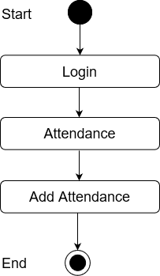

# Figure 3.7: Activity Diagram for Add Attendance

**3.3.8 Check Attendance**

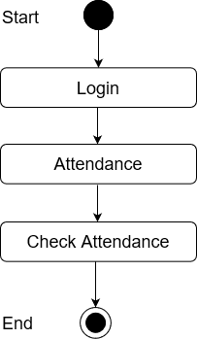

# Figure 3.8: Activity Diagram for Check Attendance

**3.3.9 Search Attendance**

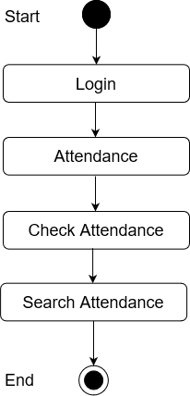

# Figure 3.9: Activity Diagram for Search Attendance

**3.3.10 Check Registered Students**

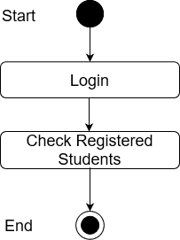

# Figure 3.10: Activity Diagram for Check Registered Students

**3.3.11 View List**

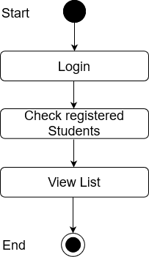

# Figure 3.11: Activity Diagram for View List

**3.3.12 Block student**

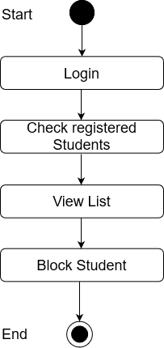

# Figure 3.12: Activity Diagram for Block Student

**3.3.13 Terminate registration**

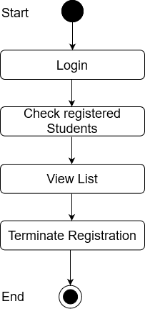

# Figure 3.13: Activity Diagram for Terminate Registration

**3.3.14 Email**

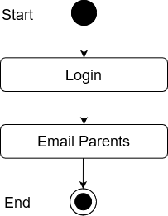

# Figure 3.14: Activity Diagram for Email Parents

**3.3.15 Upload Notes**

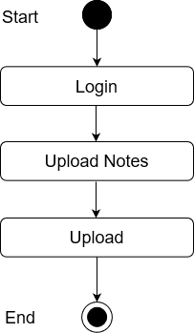

# Figure 3.15: Activity Diagram for Upload Notes

**3.3.16 Check Uploads**

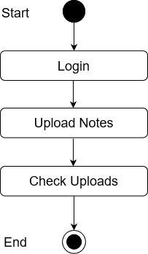

# Figure 3. 16: Activity Diagram for Check Uploads

**3.3.17 Income Tab**

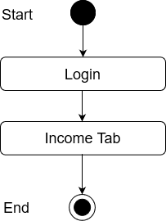

# Figure 3.17 Activity Diagram for Income Tab

**3.3.18 Add Collections**

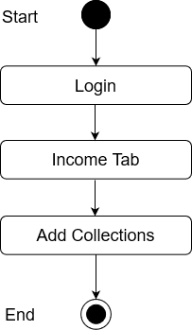

# Figure 3. 18 Activity Diagram for Add Collections

**3.3.19 Show Collections**

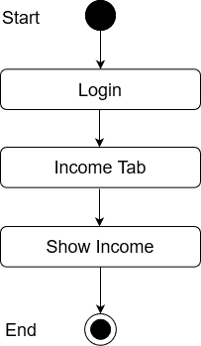

# Figure 3. 19 Activity Diagram for Show Collections

**3.3.20 Income Search**

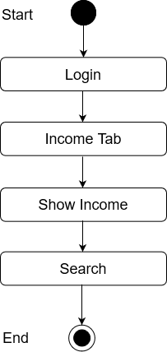

# Figure 3. 20 Activity Diagram for Income Search

**3.3.21 Discussion panel**

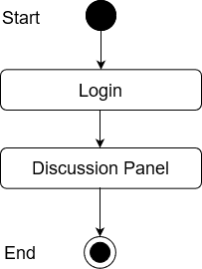

# Figure 3. 21 Activity Diagram for Discussion panel

**3.3.22 Delete Messages**

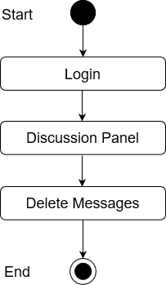

# Figure 3.22 Activity Diagram for Delete Messages

**3.3.23 MarkSheet**

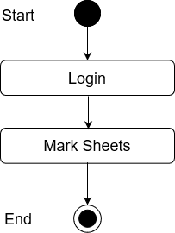

# Figure 3.23 Activity Diagram for Marksheet

**3.3.24 Add MarkSheet**

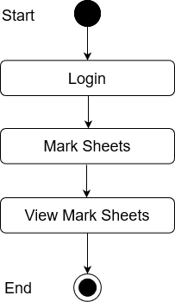

# Figure 3.24 Activity Diagram for Add Marksheet

**3.3.25 View MarkSheet**

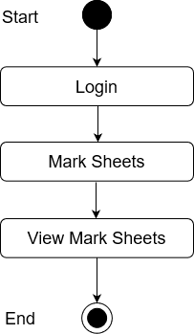

# Figure 3.25 Activity Diagram for View Marksheet

**3.3.26 Update MarkSheet**

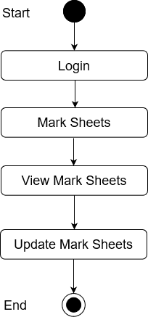

# Figure 3.26 Activity Diagram for Update Marksheet

**3.3.27 Search MarkSheet**

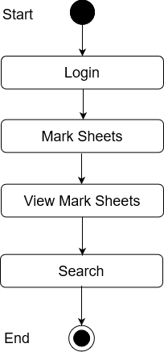

# Figure 3.27 Activity Diagram for SearchMarksheet

**3.3.28 Add Notice**

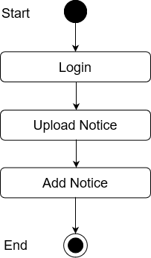

# Figure 3.28 Activity Diagram for Add Notice

**3.3.29 View Notice**

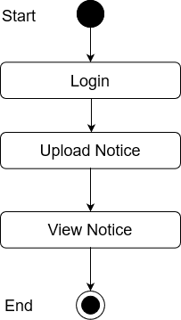

# Figure 3.29 Activity Diagram for View Notice

**3.3.30 Search Notice**

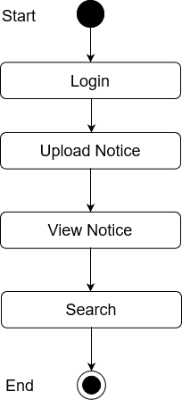

# Figure 3.30 Activity Diagram for Search Notice

**3.3.31 Assignments**

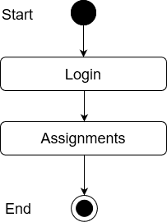

# Figure 3.31 Activity Diagram for Assignments

**3.3.32 Post Assignments**

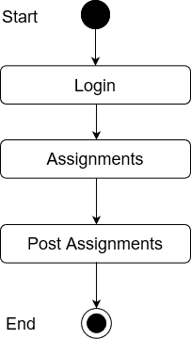

# Figure 3.32 Activity Diagram for Post Assignments

**3.3.33 View Posted**

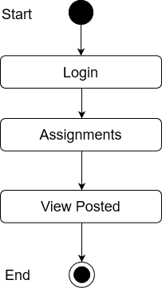

# Figure 3**.** 33 Activity Diagram for View Posted

**3.3.34 Update**

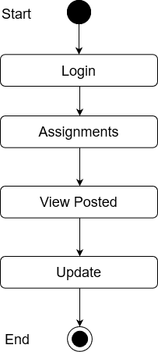

# Figure 3**.** 34 Activity Diagram for Update

**3.3.35 Check Submissions**

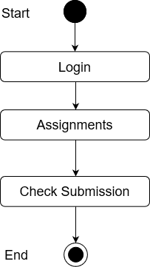

# Figure 3**.** 35 Activity Diagram for Check Submissions

**3.3.36 Register**

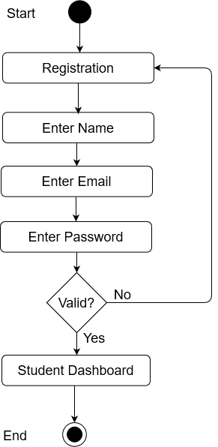

# Figure 3**.** 36 Activity Diagram for Student Registration

**3.3.37 Login**

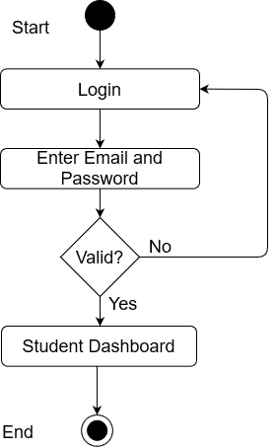

# Figure: 3**.** 37 Activity Diagram for Login

**3.3.38 Discussion Panel**

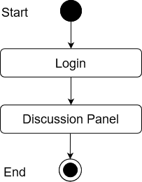

# Figure 3**.** 38 Activity Diagram for Discussion Panel

**3.3.39 Open Panel**

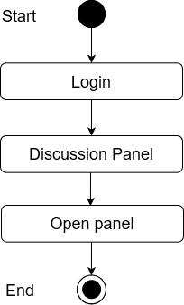

# Figure 3. 39 Activity Diagram for Open Panel

**3.3.40 Post Message**

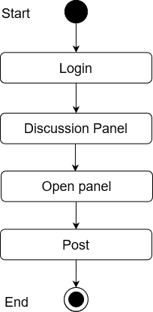

# Figure 3. 40 Activity Diagram for Post Message

**3.3.41 View My Messages**

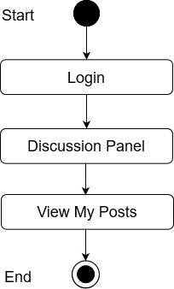

# Figure 3. 41 Activity Diagram for View My Messages

**3.3.42 Update Messages**

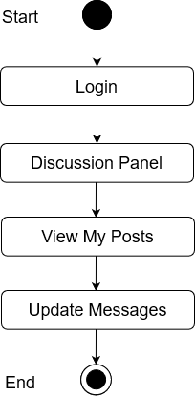

# Figure 3. 42 Activity Diagram for Update Messages

**3.3.43 Delete Messages**

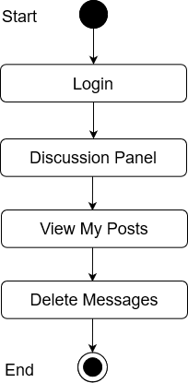

Figure 3. 43 Activity Diagram for Delete Messages

**3.3.44 Check Schedule**

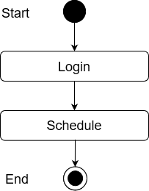

# Figure 3. 44 Activity Diagram for Check Schedule

**3.3.45 See More**

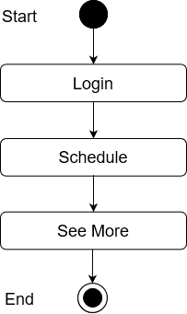

# Figure 3. 45 Activity Diagram for See More

**3.3.46 Attendance**

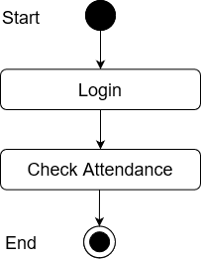

# Figure 3. 46 Activity Diagram for Attendance

**3.3.47 MarkSheet**

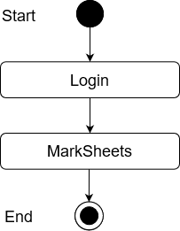

# Figure 3. 47 Activity Diagram for MarkSheet

**3.3.48 Assignments**

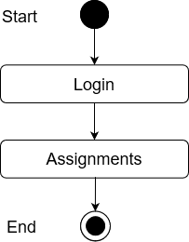

# Figure 3. 48 Activity Diagram for Assignments

**3.3.49 Submit Assignments**

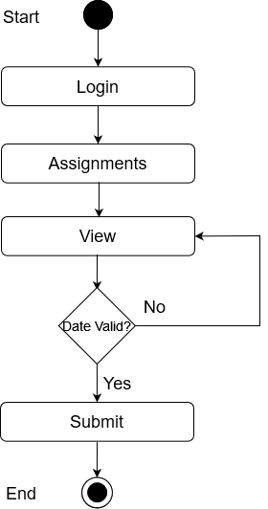

# Figure 3. 49 Activity Diagram for Submit Assignments

**3.3.50 View Notes**

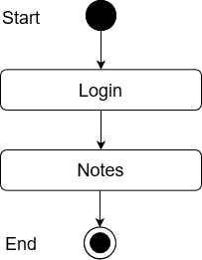

# Figure 3. 50 Activity Diagram for View Notes

**3.3.51 View Notice**

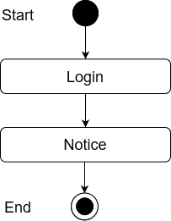

# Figure 3. 51 Activity Diagram for View Notice

**3.3.52 Search Notice**

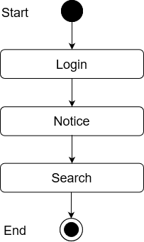

# Figure 3. 52 Activity Diagram for Search Notice

**3.3.53 My Payments**

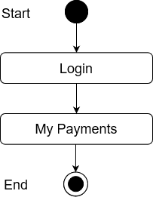

# Figure 3. 53 Activity Diagram for My Payments

**3.4 Sequence Diagram for Admin**

**3.4.1 Login**

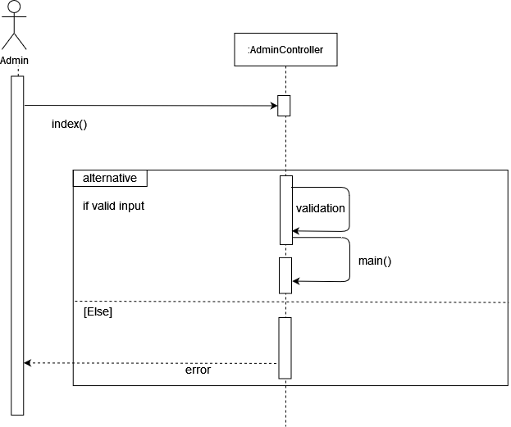

# Figure 3. 54 Sequence Diagram for Admin Login

**3.4.2 Schedule Upload**

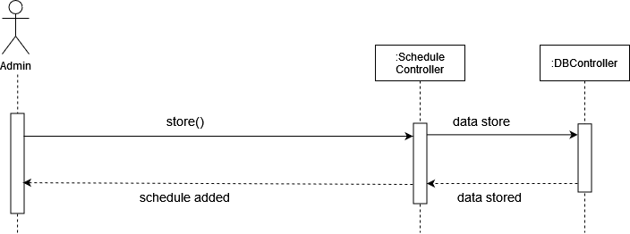

# Figure 3. 55 Sequence Diagram for Schedule Upload

**3.4.3 Schedule Show**

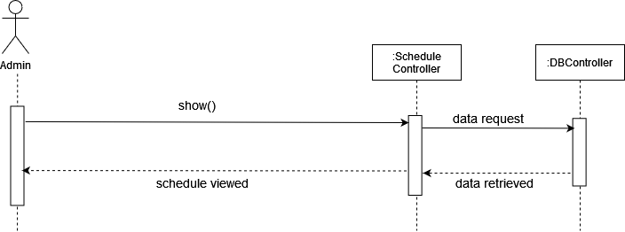

# Figure 3. 56 Sequence Diagram for Schedule Show

**3.4.4 Schedule Update**

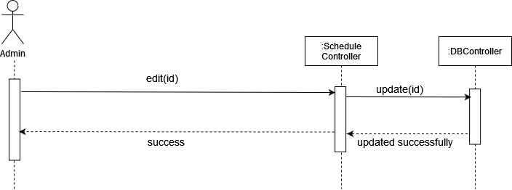

# Figure 3. 57 Sequence Diagram for Schedule Update

**3.4.5 Attendance**

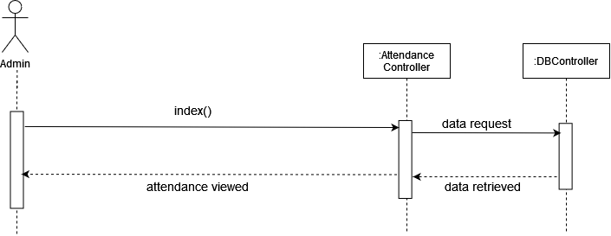

# Figure 3. 58 Sequence Diagram for Attendance

**3.4.6 Add Attendance**

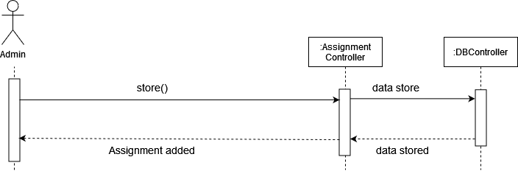

# Figure 3. 59 Sequence Diagram for Add Attendance

**3.4.7 Check Attendance**

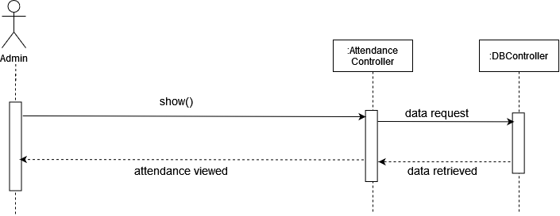

# Figure 3. 60 Sequence Diagram for Check Attendance

**3.4.8 Search Attendance**

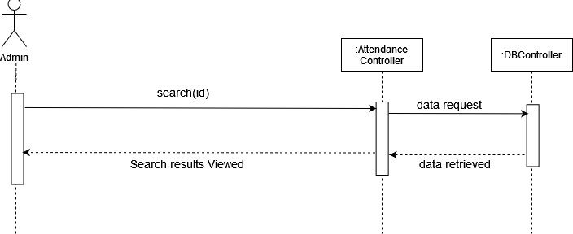

# Figure 3. 61 Sequence Diagram for Search Attendance

**3.4.9 Check registered Students**

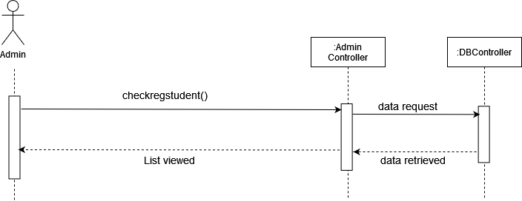

# Figure 3. 62 Sequence Diagram for Check registered Students

**3.4.10 Block Student**

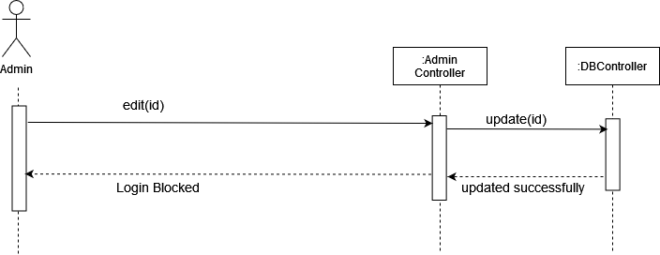

# Figure 3. 63 Sequence Diagram for Block Student

**3.4.11 Terminate Registration**

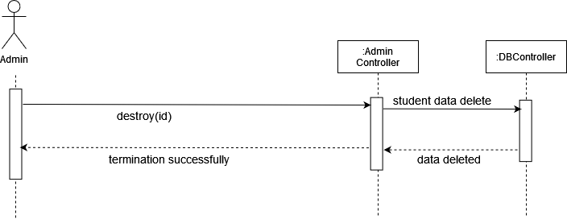

# Figure 3. 64 Sequence Diagram for Terminate Registration

**3.4.12 Email Parents**

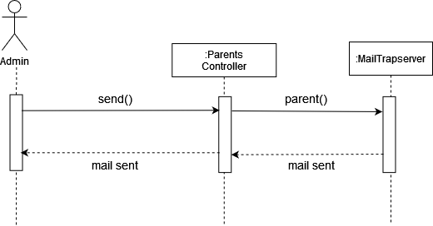

# Figure 3. 65 Sequence Diagram for Email Parents

**3.4.13 Upload Notes**

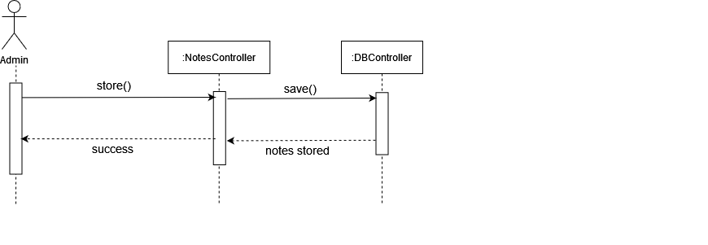

# Figure 3. 66 Sequence Diagram for Upload Notes

**3.4.14 Check Notes**

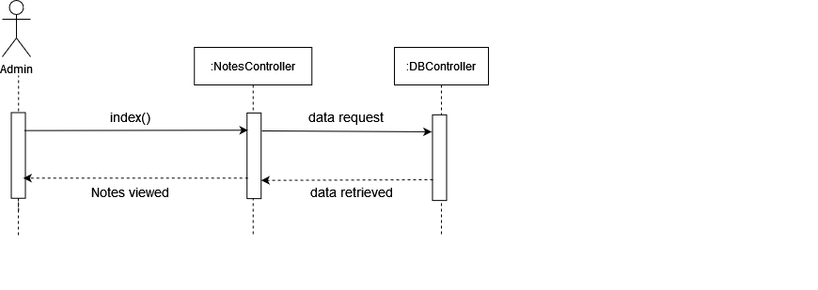

# Figure 3. 67 Sequence Diagram for Check Notes

**3.4.15 Income Tab**

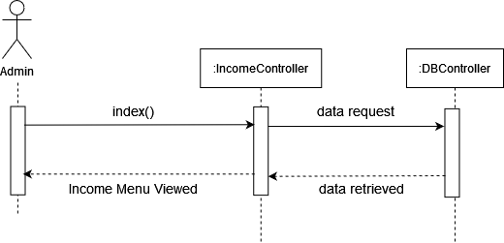

# Figure 3. 68 Sequence Diagram for Income Tab

**3.4.16 Add collections**

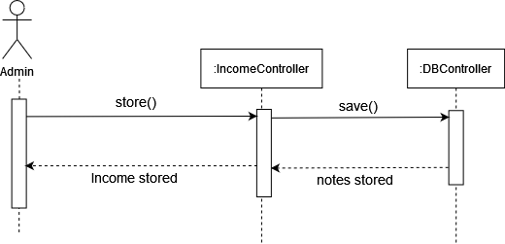

# Figure 3. 69 Sequence Diagram for Add collections

**3.4.17 Show Income**

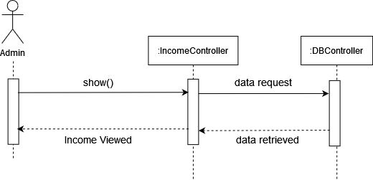

# Figure 3. 70 Sequence Diagram for Show Income

**3.4.18 Income Search**

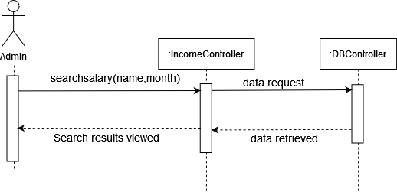

# Figure 3. 71 Sequence Diagram for Income Search

**3.4.19 Discussion panel**

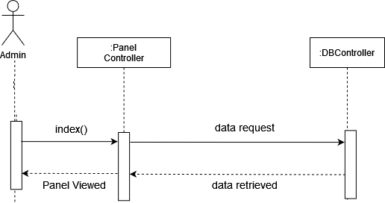

# Figure 3. 72 Sequence Diagram for Discussion panel

**3.4.20 Delete Messages**

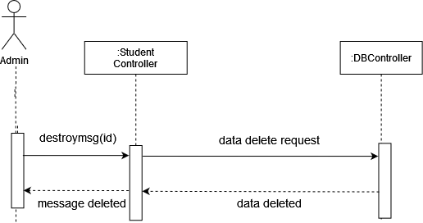

# Figure 3. 73 Sequence Diagram for Delete Messages

**3.4.21 Add MarkSheet**

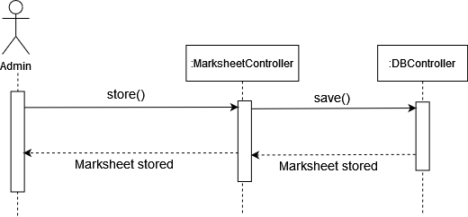

# Figure 3. 74 Sequence Diagram for Add MarkSheet

**3.4.22 View MarkSheet**

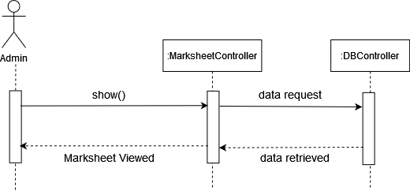

# Figure 3. 75 Sequence Diagram for View MarkSheet

**3.4.23 Marksheet Search**

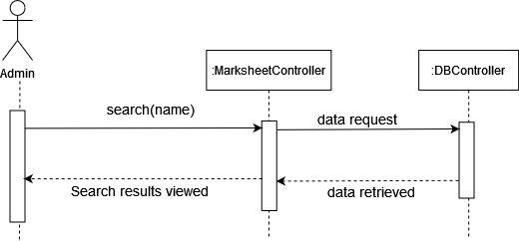

# Figure 3. 76 Sequence Diagram for Marksheet Search

**3.4.24 Marksheet Update**

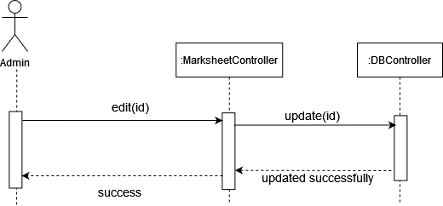

# Figure 3. 77 Sequence Diagram for Update MarkSheet

**3.4.25 Notice**

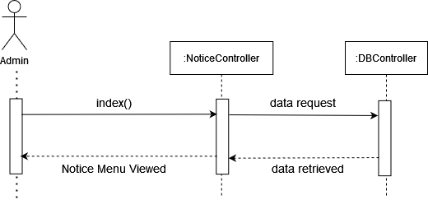

# Figure 3. 78 Sequence Diagram for Notice

**3.4.26 Upload**



# Figure 3. 79 Sequence Diagram for Upload Notice

**3.4.27 View Notice**

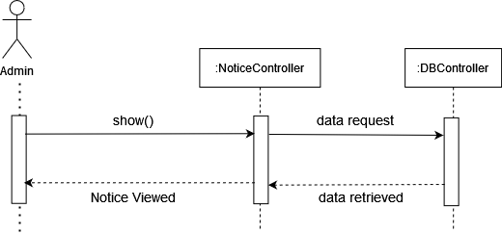

# Figure 3. 80 Sequence Diagram for ViewNotice

**3.4.28 Search Notice**

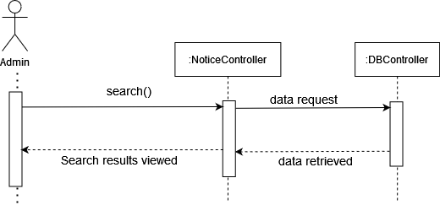

# Figure 3. 81 Sequence Diagram for Search Notice

**3.4.29 Assignments**

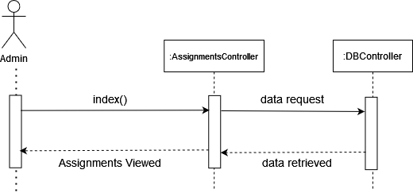

# Figure 3. 82 Sequence Diagram for Assignments

**3.4.30 Post Assignments**



# Figure 3. 83 Sequence Diagram for Post Assignments

**3.4.31 View Posted**

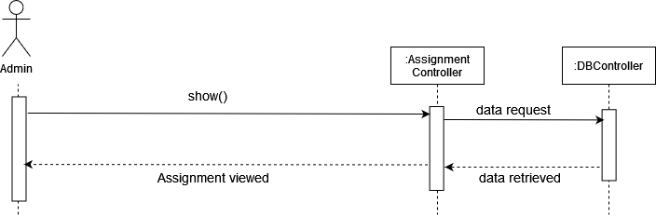

# Figure 3. 84 Sequence Diagram for View Posted

**3.4.32 Update**

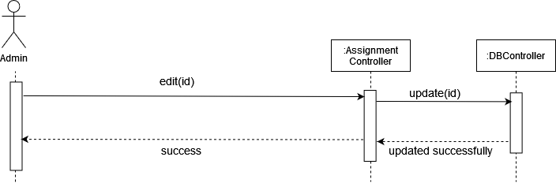

# Figure 3. 85 Sequence Diagram for Update Assignments

**3.4.33 Check Submissions**

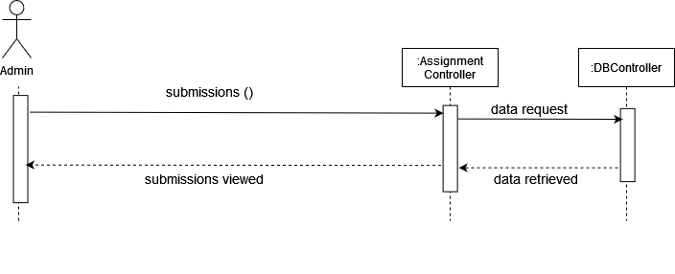

# Figure 3. 86 Sequence Diagram for Check Submissions

**3.4.34 Student Register**

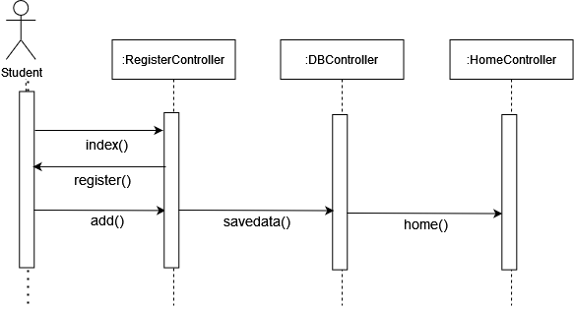

# Figure 3. 87 Sequence Diagram for Student Register

**3.4.35 Student Login**

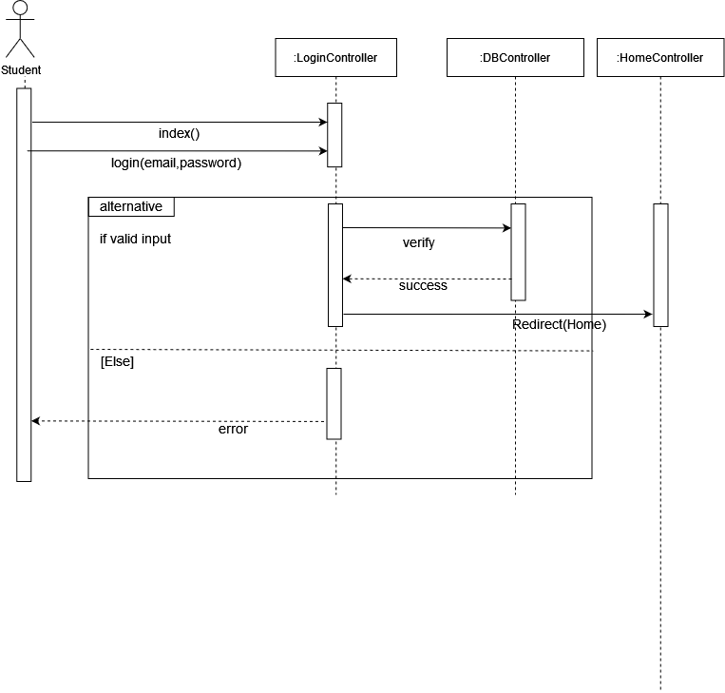

# Figure 3. 88 Sequence Diagram for Student Login

3.4.36 Discussion Panel

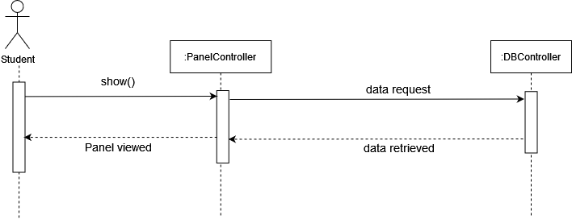

# Figure 3. 89 Sequence Diagram for Student Login

3.4.37 Post Messages

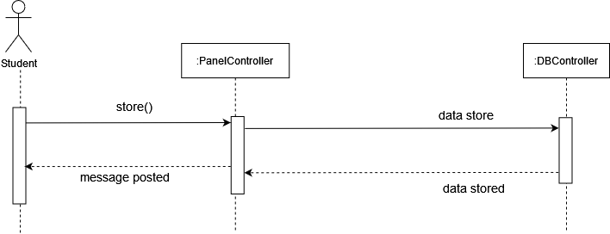

# Figure 3. 90 Sequence Diagram for Post Message

3.4.38 View My Messages

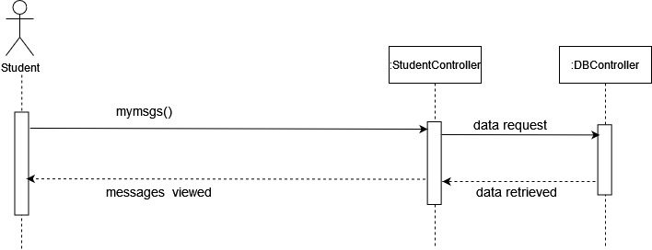

# Figure 3. 91 Sequence Diagram for View My Messages

3.4.39 Update Messages

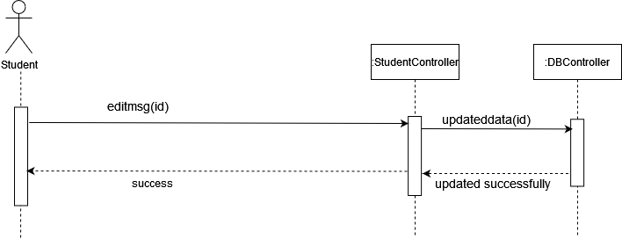

# Figure 3. 92 Sequence Diagram for Update Messages

**3.4.40 Delete Messages**

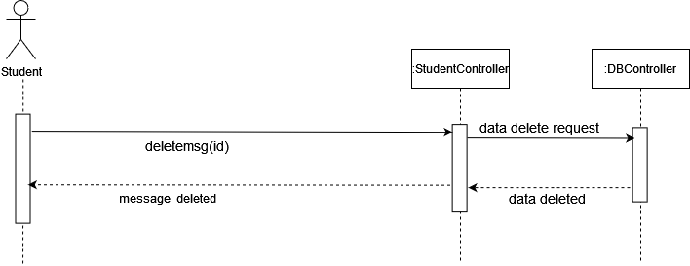

# Figure 3. 93 Sequence Diagram for Delete Messages

**3.4.41 Check Schedule**

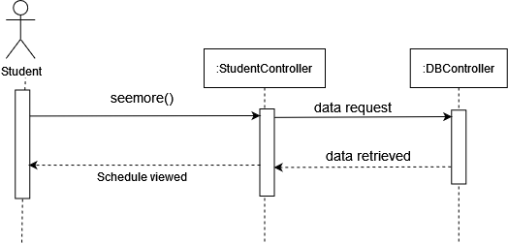

Figure 3. 94 Sequence Diagram for Check Schedule

**3.4.42 Check Attendance**



Figure 3. 95 Sequence Diagram for Check Attendance

**3.4.43 MarkSheet**

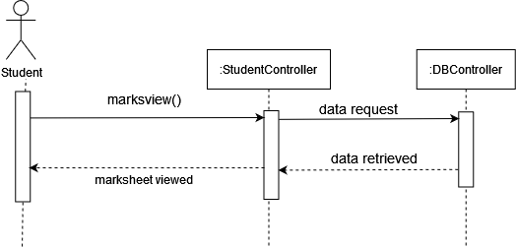

Figure 3. 96 Sequence Diagram for MarkSheet

**3.4.44 Assignments**

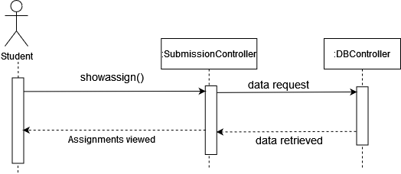

Figure 3. 97 Sequence Diagram for Assignments

**3.4.45 Submit Assignments**

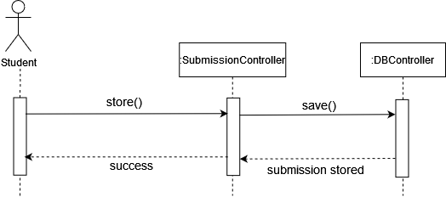

Figure 3. 98 Sequence Diagram for SubmitAssignments

**3.4.46 View Notes**

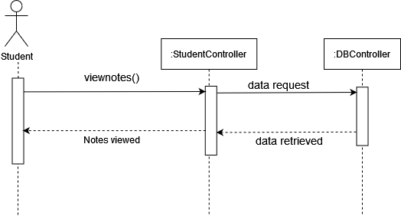

Figure 3. 99 Sequence Diagram for View Notes

**3.4.47 Notice**

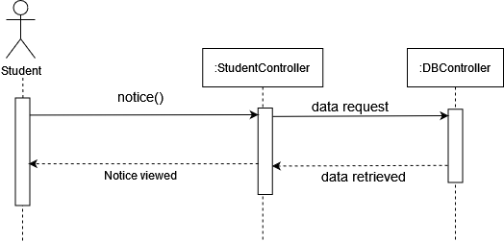

Figure 3.100 Sequence Diagram for Notice

**3.4.48 Notice Search**

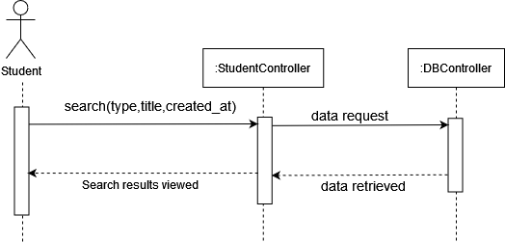

Figure 3. 101 Sequence Diagram for Notice Search

**3.4.49 My Payments**



Figure 3. 102 Sequence Diagram for My Payments

**3.5 Entity Relationship Diagram**

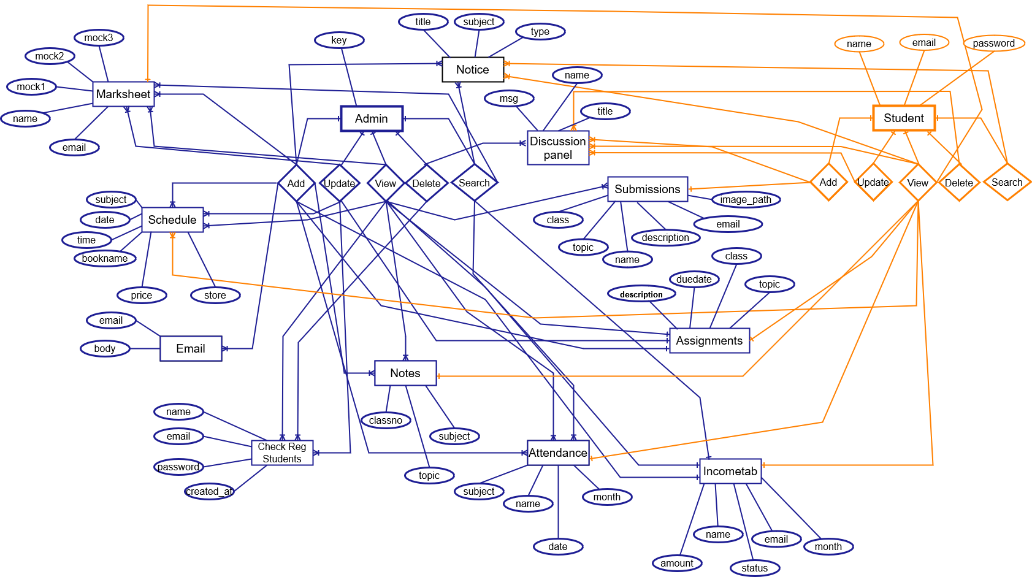

# Figure 3.103: ER Diagram for TutorsAid

**3.6 Database Design Diagram**

# 

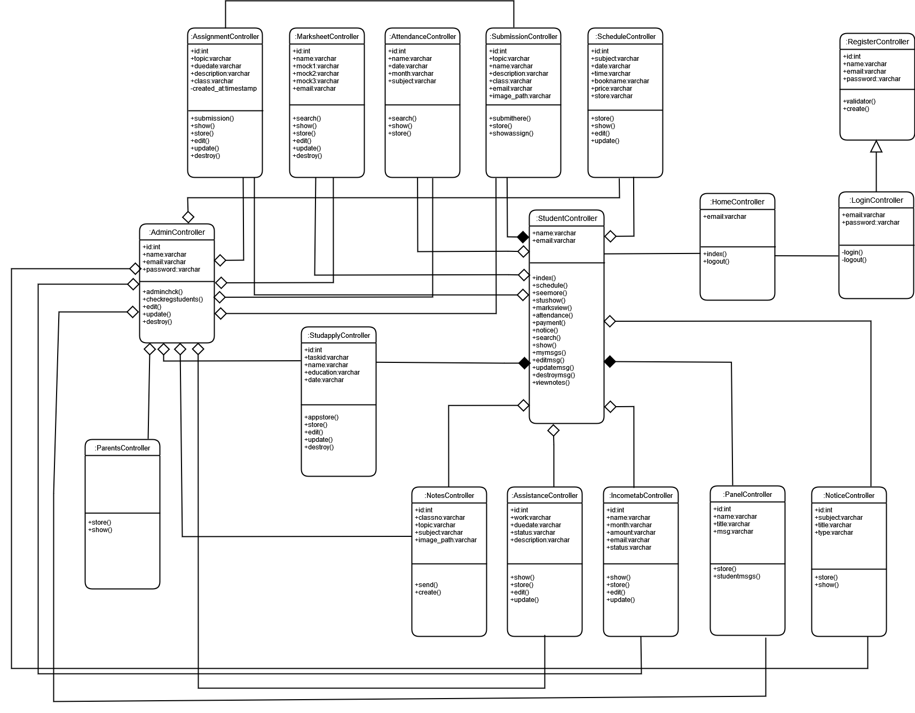

# Figure 3.104: Class Diagram for TutorsAid

**3.7 System Model**

System model is a simple presentation of a system process. The model represents a process from a specific perspective project management that defines the stages involved in the development of a system from the feasibility study of an initial system to the maintenance of the entire application.

In this project I used “**Waterfall Model**”.

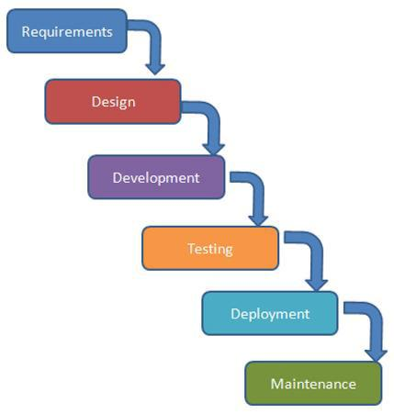

# Figure 3.105: Waterfall Model

**3.8 Design and Implementation Constraints**

**3.8.1 Framework or Software Language:**

TutorsAid is written by PHP using Laravel framework with a bootstrap template for user interface and data stored in MySQL database.

**3.9 Development Tools and Technology:**

* IDE: Visual Studio Code
* Database: MySQL
* UI: Html, CSS, Bootstrap, JavaScript,Ajaz
* Framework: Laravel 6.18.26
* Language: PHP 7.3.6
* Web-Server: XAMPP Server

**CHAPTER 4**

**SYSTEM TESTING**

|  |  |  |  |  |  |
| --- | --- | --- | --- | --- | --- |
| **Test  Case  ID** | **Use-Case** | **Test Scenario** | **Expected  Outcome** | **Actual Outcome** | **Remarks** |
| TC-01 | Admin Login | Admin will enter the name and code to enter the system | Admin Login can login successfully | Admin Logins in successfully | Passed |
| TC-02 | Add schedule | Admin will be able to upload new schedule | Admin can upload new schedule | Admin can successfully add new schedule | Passed |
| TC-03 | View Schedule | Admin will be able to view schedules | Admin can view schedules | Admin can successfully view schedules | Passed |
| TC-04 | Update Schedule | Admin will be able to update schedules | Admin can update schedules | Admin can successfully update schedules | Passed |
| TC-05 | Add Attendance | Admin will be able to add attendance | Admin can add attendance | Admin can successfully add attendance | Passed |
| TC-06 | Check attendance | Admin will be able to check attendance | Admin can check attendance | Admin can successfully check attendance | Passed |
| TC-07 | Search attendance | Admin will be able to Search attendance and get results | Admin can search attendance | Admin can successfully search attendance and get results | Passed |
| TC-08 | Check Registered Students | Admin will be able to check the registered students menu | Admin can check the registered students menu | Admin can access the registered students menu successfully | Passed |

|  |  |  |  |  |  |
| --- | --- | --- | --- | --- | --- |
| TC-09 | View List | Admin will be able to check the list of students | Admin can check the list of students | Admin can view the registered students menu successfully | Passed |
| TC-10 | Block Student | Admin will be able to block a student from logging in | Admin can block a student from logging in | Admin can block a student from logging in successfully | Passed |
| TC-11 | Terminate Registration | Admin will be able to terminate the registration of a student | Admin can terminate the registration of a student | Admin can a student registration successfully | Passed |
| TC-12 | Email parents | Admin will be able to send emails to parents | Admin can be able to send emails to parents | Admin will be able to send emails to parents successfully | Passed |
| TC-13 | Upload Notes | Admin will be able to upload notes | Admins can upload notes | Admin successfully upload notes | Passed |
| TC-14 | Check Uploads | Admin will be able to view the uploaded notes | Admin can view the uploaded notes | Admin can view the uploaded notes successfully | Passed |
| TC-15 | Income tab | Admin will be able to view the income tab | Admin can view the income tab | Admin can view the income tab successfully | Passed |
| TC-16 | Add Collections | Admin will be able to add collections | Admin can add collections | Admin will be able to add collections successfully | Passed |
| TC-17 | Show Collections | Admin will be able to view the collections | Admin can view the collections | Admin will be able to view collections successfully | Passed |
| TC-18 | Search Collections | Admin will be able to search the collections | Admin can search the collections | Admin will be able to search collections successfully | Passed |
| TC-19 | Discussion panel | Admin will be able to view messages in the Discussion Panel | Admin can view messages in the Discussion Panel | Admin can view messages in the Discussion Panel Successfully | Passed |
| TC-20 | Delete Messages | Admin will be able to delete the messages from discussion panel | Admin can delete the messages from discussion panel | Admin can delete the messages from discussion panel successfully | Passed |
| TC-21 | Marksheet | Admin will be able to enter marksheet menu | Admin can enter marksheet menu | Admin can enter the marksheet menu successfully | Passed |
| TC-22 | Add Marksheet | Admin will be able to add marksheet | Admin can add marksheet | Admin can add marksheet successfully | Passed |
| TC-23 | View Marksheet | Admin will be able to view marksheet | Admin can view marksheet | Admin can view marksheet successfully | Passed |
| TC-24 | Search Marksheet | Admin will be able to search marksheets | Admin can search marksheets | Admin can search marksheets successfully | Passed |
| TC-25 | Update Marksheet | Admin will be able to update marksheet | Admin can update  marksheet | Admin can update marksheet successfully | Passed |
| TC-26 | Upload Notice | Admin will be able to upload notice | Admin can upload notice | Admin can upload notice successfully | Passed |
| TC-27 | View Notice | Admin will be able to view notice | Admin can view notice | Admin can view notice successfully | Passed |
| TC-28 | Search Notice | Admin will be able to search notice | Admin can search notice | Admin can update search successfully | Passed |
| TC-29 | Assignments | Admin will be able to enter assignments menu | Admin can enter assignments menu | Admin can enter assignments menu successfully | Passed |
| TC-30 | Post Assignments | Admin will be able to post assignments | Admin can enter posts assignments | Admin can post assignments successfully | Passed |
| TC-31 | View Posted | Admin will be able to view posted assignments | Admin can view posted assignments | Admin can view posted assignments successfully | Passed |
| TC-32 | Update Assignments | Admin will be able to update assignments | Admin can update assignments | Admin can update assignments successfully | Passed |
| TC-33 | Check submissions | Admin will be able to check submissions | Admin can check submissions | Admin can check submissions successfully | Passed |
| TC-34 | Register | Students will be able to register to the system | Students can register to the system | Students can register to the system successfully | Passed |
| TC-35 | Login | Students will be able to login to the system | Students can login to the system | Students can login to the system successfully | Passed |
| TC-36 | Open panel | Students will be able to view messages in the Discussion Panel | Student can view messages in the Discussion Panel | Student can view messages in the Discussion Panel Successfully | Passed |
| TC-37 | Post Messages | Students will be able to post messages in the Discussion Panel | Students can post messages in the Discussion Panel | Students can post messages in the Discussion Panel | Passed |
| TC-38 | View My Messages | Students will be able to view their messages | Students can view their messages | Students can view their messages successfully | Passed |
| TC-39 | Update Messages | Students will be able to update their messages | Students can update their messages | Students can update their messages successfully | Passed |
| TC-40 | Delete Messages | Students will be able to delete their messages | Students can delete their messages | Students can delete their messages successfully | Passed |
| TC-41 | Check Schedule | Students will be able to check schedule | Students can check schedule | Students can check schedule successfully | Passed |
| TC-42 | Check Attendance | Students will be able to check attendance | Students can check attendance | Students can check attendance successfully | Passed |
| TC-43 | View Marksheet | Students will be able to view marksheet | Students can view marksheet | Students can view marksheet successfully | Passed |
| TC-44 | Assignments | Students will be able to view assignments | Students can view assignments | Students can view assignments successfully | Passed |
| TC-45 | Submit Assignment | Students will be able to submit assignment | Students can submit assignment | Students can submit assignment successfully | Passed |
| TC-46 | View Notes | Students will be able to view notes | Students can view notes | Students can view notes successfully | Passed |
| TC-47 | Notice | Students will be able to check notice | Students can check notice | Students can check notice successfully | Passed |
| TC-48 | Notice Search | Students will be able to search notice | Students can search notice | Students can search notice successfully | Passed |
| TC-49 | My Payments | Students will be able to check their payments | Students can check their payments | Students can check their payments | Passed |

Test Cases: 49

Passed: 49

**CHAPTER 5**

**USER MANUAL**

**5.1 Admin Login Page**

In this page the admin enters name and code

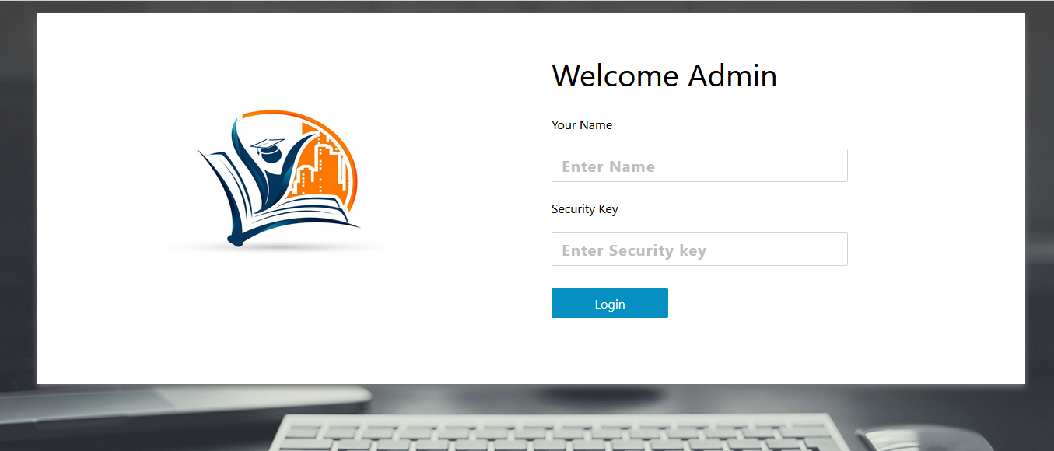

# Figure 5.106: UI (Admin Login Page)

**5.2 Admin panel**

Admin Panel Page

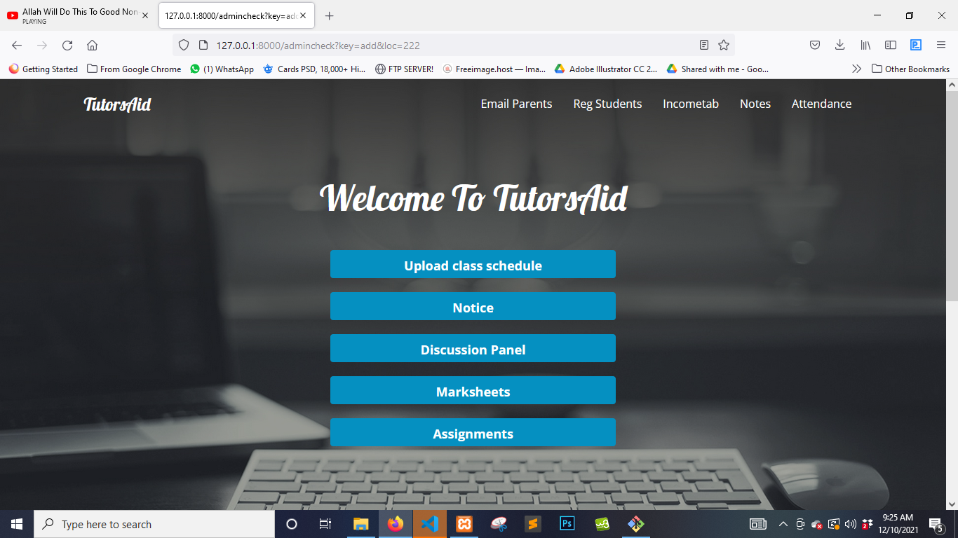

# Figure 5.107: UI (Admin Panel Page)

**5.3 Schedule Menu**

Admin can view class schedule menu

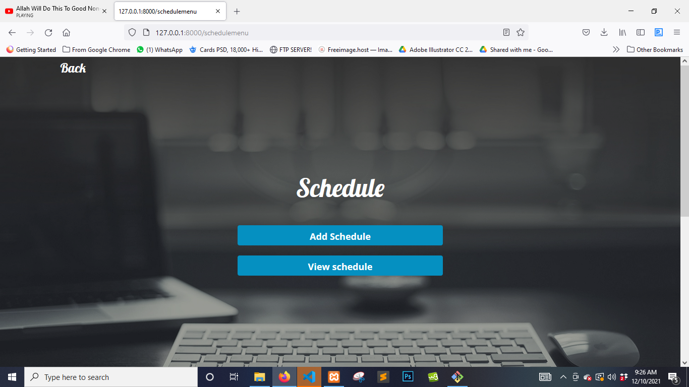

# Figure 5.108: UI (schedule menu)

**5.4 Add Schedule**

Admin can add schedule

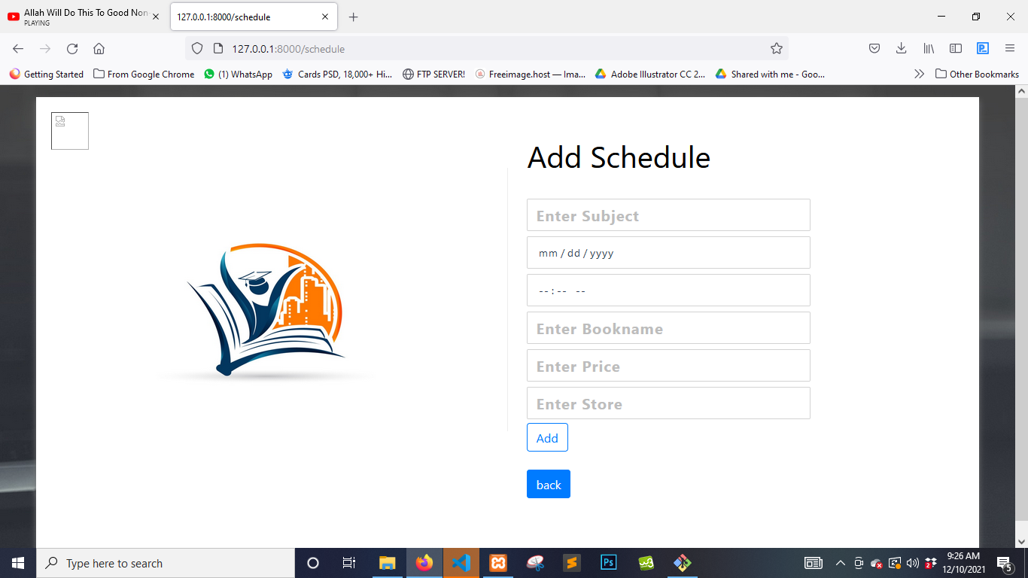

# Figure 5.109: UI (Add schedule)

**5.5 Check Schedule**

Admin can check class schedule

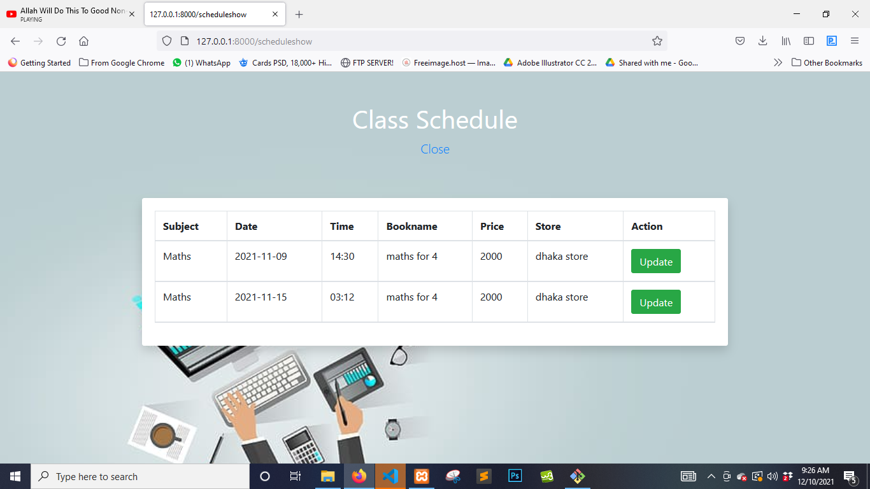

# Figure 5.110: UI (check class schedule)

**5.6 Update Schedule**

Admin can update class schedule

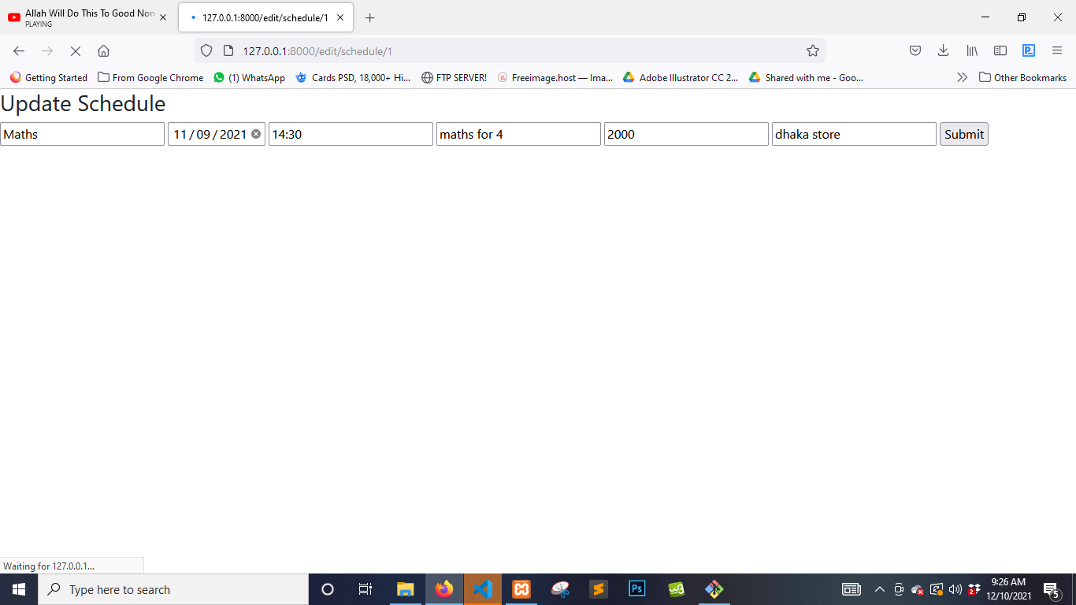

# Figure 5.111: UI (update class schedule)

**5.7 Attendance**

Admin can view attendance menu

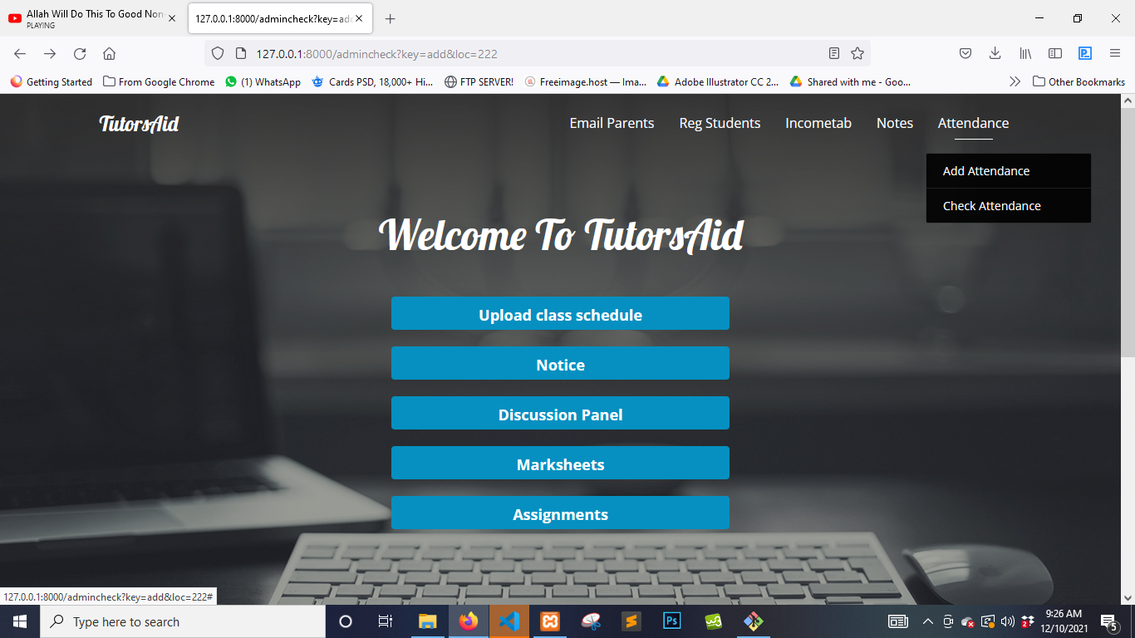

# Figure 5.112: UI (Attendance)

**5.8 Add Attendance**

Admin can add attendance

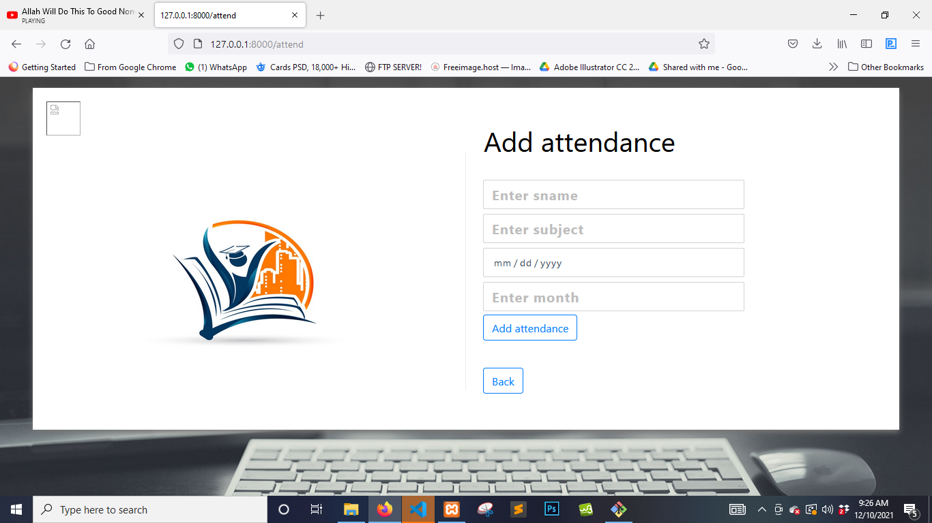

# Figure 5.113: UI (Add Attendance)

**5.9 Check Attendance**

Admin can check attendance

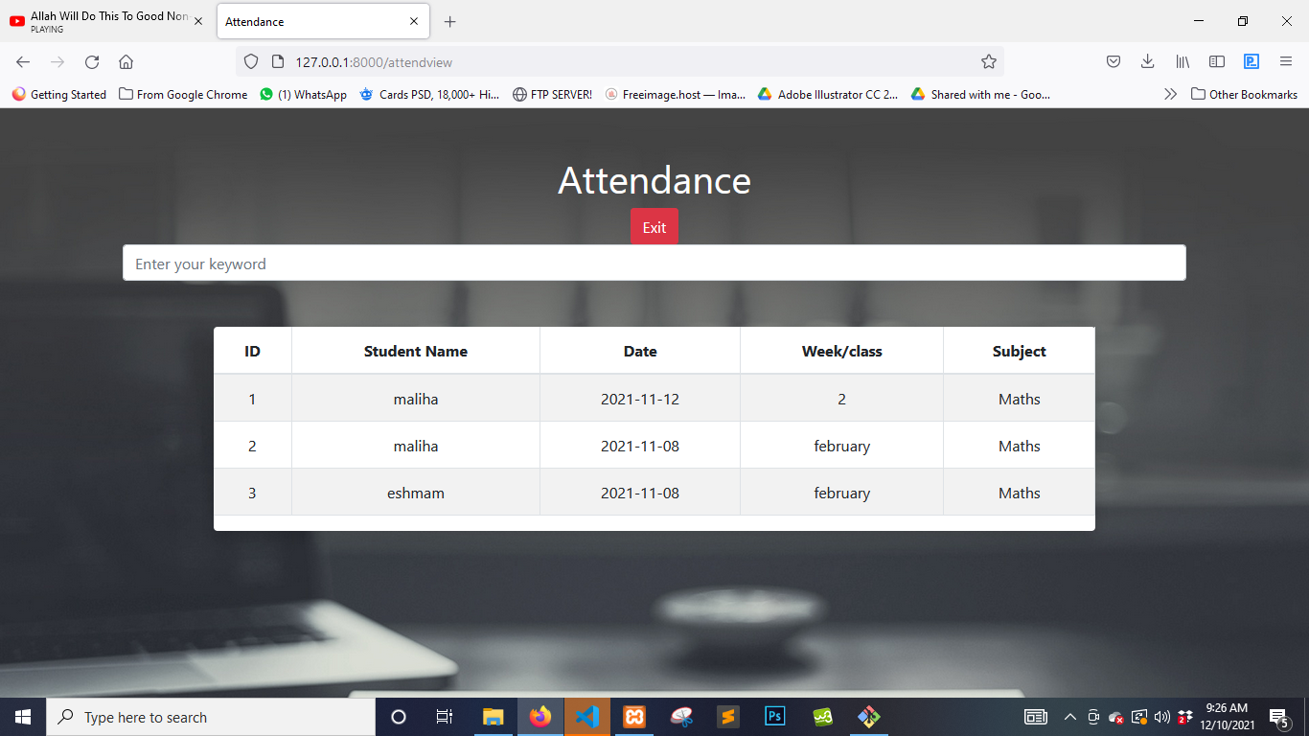

# Figure 5.114: UI (check attendance)

**5.10 Search Attendance**

Admin can search attendance

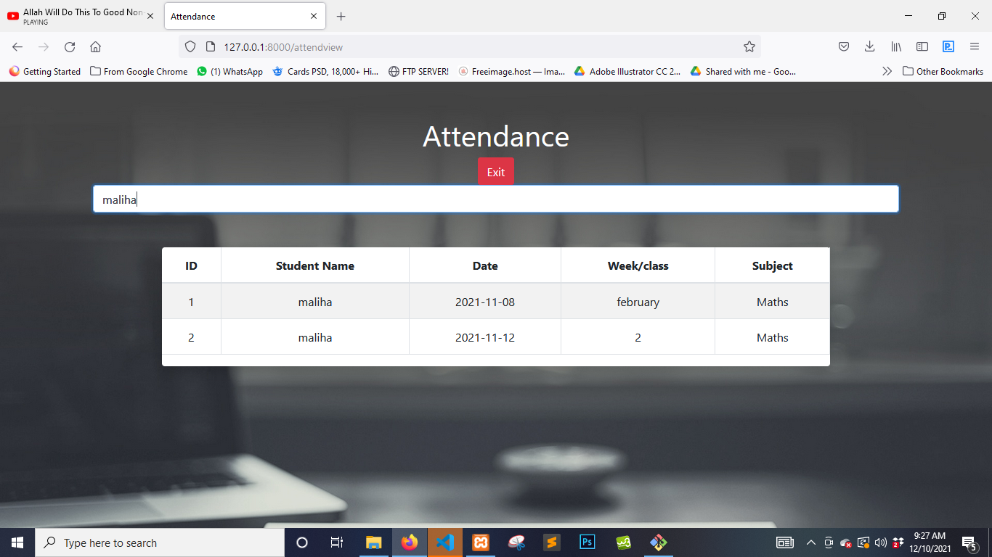

# Figure 5.115: UI (search attendance)

**5.11 Check Registered Students**

Admin can enter the check registered students menu

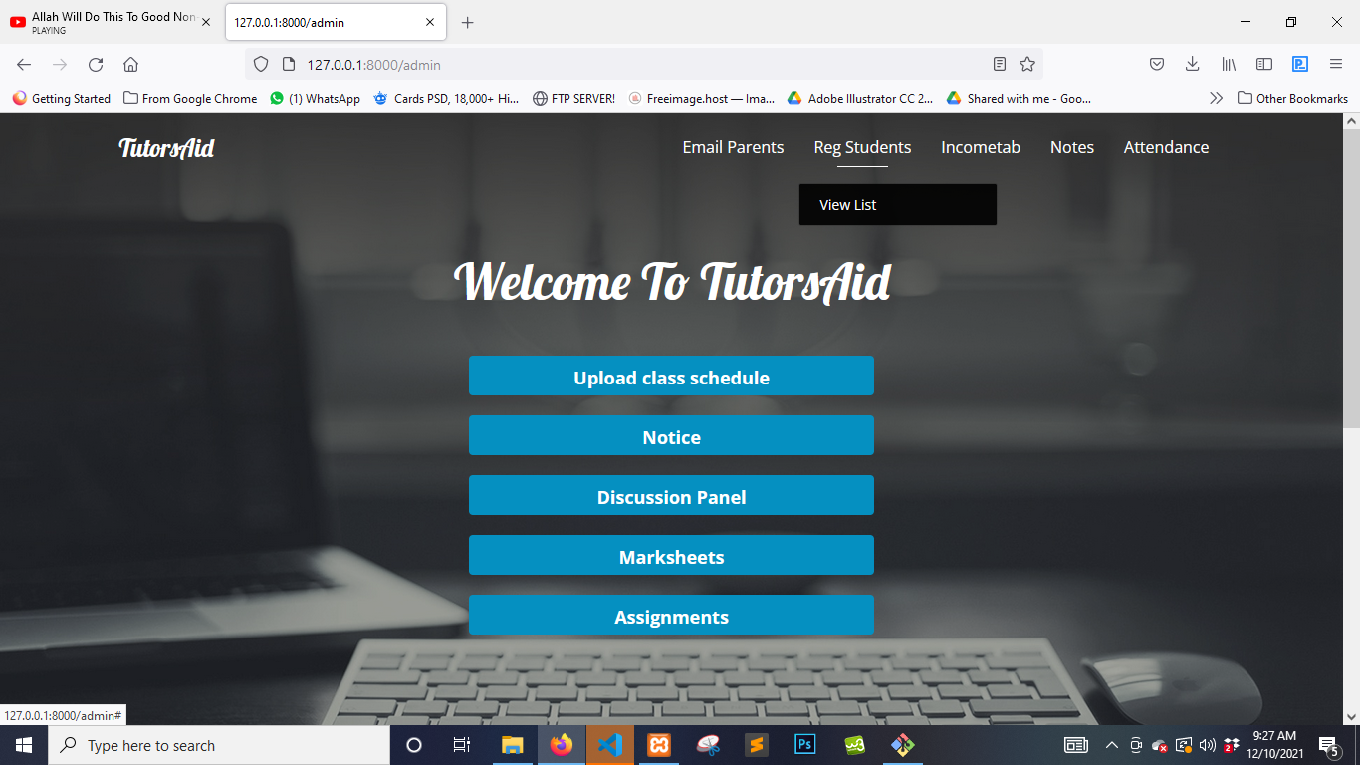

# Figure 5.116: UI (check registered students menu)

**5.12 View List**

Admin can view the list of registered students

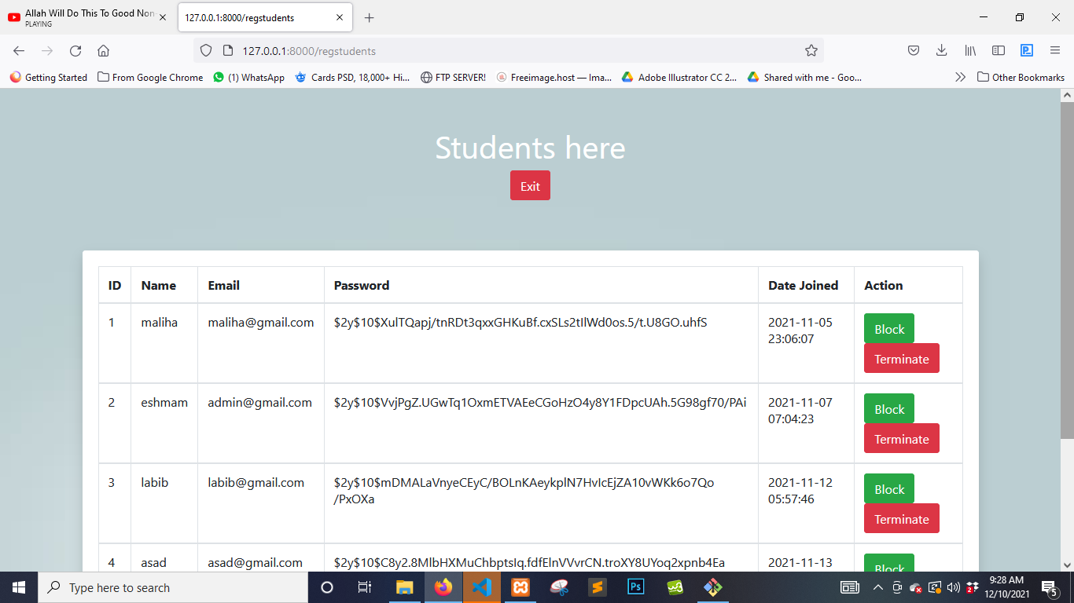

# Figure 5.117: UI (view list)

**5.12 Block Student**

Admin can block a student’s entry here

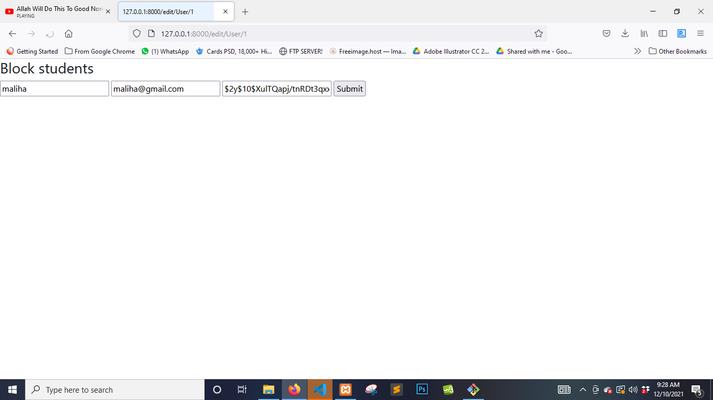

# Figure 5.118: UI (Block Students)

**5.13 Terminate Registration**

Admin can terminate a students registration here

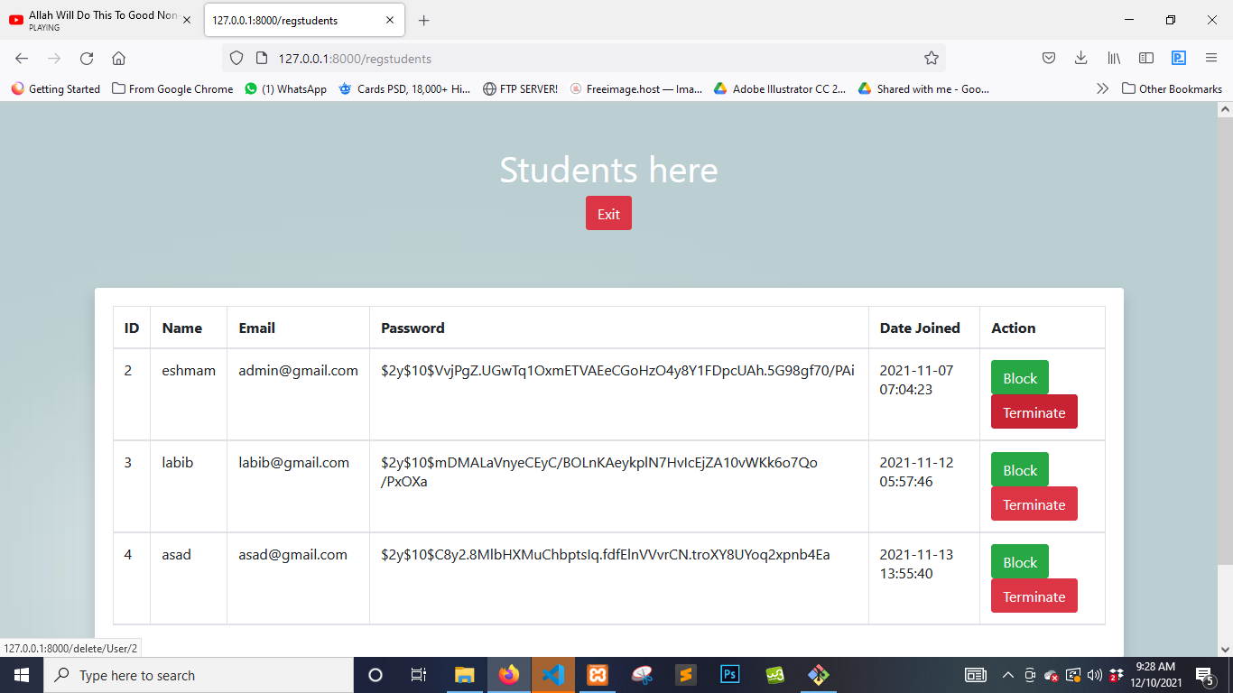

# Figure 5.119: UI (Terminate Registration)

**5.14 Email Parents**

Admin can send emails to parents from here

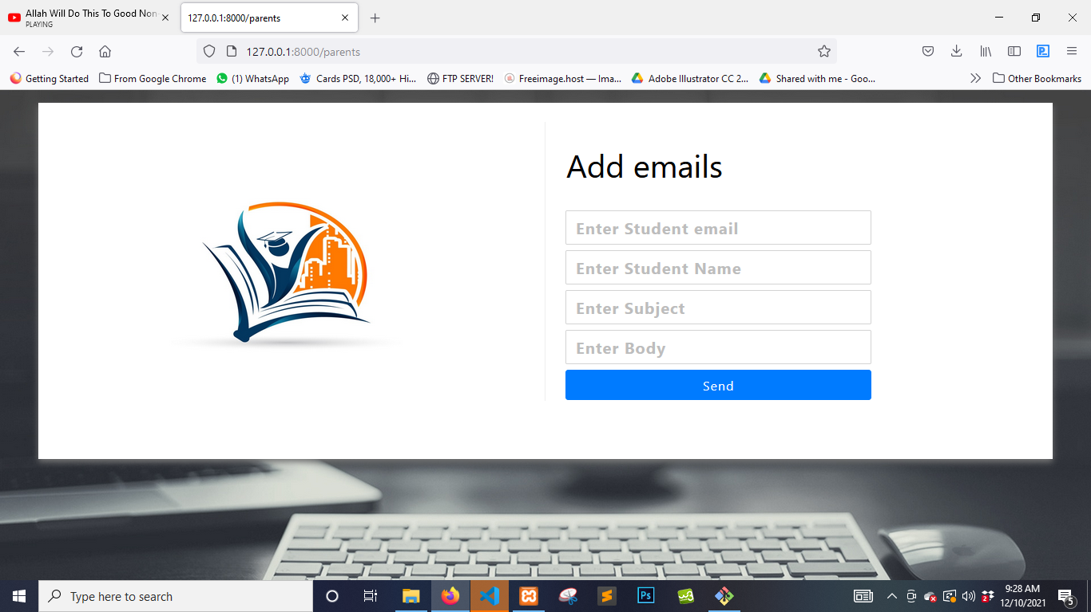

# Figure 5.120: UI (Email Parents)

**5.15 Notes**

Admin can view the notes menu here

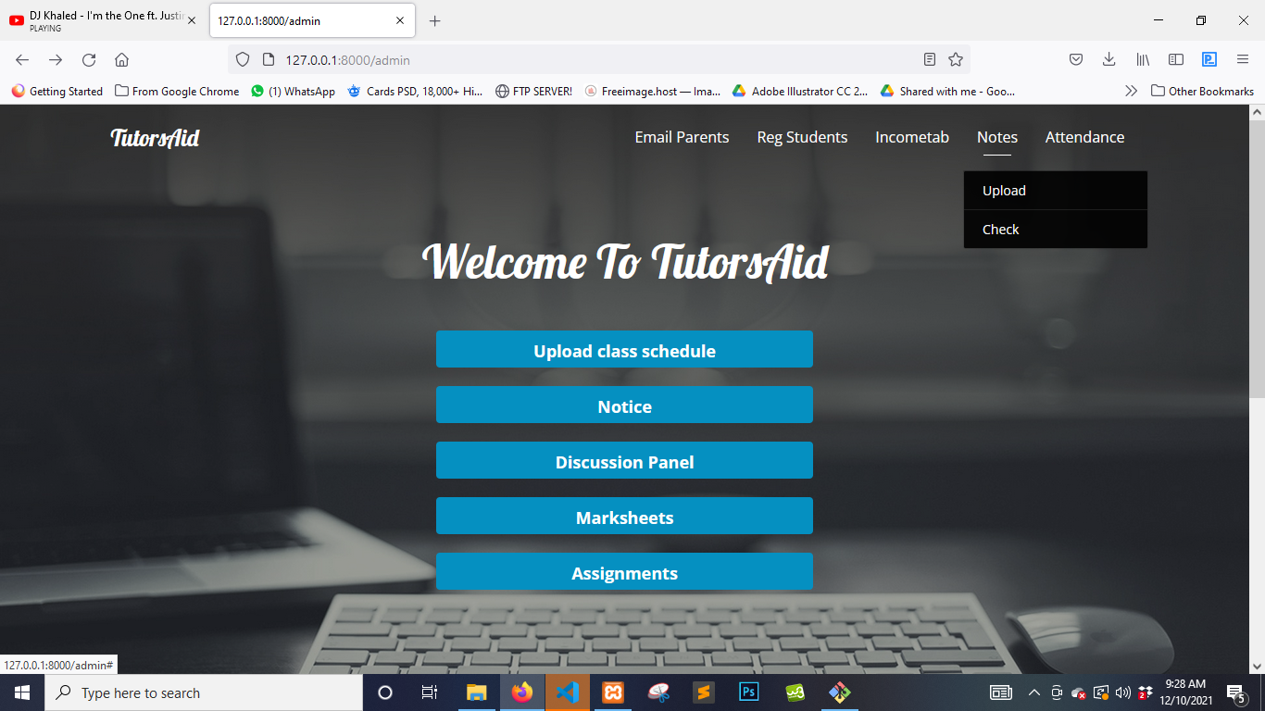

# Figure 5.121: UI (Notes Menu)

**5.16 Upload Notes**

Admin can upload the notes here

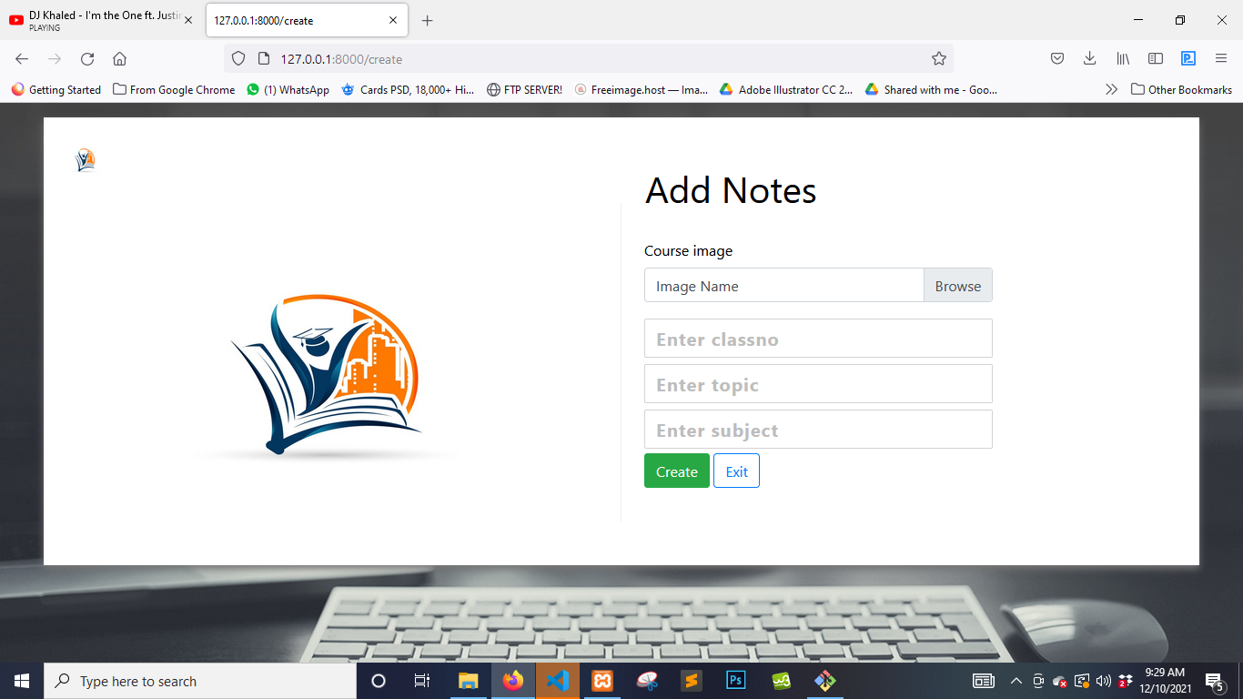

# Figure 5.122: UI (Add Notes)

**5.17 Check uploads**

Admin can check uploaded notes here

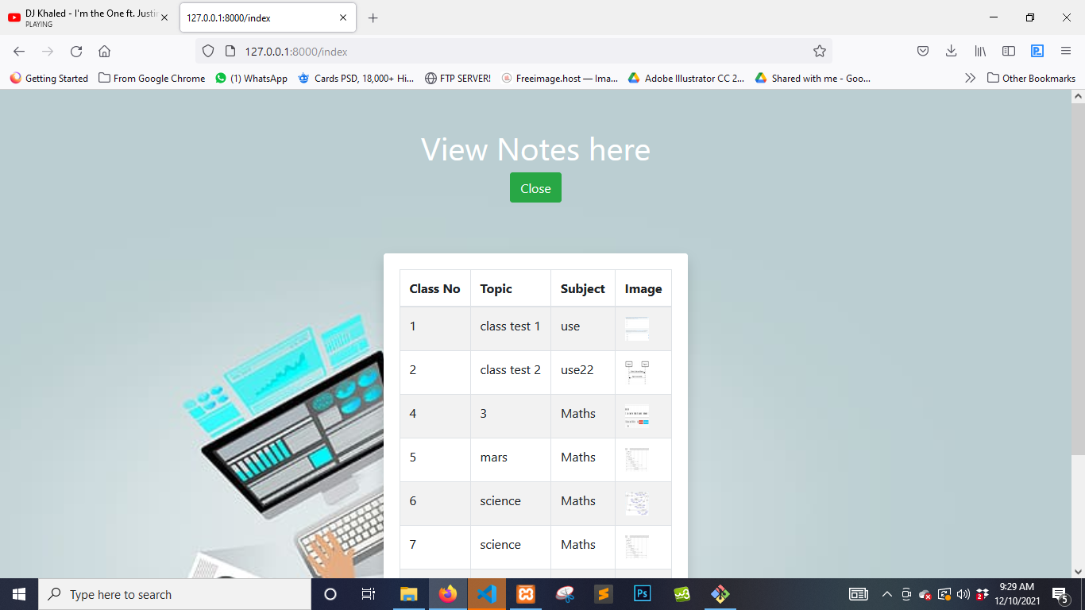

# Figure 5.123: UI (Check Uploads)

**5.18 Income Tab**

Admin can view the income tab menu here

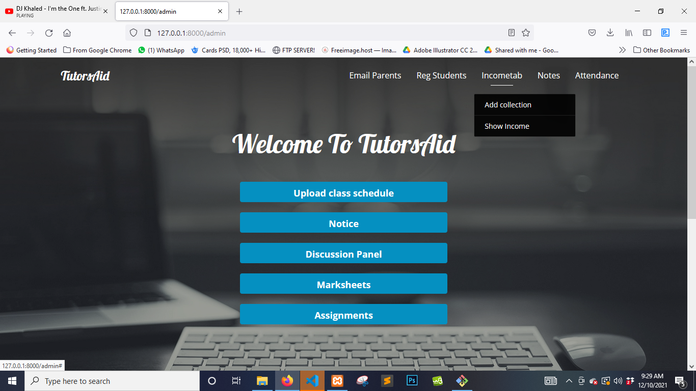

# Figure 5.124: UI (income tab menu)

**5.19 Add Collection**

Admin can add income here

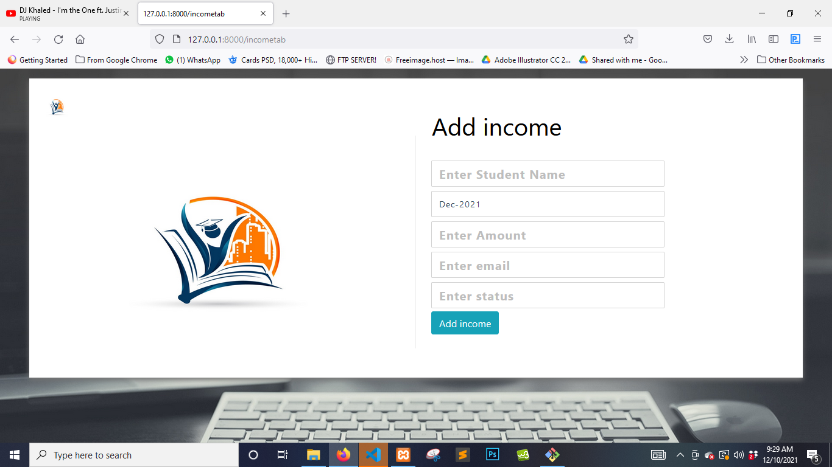

# Figure 5.125: UI (Add collection)

**5.20 Show Income**

Admin can show income here

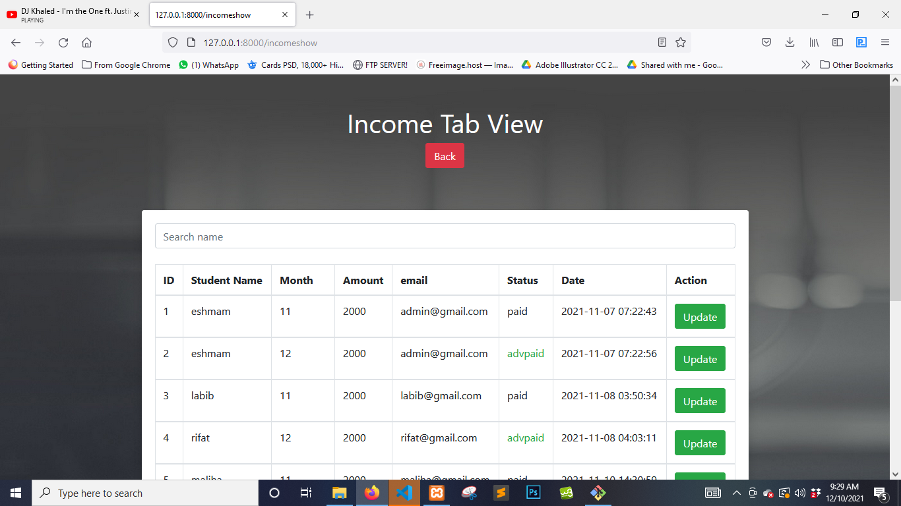

# Figure 5.126: UI (show income)

**5.21 Search Income**

Admin can search income here

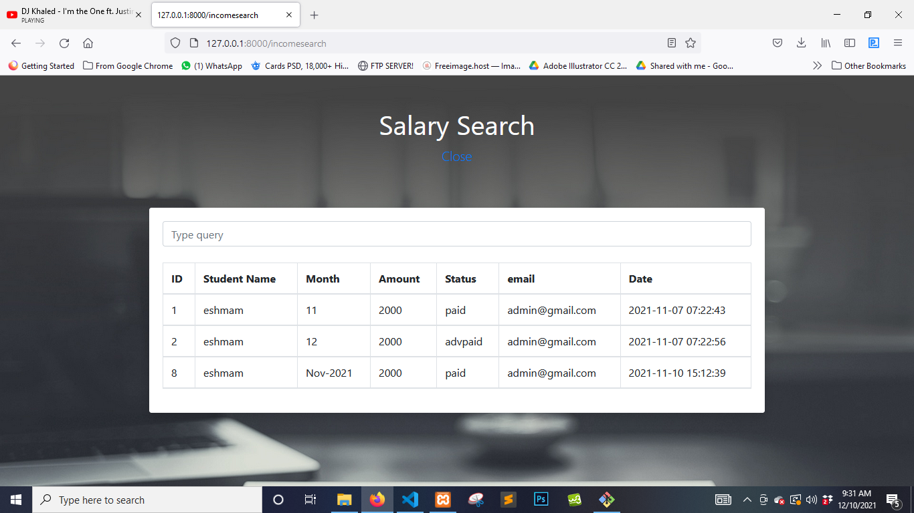

# Figure 5.127: UI (search income)

**5.22 Discussion Panel**

Admin can access the discussion panel here

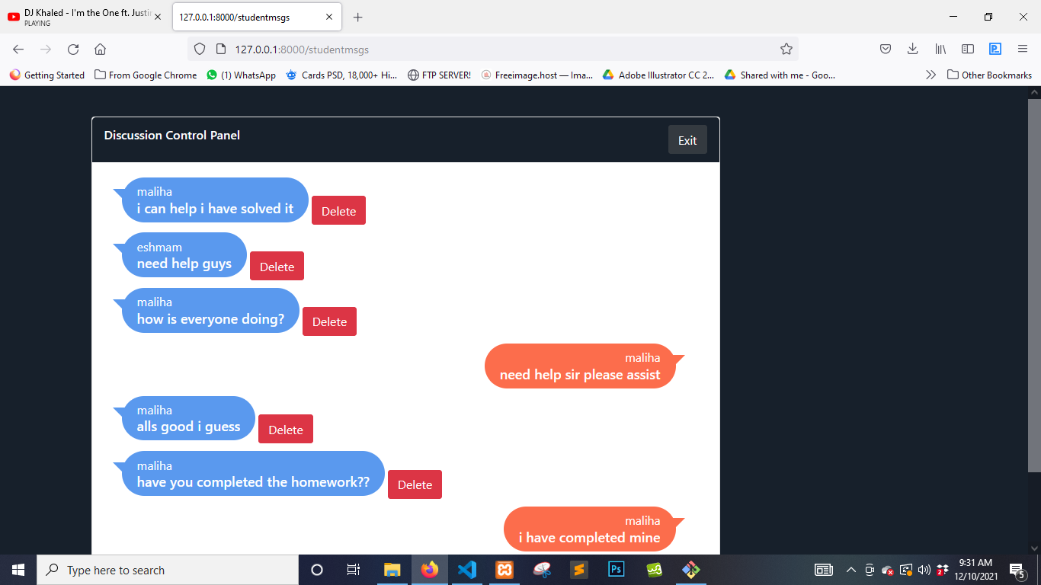

# Figure 5.128: UI (Discussion Panel)

**5.23 Delete Messages**

Admin can delete messages here

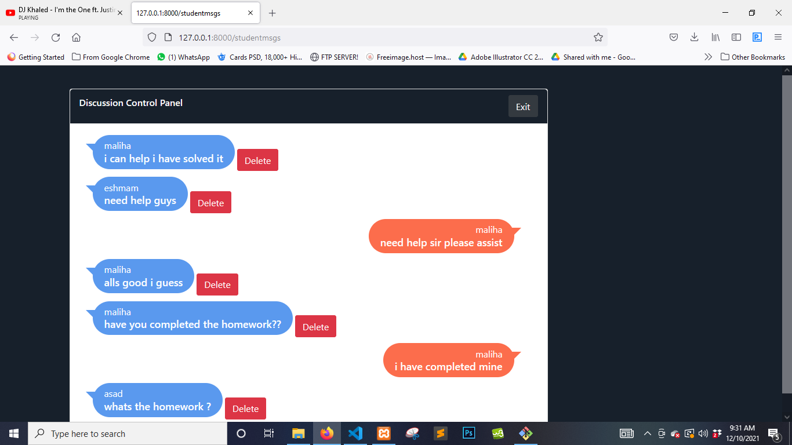

# Figure 5.129: UI (Delete Messages)

**5.24 Marksheet**

Admin can access the marksheet menu

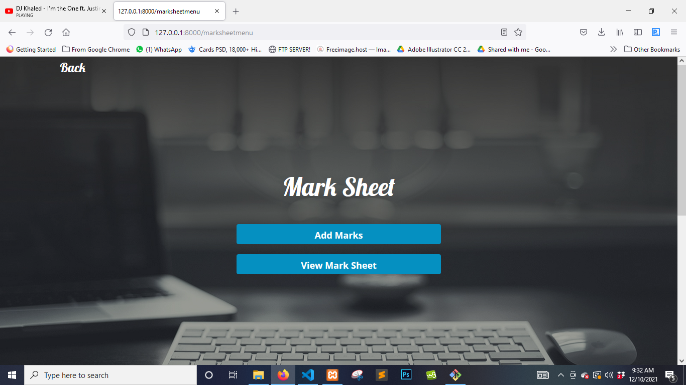

# Figure 5.130: UI (Marksheet Menu)

**5.25 Add Marksheet**

Admin can add marksheet

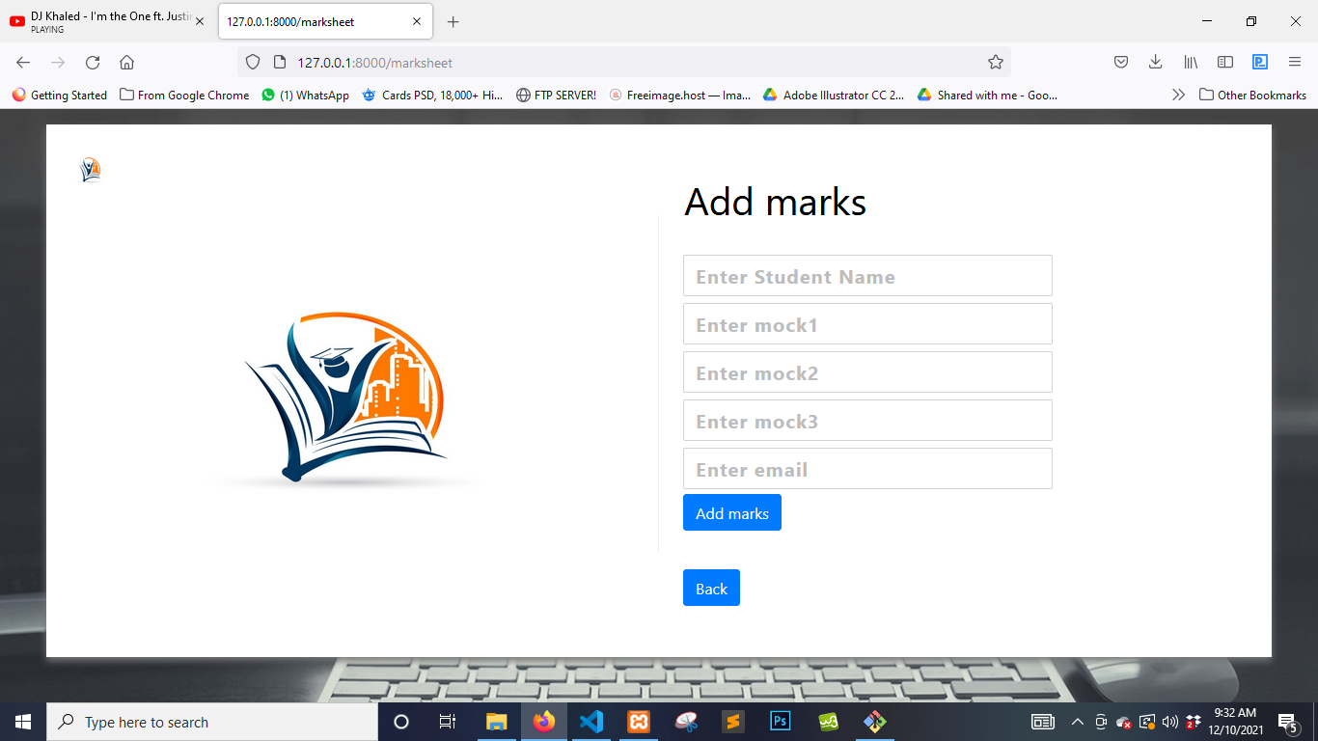

# Figure 5.131: UI (Add Marksheet)

**5.26 View Marksheet**

Admin can view marksheet

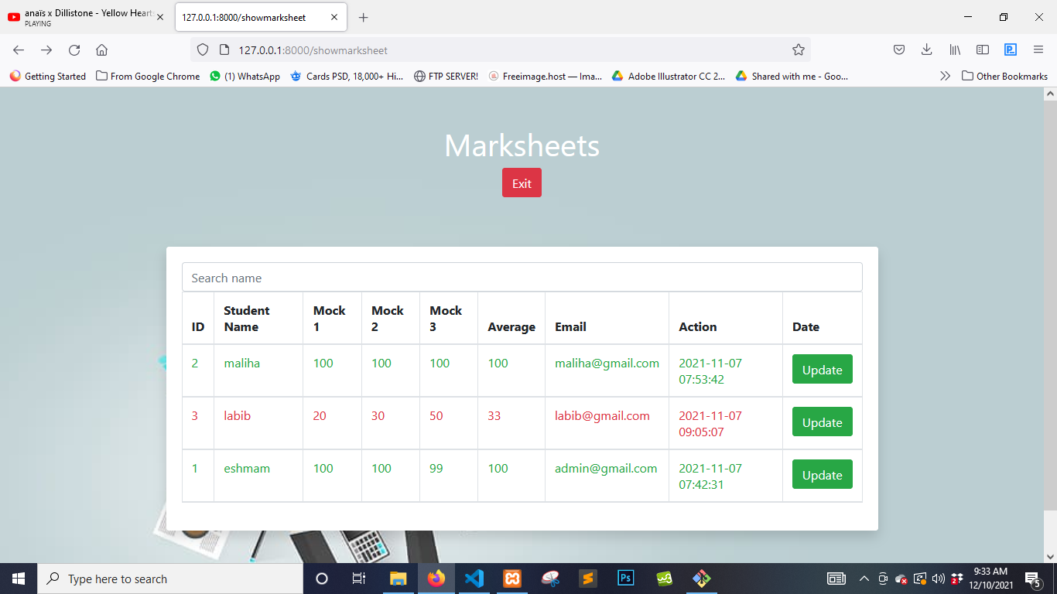

# Figure 5.132: UI (View Marksheet)

**5.27 Search Marksheet**

Admin can search marksheet

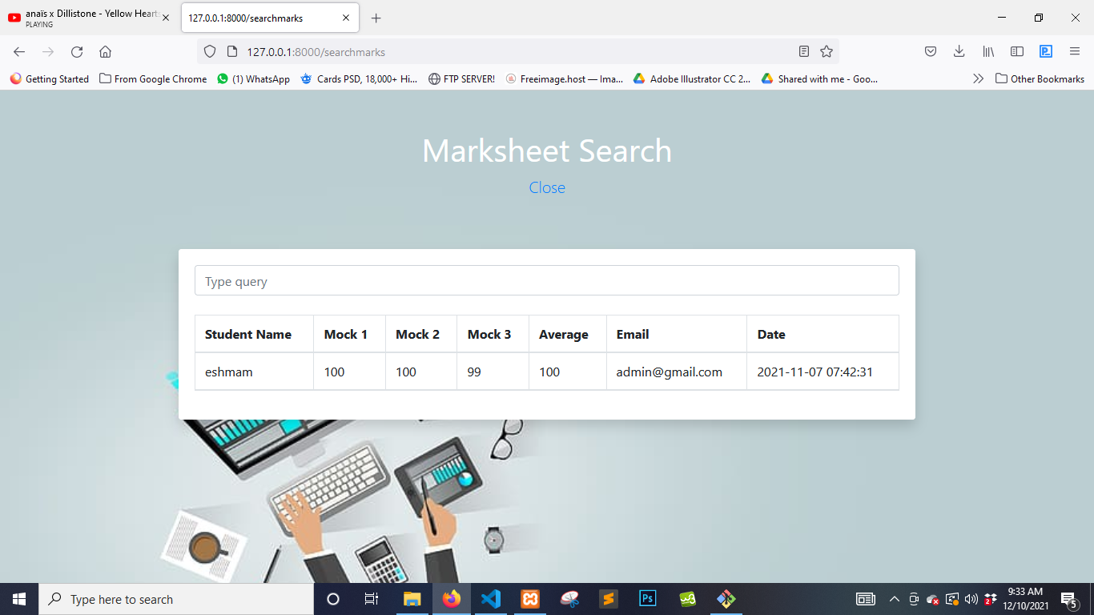

# Figure 5.133: UI (Search Marksheet)

**5.28 Update Marksheet**

Admin can update marksheet

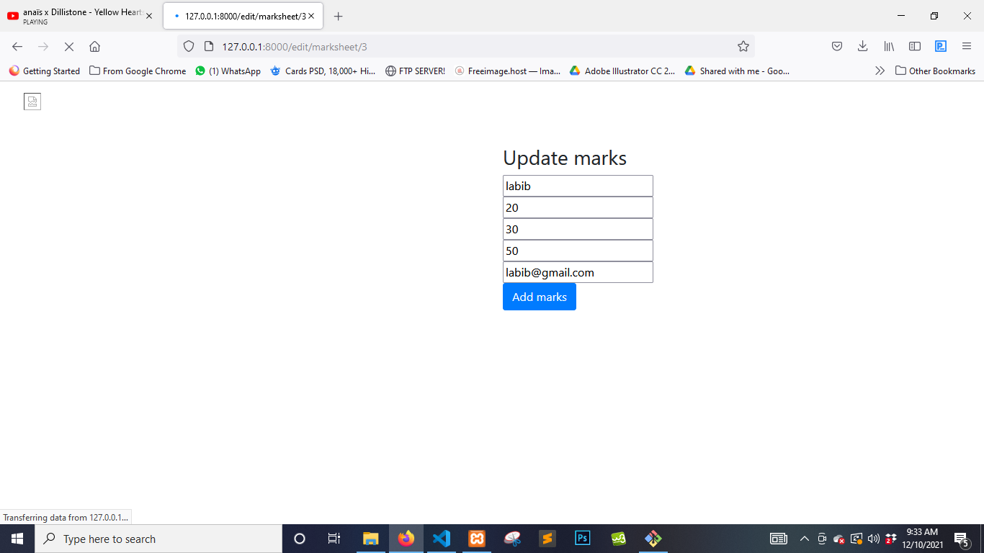

# Figure 5.134: UI (Update Marksheet)

**5.29 Notice**

Admin can enter the notice menu

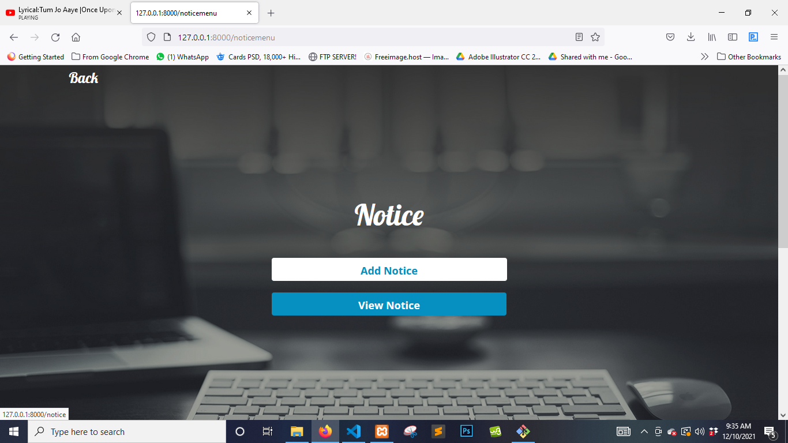

# Figure 5.135: UI (Notice Menu)

**5.30 Add Notice**

Admin can add notice

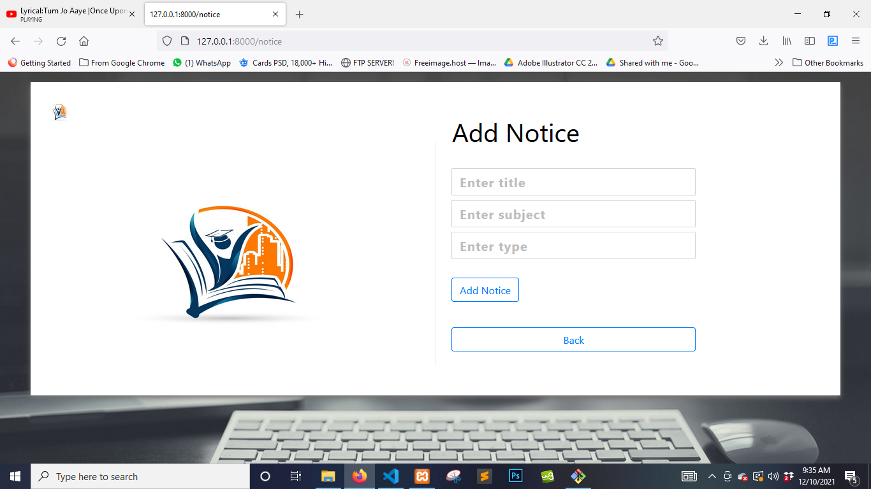

# Figure 5.136: UI (Add Notice)

**5.31 View Notice**

Admin can view notices here

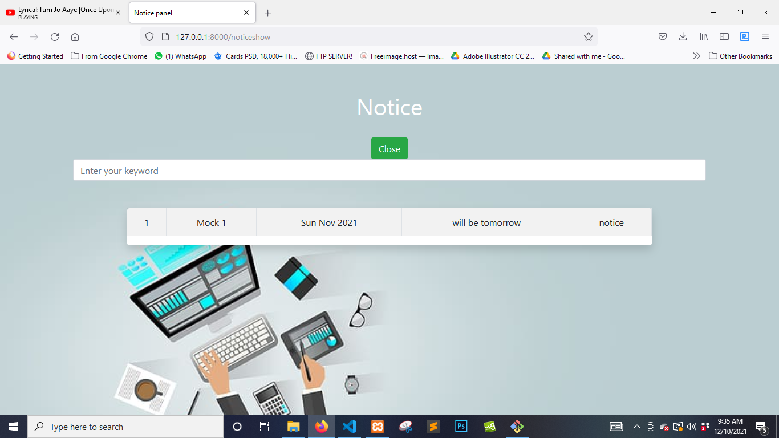

# Figure 5.137: UI (View Notice)

**5.32 Search Notice**

Admin can search notices here

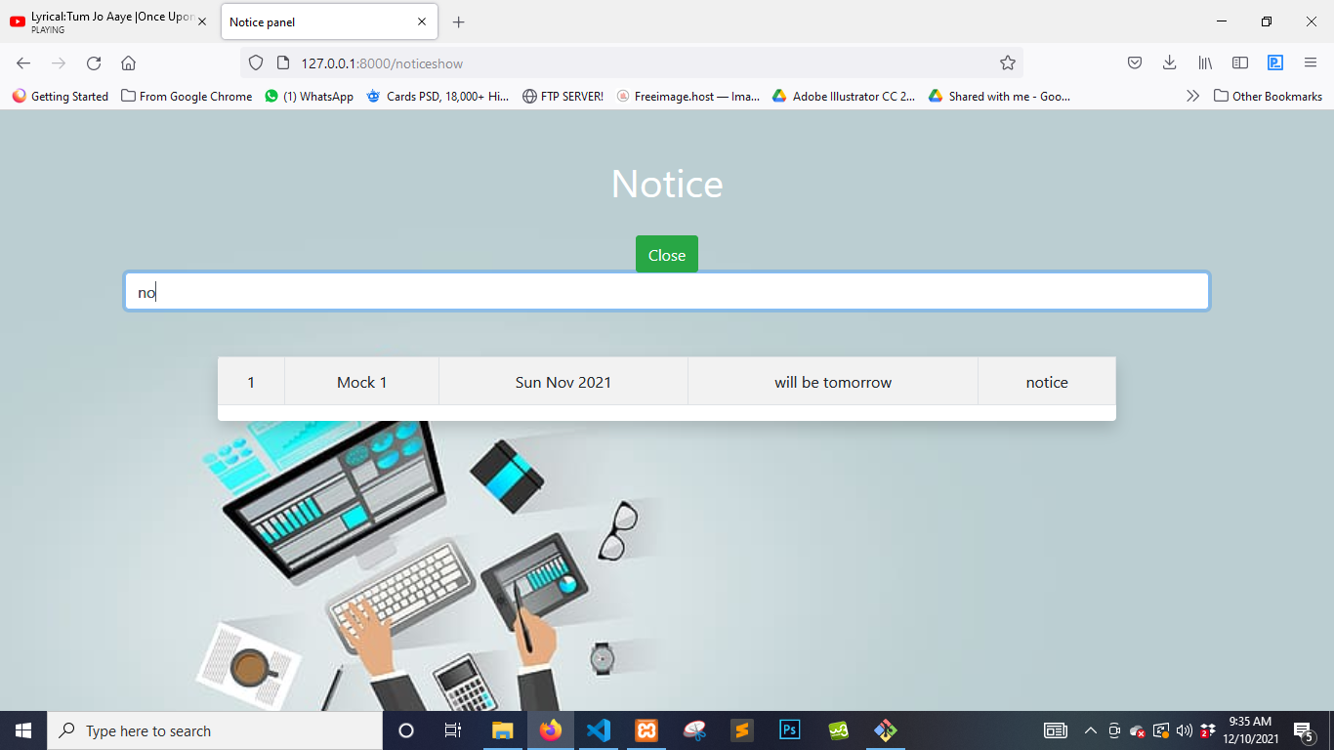

# Figure 5.138: UI (Search Notice)

**5.33 Assignments Menu**

Admin can access the assignments menu

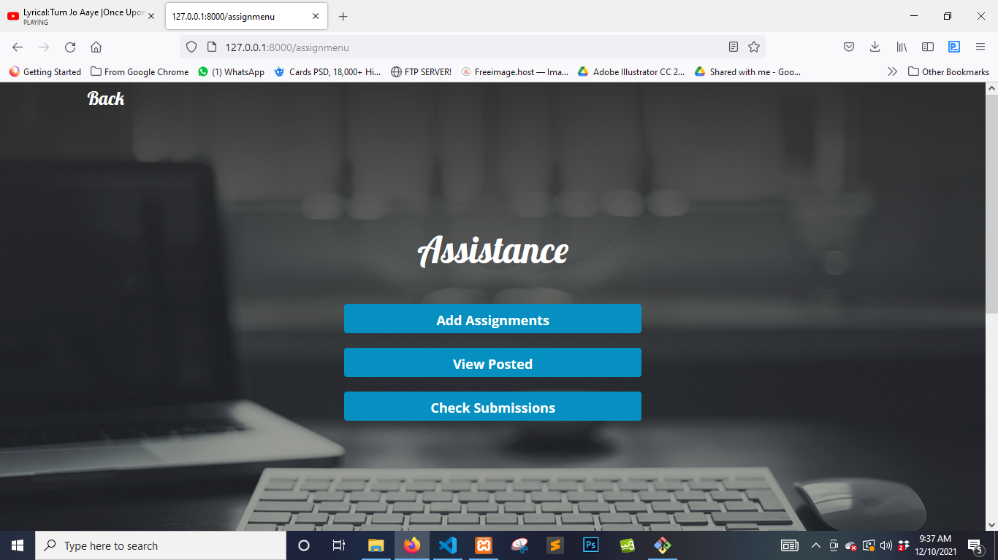

# Figure 5.139: UI (Assignments Menu)

**5.34 Post Assignments**

Admin can post assignments here

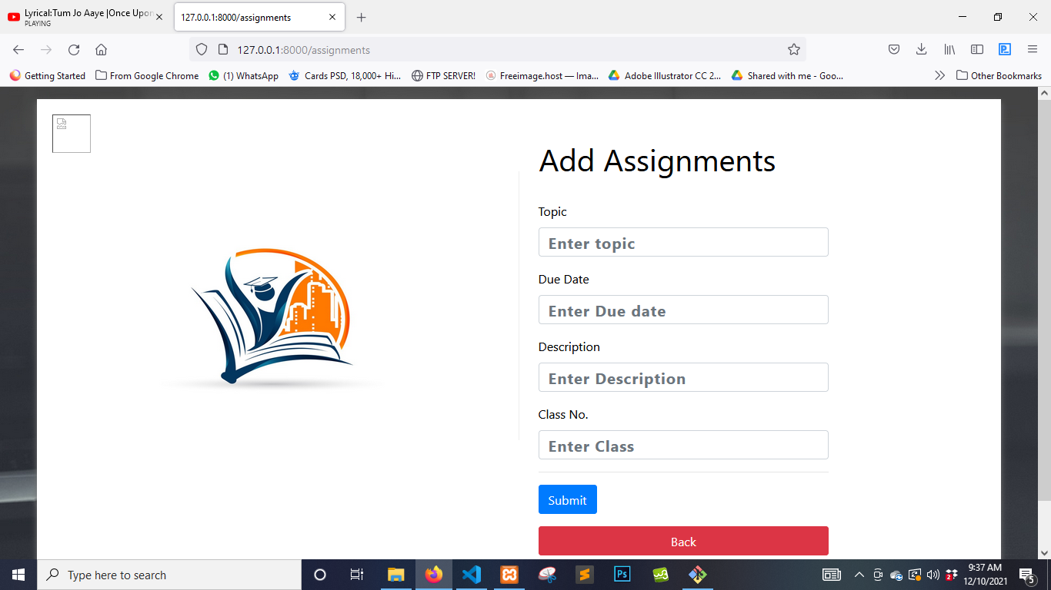

# Figure 5.140: UI (Post Assignments)

**5.35 View Posted**

Admin can view posted assignments here

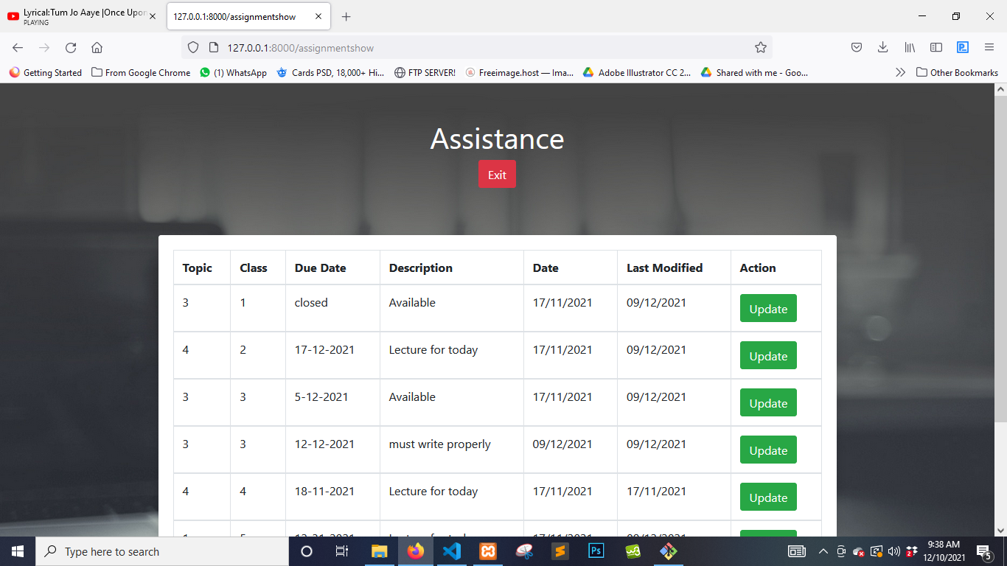

# Figure 5.141: UI (View Posted)

**5.36 Update Assignments**

Admin can update assignments here

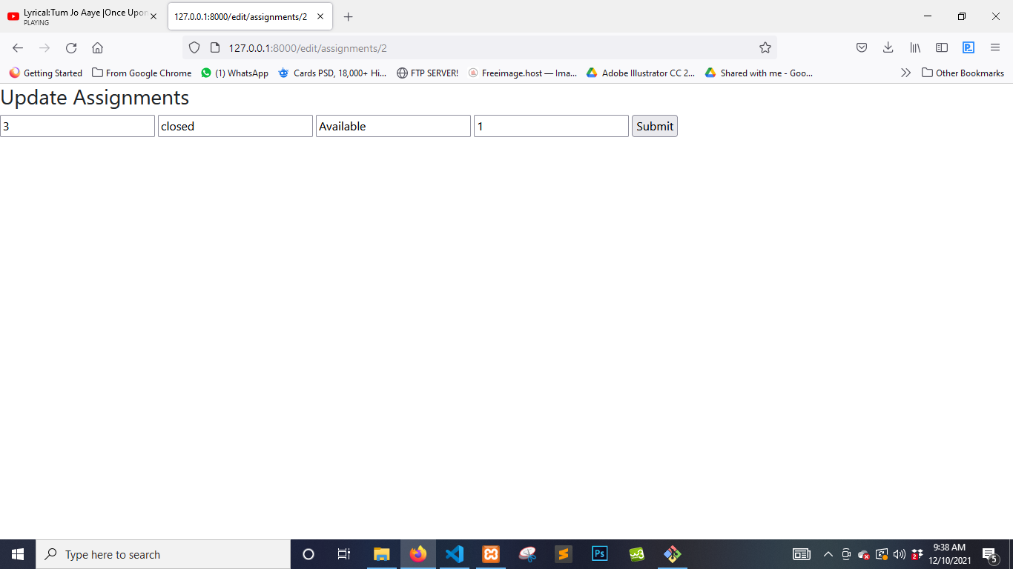

# Figure 5.142: UI (Update Assignments)

**5.37 Check submissions**

Admin can check submissions of students here

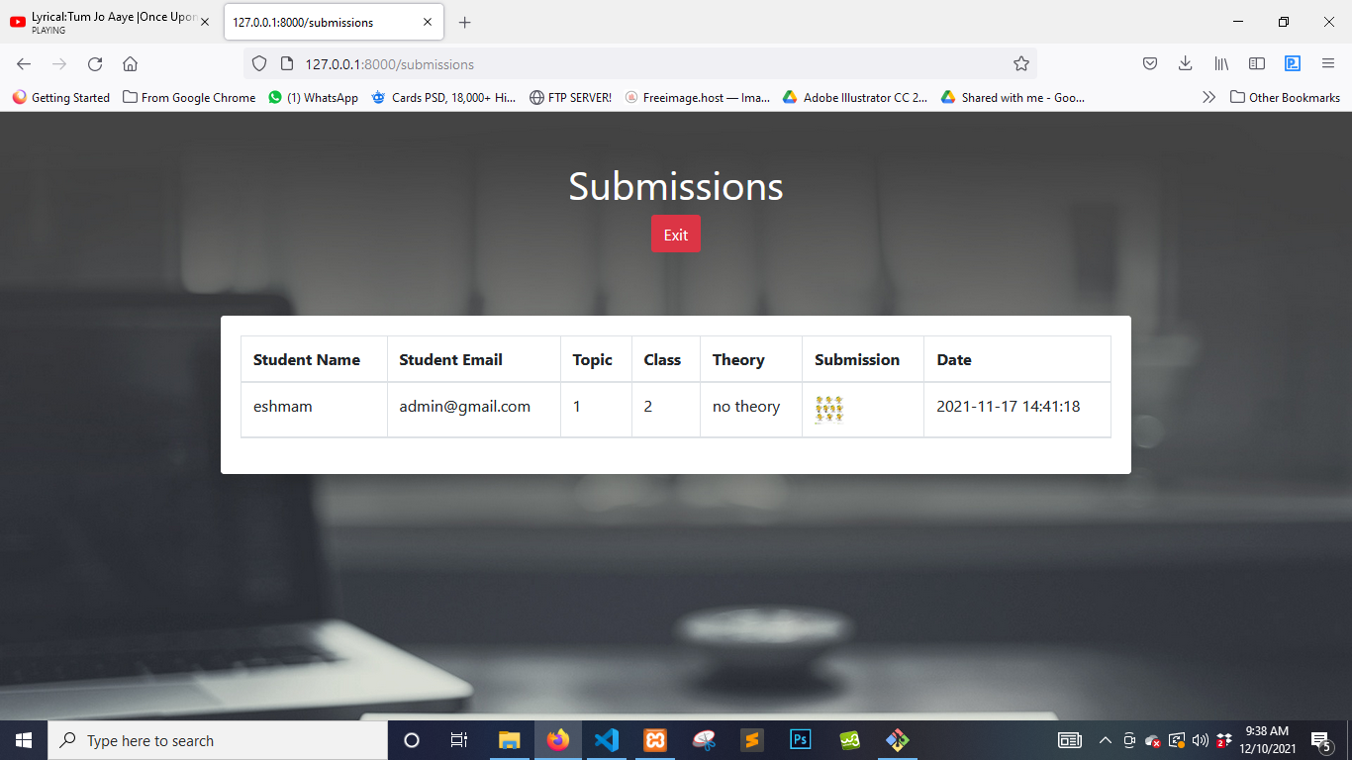

# Figure 5.143: UI (Check Submissions)

**5.38 Register**

Student can register here to access the system

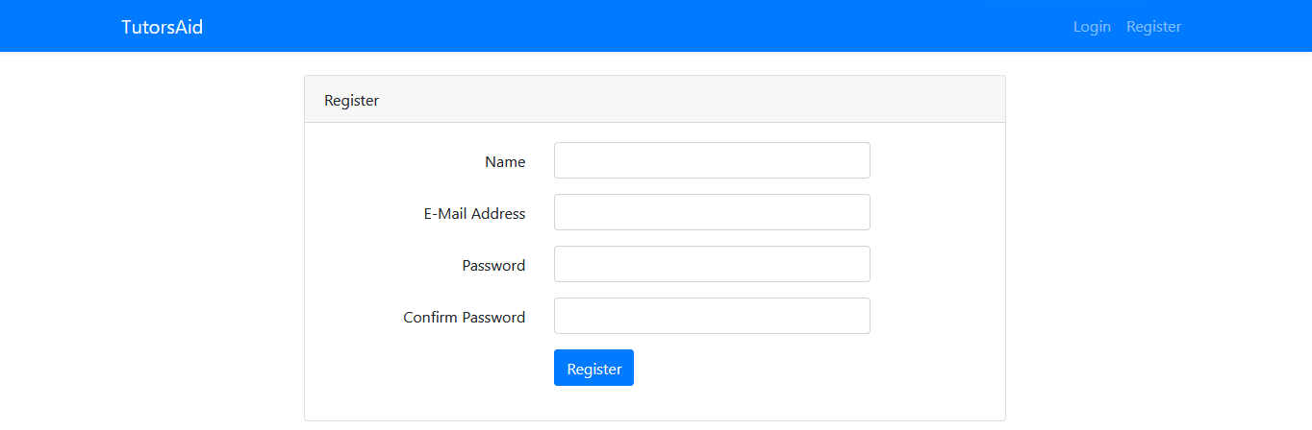

# Figure 5.144: UI (Student Register)

**5.39 Login**

Student can login to the system after registration

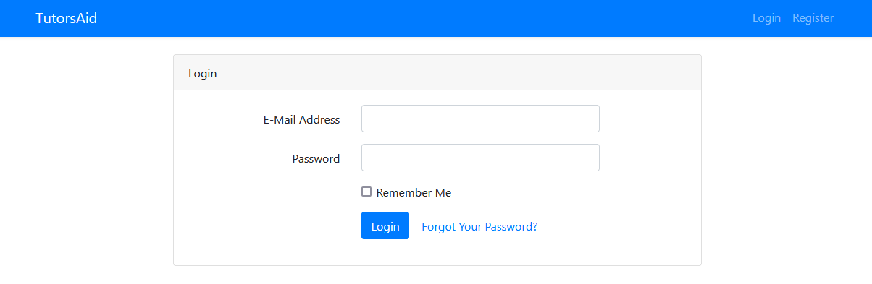

# Figure 5.145: UI (Student Login)

**5.40 Student Panel**

Student can access the student panel after registration/login

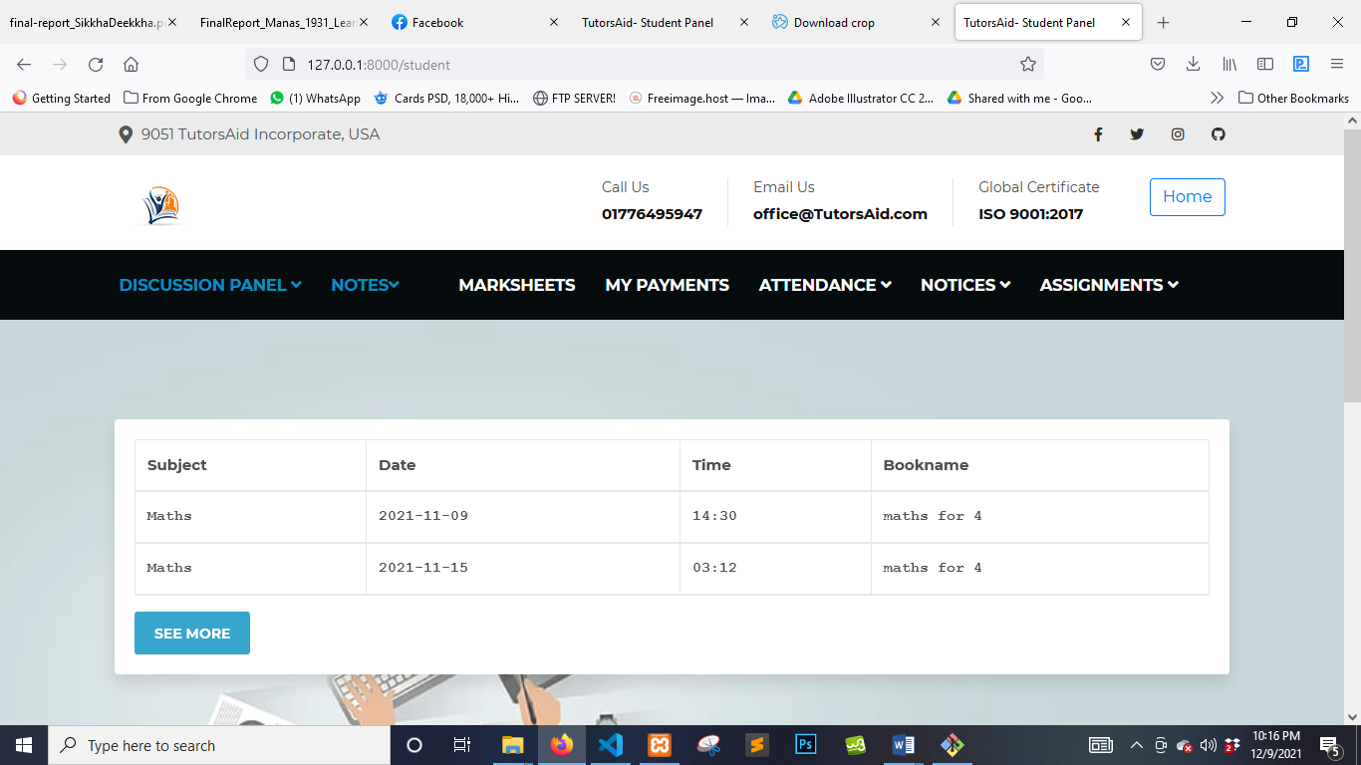

# Figure 5.146: UI (Student Panel)

**5.41 Discussion panel**

Student can access the discussion panel

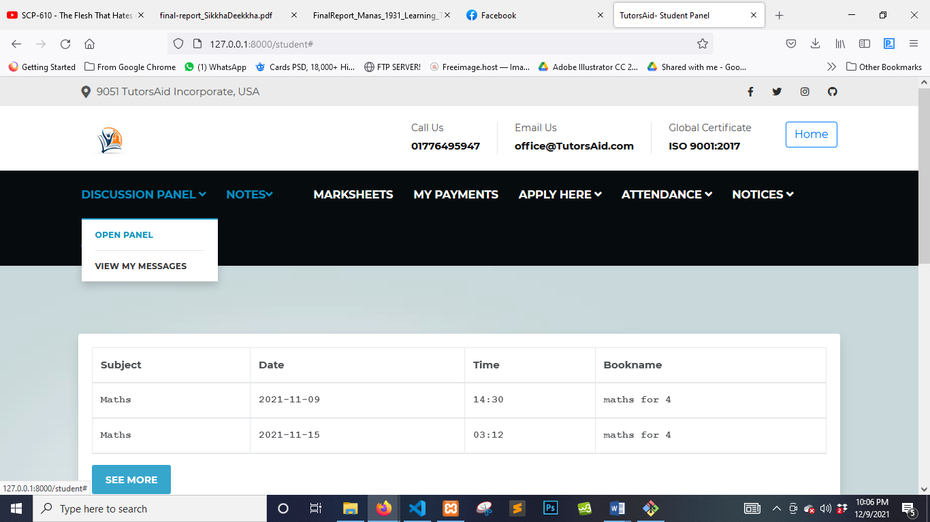

# Figure 5.147: UI (Discussion Panel)

**5.42 Open Panel**

Student can access the panel here

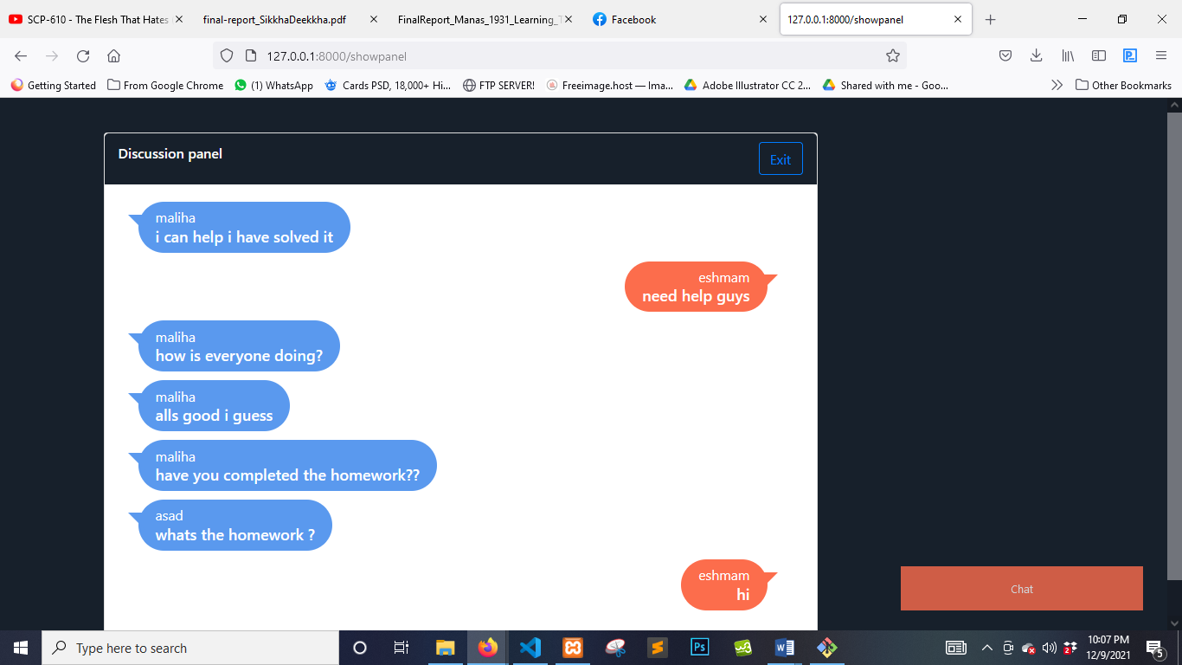

# Figure 5.148: UI (Open Panel)

**5.43 Post Messages**

Student can post messages here

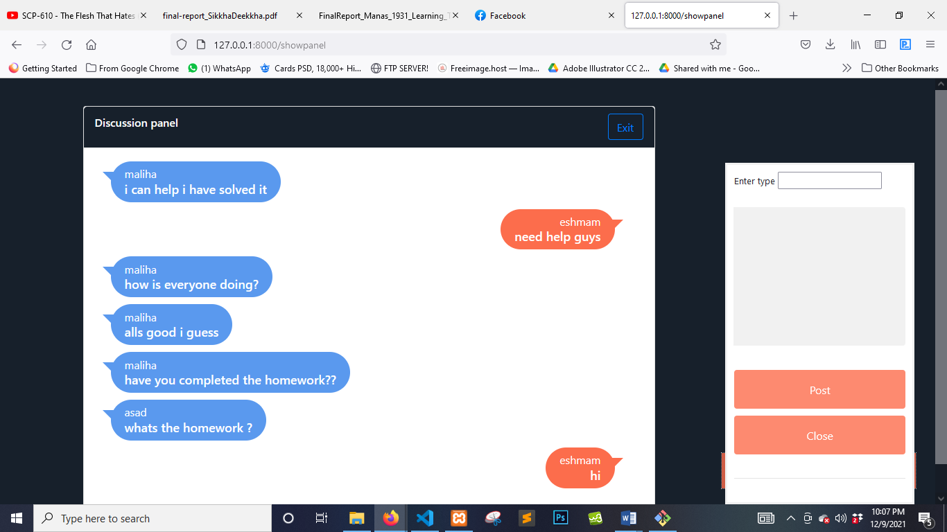

# Figure 5.149: UI (Post Messages)

**5.44 View My Messages**

Student can view their messages here

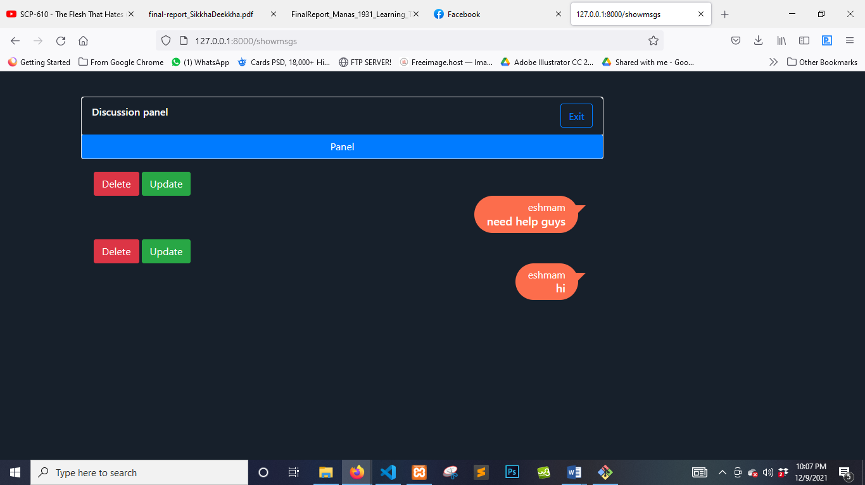

# Figure 5.150: UI (View My Messages)

**5.45 Update Message**

Student can update messages here

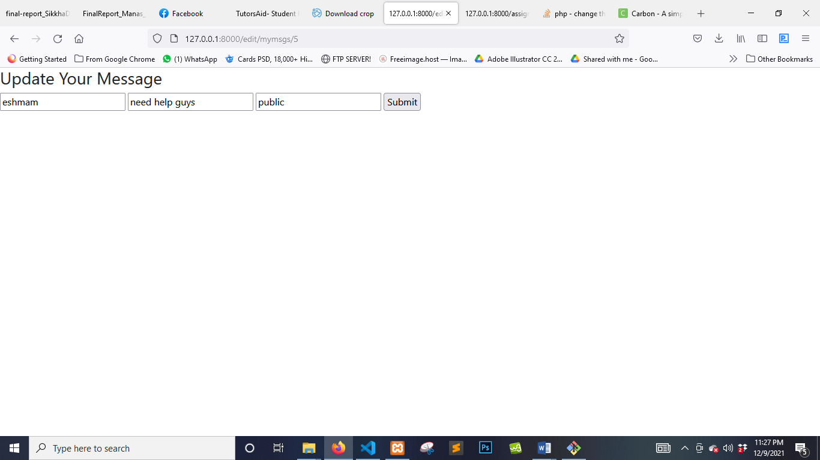

# Figure 5.151: UI (Update Messages)

**5.46 Delete Message**

Student can delete their messages here

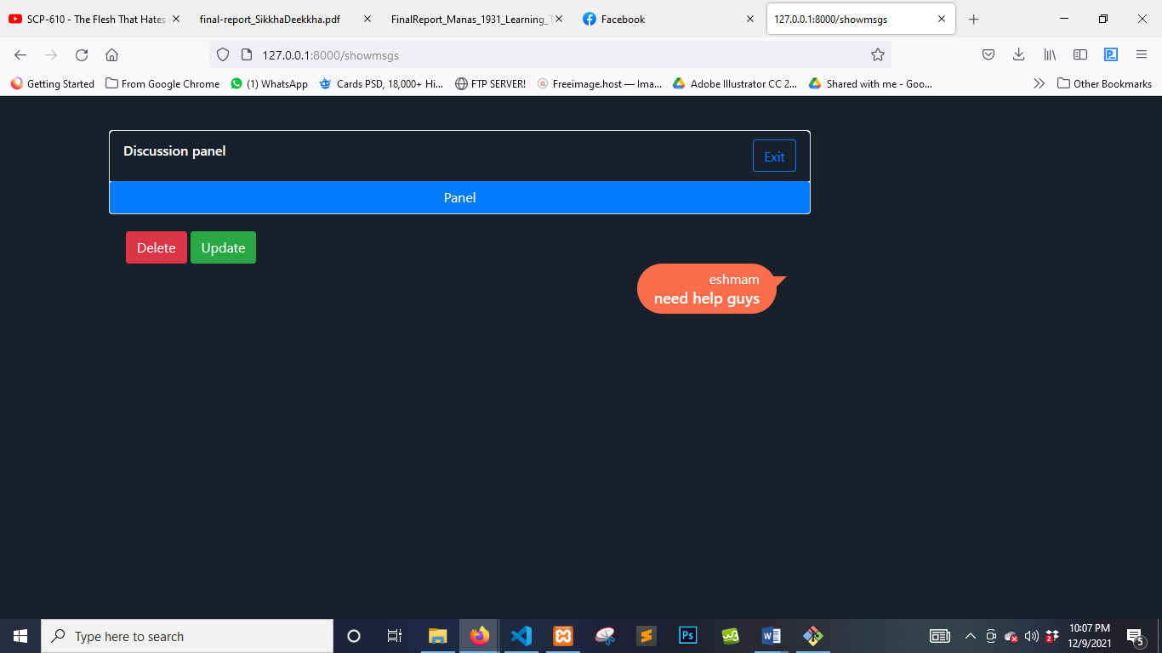

# Figure 5.152: UI (Delete Messages)

**5.47 Check Schedule**

Student can check schedule here



# Figure 5.153: UI (Check Schedule)

**5.48 See more**

Student can see more info regarding the schedule here

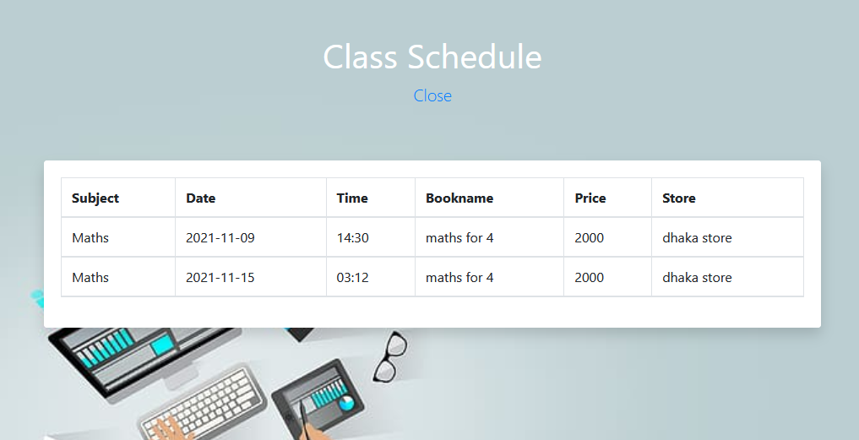

# Figure 5.154: UI (See More)

**5.49 Check Attendance**

Student can see their attendance here

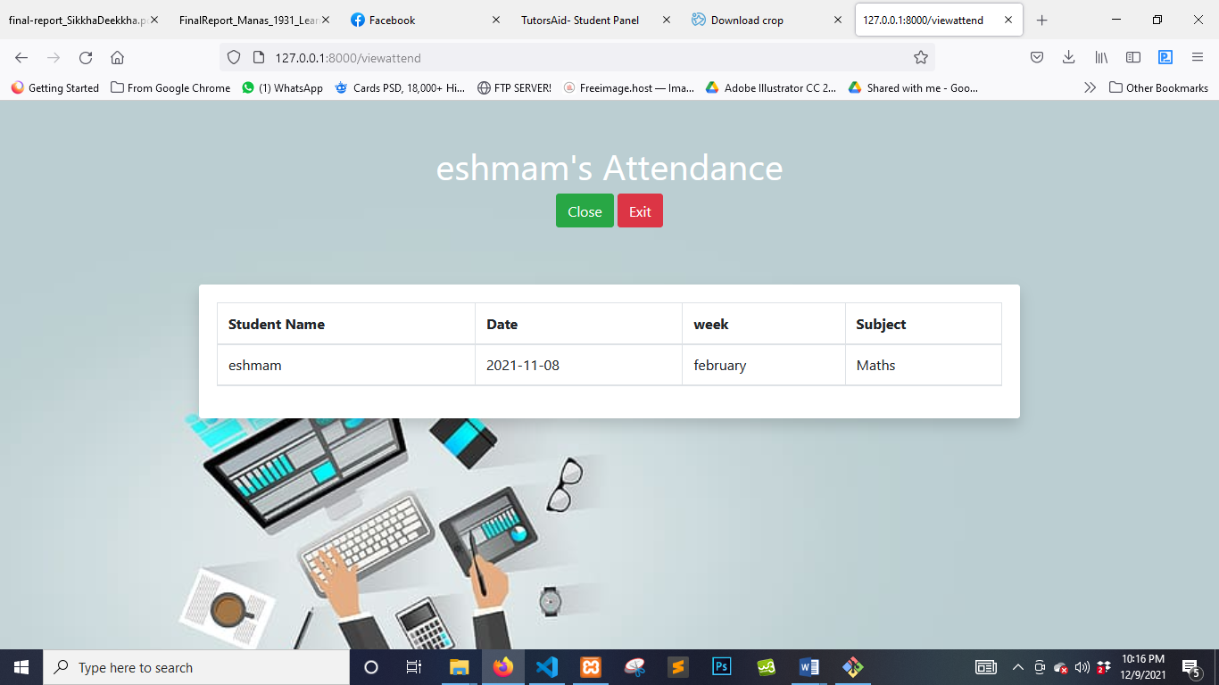

# Figure 5.155: UI (Check Attendance)

**5.50 Marksheet**

Student can see their marksheet here

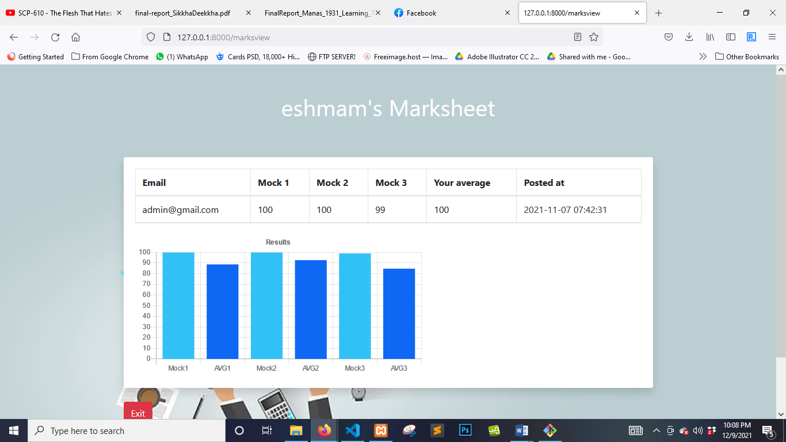

# Figure 5.156: UI (Marksheet)

**5.51 Assignments**

Student can view posted assignments here

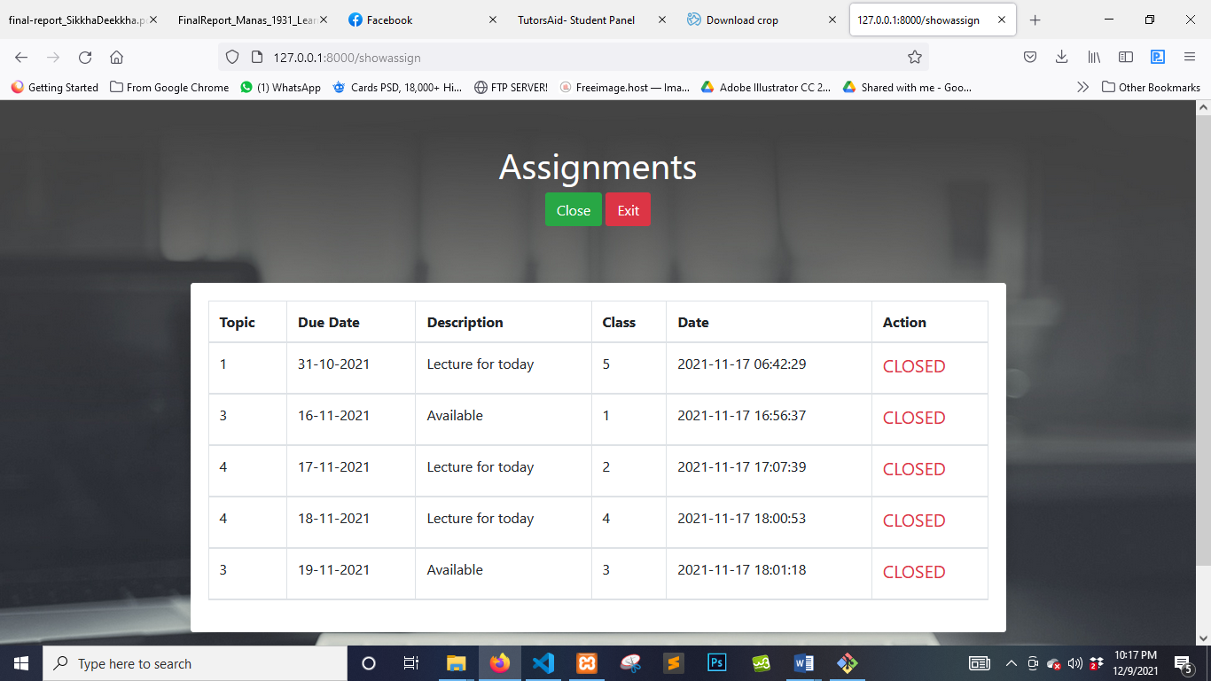

# Figure 5.157: UI (Assignments)

**5.51 Submit**

Student can submit their assignments here

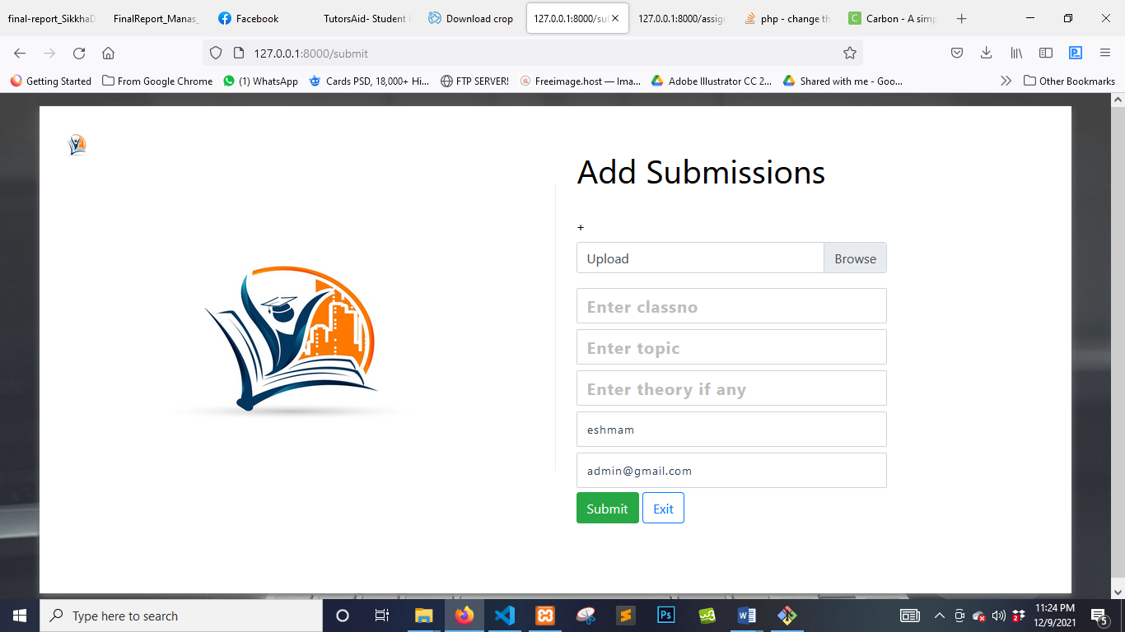

# Figure 5.157: UI (Submit)

**5.52 View notes**

Student can view notes posted by the admin here

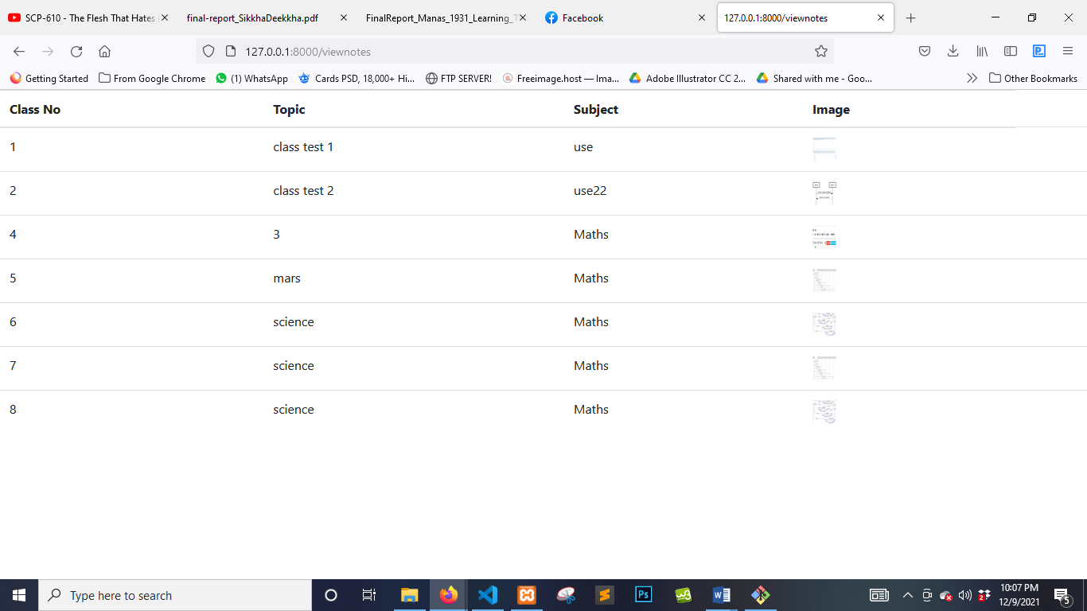

# Figure 5.158: UI (View Notes)

**5.53 Notice**

Student can view the notices here

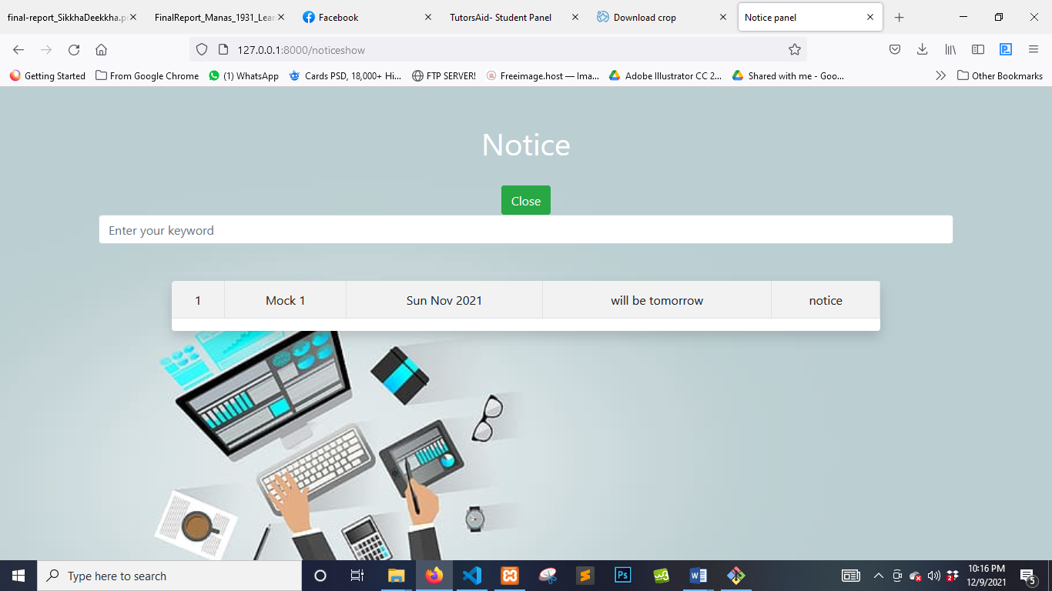

# Figure 5.159: UI (Notice)

**5.54 Search Notice**

Student can search notices here

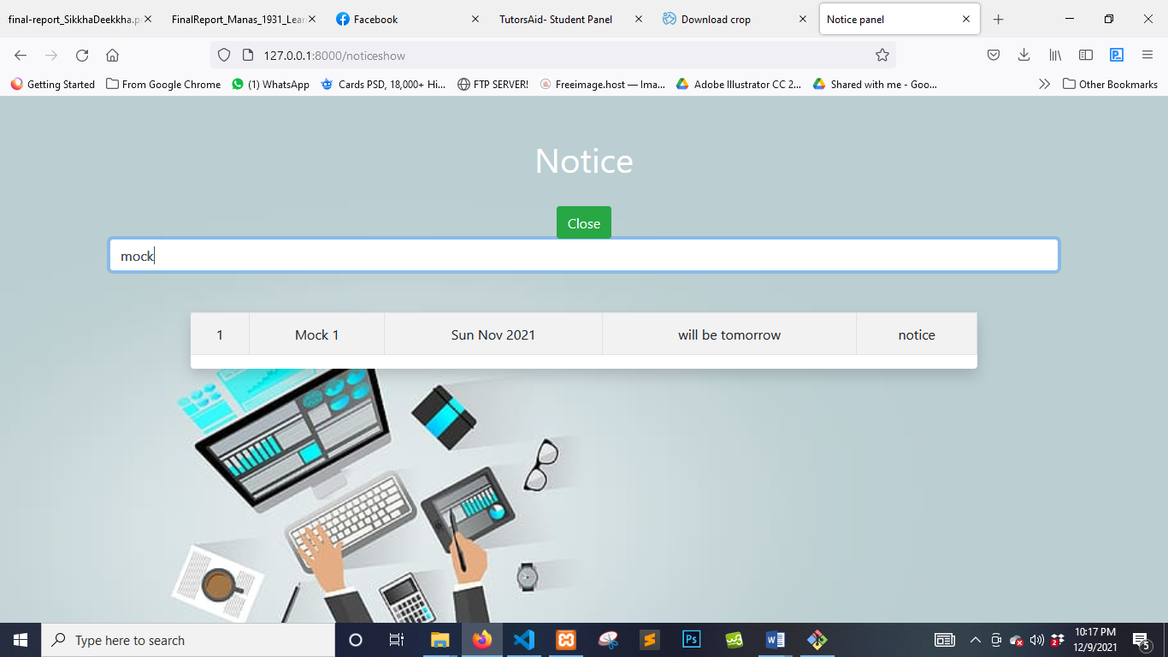

# Figure 5.160: UI (Search Notice)

**5.55 My payments**

Student can see the payments they made

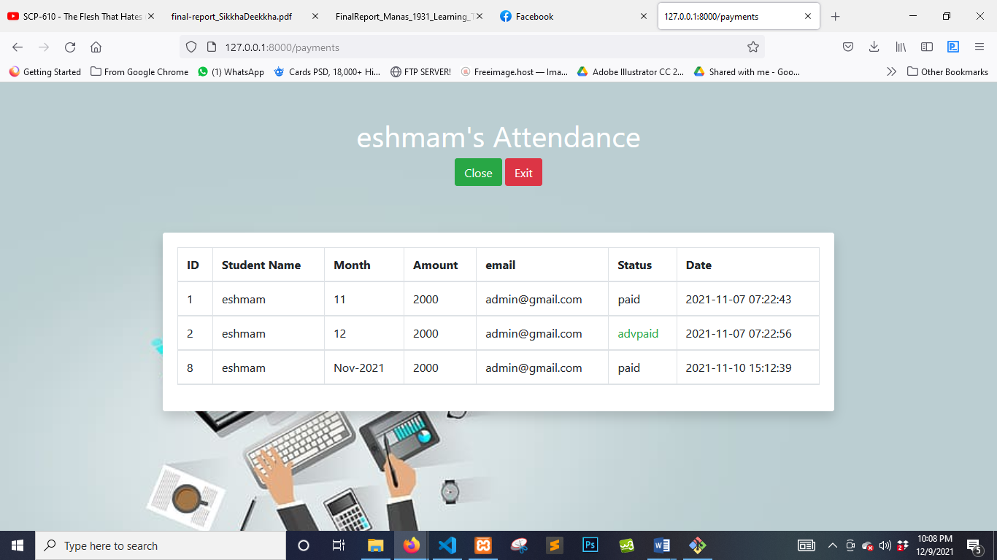

# Figure 5.161: UI (My payments)

**CHAPTER 6**

**PROJECT SUMMARY**

**6.1 GitHub Link**

https://github.com/Muhtasim-Eshmam/TutorsAid

**6.2 Limitations**

Different teachers have different requirements and expectations it is very hard to develop a project that will satisfy all their requirements. This project can solve many modern day problems but not all.

**Web version only**: This system is available in web version only. But we all know now people want anapplication for any kind of internet work. I did not create any Android ISO version of this project.

**6.3 Obstacles & Achievements**

I had collected several data and requirements and began developing them. It wasn’t anywhere near easy as the requirements surpassed my knowledge of the framework I was using. I had to experiment and research a lot and finally achieved the best solutions to satisfy the requirements. I developed this project with advanced features and though it seemed tough but I had managed to cover all the requirements and complete the project.

**6.4 Future Scope**

Despite being a complete project there are still more requirements out there and more teachers to sit down with and gather their demands and requirements. However, till I come across and new features I will be improving the existing features. I will try to modify certain areas and add enhancements to make the system smoother and more user friendly